Traduzido até a página 15

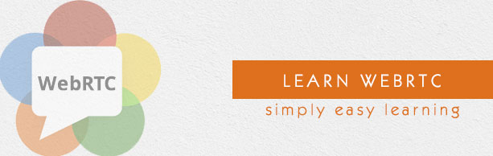

Tutorial WebRTC

Parte superior do formulário

Versão PDF Guia rápido Recursos Pesquisa de emprego Discussão

Com Web Real-Time Communication (WebRTC), modernas aplicações web podem facilmente transmitir conteúdo de áudio e vídeo para milhões de pessoas. Neste tutorial, explicamos como você pode usar o WebRTC para configurar conexões peer-to-peer para outros navegadores da web de forma rápida e fácil.

Público

Este tutorial vai ajudar todos os desenvolvedores que gostariam de aprender como criar aplicativos, como publicidade em tempo real, jogos multiplayer, transmissão ao vivo, e-learning, para citar alguns, onde a ação ocorre em tempo real.

Pré-requisitos

O WebRTC é uma poderosa ferramenta que pode ser usada para infundir recursos de Comunicações em Tempo Real (RTC) em navegadores e aplicativos móveis. Este tutorial abrange apenas os conceitos básicos da WebRTC e qualquer desenvolvedor regular com algum nível de exposição ao gerenciamento de sessão em tempo real pode facilmente entender os conceitos aqui discutidos.

WebRTC – Visão Geral

(Overview)

A Web não é mais estranha à comunicação em tempo real à medida que a WebRTC (Web Real-Time Communication) entra em jogo. Embora tenha sido lançado em maio de 2011, ainda está em desenvolvimento e seus padrões estão mudando. Um conjunto de protocolos é padronizado pela comunicação em tempo real no grupo de trabalho WEB-browsers http://tools.ietf.org/wg/rtcweb/ do IETF (Internet Engineering Task Force) enquanto novos conjuntos de APIs são padronizados pelo Grupo de Trabalho de Comunicações em Tempo Real da Web em http://www.w3.org/2011/04/webrtc/ do W3C (World Wide Web Consortium). Com o surgimento do WebRTC, aplicativos web modernos podem facilmente transmitir conteúdo de áudio e vídeo para milhões de pessoas.

Basic Scheme - Esquema básico

O WebRTC permite que você configure conexões peer-to-peer para outros navegadores da Web de forma rápida e fácil. Para criar tal aplicativo a partir do zero, você precisaria de uma grande quantidade de frameworks e bibliotecas que lidam com problemas típicos, como perda de dados, queda de conexão e NAT traversal. Com o WebRTC, tudo isso vem incorporado no navegador “Out of box”. Esta tecnologia não precisa de plugins ou de software de terceiros. É de código aberto e seu código fonte está disponível gratuitamente em http://www.webrtc.org/.

A API WebRTC inclui captura de mídia, codificação e decodificação de áudio e vídeo, camada de transporte e gerenciamento de sessão.

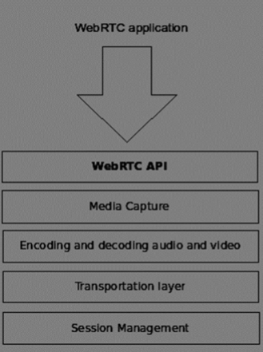

Media Capture

Captura de mídia

O primeiro passo é ter acesso à câmera e ao microfone do dispositivo do usuário. Detectamos o tipo de dispositivos disponíveis, obtenha permissão do usuário para acessar esses dispositivos e gerenciar o fluxo. (stream )

Encoding and Decoding Audio and Video

Codificação e Decodificação de Áudio e Vídeo

Não é uma tarefa fácil enviar uma transmissão de dados de áudio e vídeo pela Internet. É aí que a codificação e a decodificação são usadas. Este é o processo de dividir quadros de vídeo e ondas de áudio em pedaços menores e compactá-los. Este algoritmo é chamado de **codec**. Há uma enorme quantidade de **codecs** diferentes, que são mantidos por diferentes empresas com diferentes objetivos de negócios. Há também muitos codecs dentro da WebRTC como H.264, iSAC, Opus e VP8. Quando dois navegadores se conectam, eles escolhem o melhor codec suportado entre dois usuários. Felizmente, a WebRTC faz a maior parte da codificação nos bastidores.

Transportation Layer

Camada de transporte

A camada de transporte administra a ordem dos pacotes, lida com a perda de pacotes e liga-se a outros usuários. Novamente a WebRTC API nos dá um acesso fácil aos eventos que nos dizem quando há problemas com a conexão.

Session Management

Gerenciamento de Sessão

O gerenciamento de sessão trata de gerenciar, abrir e organizar conexões. Isso é comumente chamado de **signaling** “sinalização”. Se você transferir fluxos de áudio e vídeo para o usuário, também faz sentido transferir dados colaterais. Isso é feito pela API **RTCDataChannel**.

Engenheiros de empresas como Google, Mozilla, Opera e outros fizeram um ótimo trabalho para trazer essa experiência em tempo real para a Web.

Browser Compatibility

Compatibilidade do navegador

Os padrões WebRTC são um dos mais rápidos que evoluem na web, portanto, isso não significa que todos os navegadores suportam todos os mesmos recursos ao mesmo tempo. Para verificar se o seu navegador suporta WebRTC ou não, você pode visitar http://caniuse.com/#feat=rtcpeerconnection. Ao longo de todos os tutoriais, recomendo que use o Chrome para todos os exemplos.

Trying out WebRTC

Testando WebRTC

Vamos começar a usar o WebRTC agora. Navegue no seu navegador para o site de demonstração em <https://apprtc.appspot.com/>

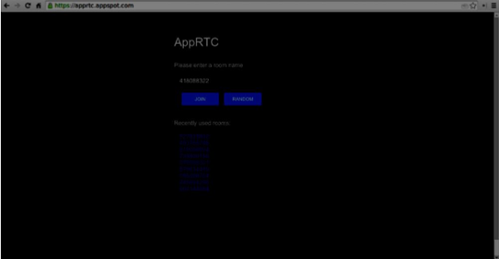

Clique no botão "JOIN". Você deve ver uma notificação suspensa.

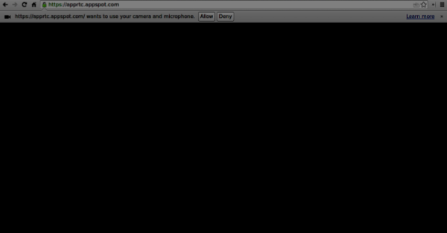

Clique no botão Permitir “Alow” para começar a transmitir o seu vídeo e áudio para a página da Web. Você deve ver um fluxo de vídeo “Video Stream” de si mesmo.

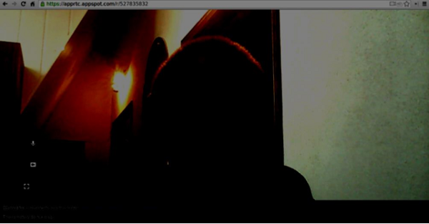

Agora abra o URL que você está atualmente em uma nova aba do navegador e clique em "Inscreva-se". Você deve ver dois fluxos de vídeo - um do seu primeiro cliente e outro do segundo.

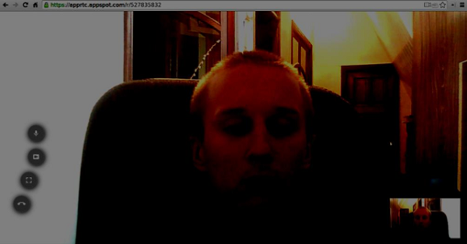

Agora você deve entender porque o WebRTC é uma ferramenta poderosa.

Use Cases

Casos de uso

A web em tempo real abre a porta para uma nova gama de aplicativos, incluindo Chat baseado em texto, tela e compartilhamento de arquivos, jogos, Vídeo Chat e muito mais. Além de comunicações você pode usar o WebRTC para outros fins como:

• marketing em tempo real

• publicidade em tempo real

• comunicações de back office (CRM, ERP, SCM, FFM)

• gerenciamento de RH

• redes sociais

• serviços de namoro

• consultas médicas on-line

• serviços financeiros

• Vigilância

• jogos multiplayer

• transmissão ao vivo

• e-learning

Summary

Sumário

Agora você deve ter uma compreensão clara do termo WebRTC. Você também deve ter uma idéia de quais tipos de aplicativos podem ser criados com WebRTC, como você já tentou em seu navegador. Para resumir, a WebRTC é uma tecnologia bastante útil.

# WebRTC - Architecture

**Arquitetura**

A arquitetura geral de WebRTC possui um grande nível de complexidade.

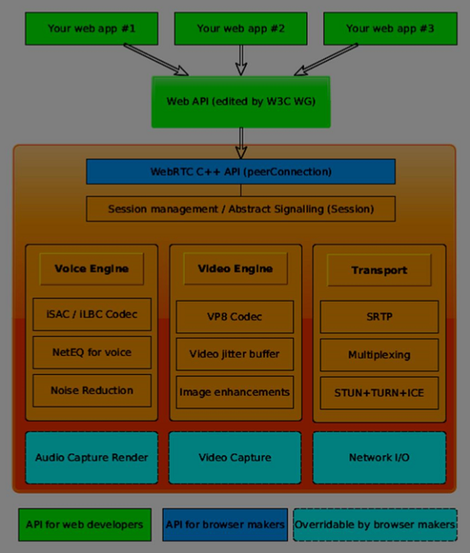

Aqui você pode encontrar três camadas diferentes −

• API para desenvolvedores web - esta camada contém todos os desenvolvedores web da API necessários, incluindo objetos RTCPeerConnection, RTCDataChannel e MediaStrean.

• API para fabricantes de navegadores

• API Overridable, quais fabricantes de navegador podem se conectar.

Componentes de transporte Permitem estabelecer conexões em vários tipos de redes, enquanto os mecanismos de voz e vídeo são responsáveis ​​por transferir fluxos de áudio e vídeo de uma placa de som e câmera para a rede. Para os desenvolvedores da Web, a parte mais importante é a API da WebRTC.

Se analisarmos a arquitetura WebRTC do lado do cliente-servidor, podemos ver que um dos modelos mais usados ​​é inspirado no “Trapezoid SIP” (Session Initiation Protocol).

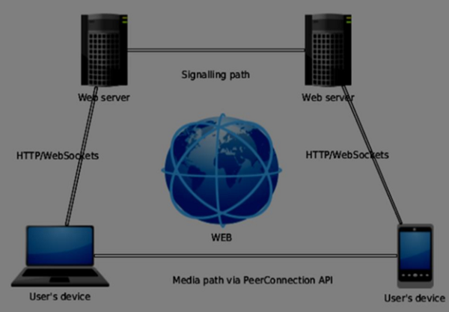

Neste modelo, ambos os dispositivos estão executando uma aplicação web de diferentes servidores. O objeto RTCPeerConnection configura fluxos para que eles possam se conectar uns aos outros, peer-to-peer. Esta sinalização é feita via HTTP ou WebSockets.

Mas o modelo mais comumente usado é o Triângulo −

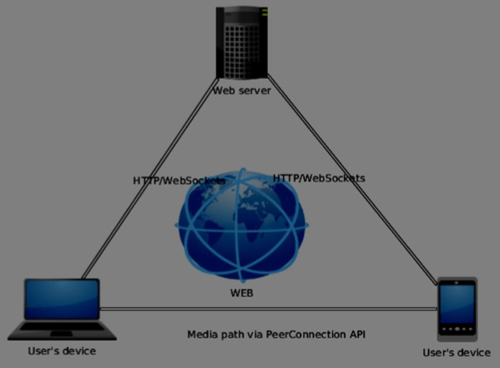

Neste modelo, ambos os dispositivos usam a mesma aplicação web. Dá ao desenvolvedor web mais flexibilidade ao gerenciar conexões de usuário.

## **A API WebRTC**

A API WebRTC consiste em alguns objetos javascript principais –

**• RTCPeerConnection**

**• MediaStream**

**• RTCDataChannel**

### **The RTCPeerConnection object**

**O objeto RTCPeerConnection**

Este objeto é o ponto de entrada principal para a API WebRTC. Isso nos ajuda a conectar-se a pares, inicializar conexões e anexar fluxos de mídia. Ele também gerencia uma conexão UDP com outro usuário.

A tarefa principal do objeto RTCPeerConnection é configurar e criar uma conexão entre pares. Podemos facilmente ligar chaves pontos da conexão porque este objeto dispara um conjunto de eventos quando eles aparecem. Esses eventos dão acesso à configuração de nossa conexão. −

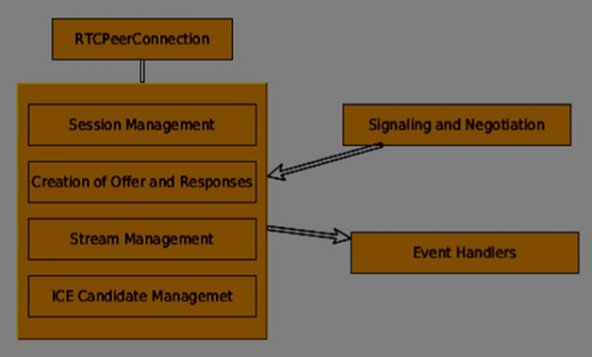

O RTCPeerConnection é um objeto simples de javascript, que você pode simplesmente criar dessa maneira −

[code]

var conn = new RTCPeerConnection(conf);

conn.onaddstream = function(stream) {

// use stream here

};

[/code]

O objeto RTCPeerConnection aceita um parâmetro conf, que abordaremos mais adiante nestes tutoriais. O evento onaddstream é disparado quando o usuário remoto adiciona um fluxo de vídeo ou áudio para sua conexão entre pares “peer connection”.

### **MediaStream API**

A API ***MediaStream***

Os navegadores modernos oferecem ao desenvolvedor acesso à API getUserMedia, também conhecida como API MediaStream. Existem três pontos-chave de funcionalidade:

• Oferece um acesso de desenvolvedor a um objeto de fluxo que representa fluxos de vídeo e áudio

• Gerencia a seleção de dispositivos de usuário de entrada no caso de um usuário possuir várias câmeras ou microfones no dispositivo

• Fornece uma segurança Nível perguntando ao usuário todo o tempo que ele quer buscar s stream

*Modern browsers give a developer access to the getUserMedia API, also known as the MediaStream API. There are three key points of functionality −*

* *It gives a developer access to a stream object that represent video and audio streams*
* *It manages the selection of input user devices in case a user has multiple cameras or microphones on his device*
* *It provides a security level asking user all the time he wants to fetch s stream*
* Para testar esta API, vamos criar uma página HTML simples. Ele mostrará um único elemento <video>, pergunte à permissão do usuário para usar a câmera e mostrar uma transmissão ao vivo da câmera na página. Crie um arquivo index.html e adicione –

<html>

<head>

<meta charset = "utf-8">

</head>

<body>

<video autoplay></video>

<script src = "client.js"></script>

</body>

</html>

Em seguida, adicione um arquivo client.js –

[code]

//checks if the browser supports WebRTC

function hasUserMedia() {

navigator.getUserMedia = navigator.getUserMedia || navigator.webkitGetUserMedia

|| navigator.mozGetUserMedia || navigator.msGetUserMedia;

return !!navigator.getUserMedia;

}

if (hasUserMedia()) {

navigator.getUserMedia = navigator.getUserMedia || navigator.webkitGetUserMedia

|| navigator.mozGetUserMedia || navigator.msGetUserMedia;

//get both video and audio streams from user's camera

navigator.getUserMedia({ video: true, audio: true }, function (stream) {

var video = document.querySelector('video');

//insert stream into the video tag

video.src = window.URL.createObjectURL(stream);

}, function (err) {});

}else {

alert("Error. WebRTC is not supported!");

}

[/code]

Agora, abra o index.html e você deve ver o fluxo de vídeo exibindo seu rosto. Mas tenha cuidado, porque o WebRTC funciona apenas do lado do servidor. Se você simplesmente abrir esta página com o navegador, ela não funcionará. Você precisa hospedar esses arquivos nos servidores Apache ou Node ou qual prefere.

### **The RTCDataChannel object**

O objeto RTCDataChannel

Enquanto estiver enviando fluxos de mídia entre pares, você também pode enviar dados adicionais usando a API DataChannel. Esta API é tão simples quanto a API MediaStream. O trabalho principal é criar um canal proveniente de um objeto RTCPeerConnection existente −

[code]

var peerConn = new RTCPeerConnection();

//establishing peer connection

//...

//end of establishing peer connection

var dataChannel = peerConnection.createDataChannel("myChannel", dataChannelOptions);

// here we can start sending direct messages to another peer

[/code]

Isto é tudo o que você precisava, apenas duas linhas de código. Tudo o resto é feito na camada interna do navegador. Você pode criar um canal em qualquer conexão entre pares até que o objeto RTCPeerConnection esteja fechado.

### **Summary**

Sumario

Você deve ter uma compreensão firme da arquitetura WebRTC. Também cobrimos as APIs MediaStream, RTCPeerConnection e RTCDataChannel. A API WebRTC é um alvo em movimento, portanto, mantenha sempre as últimas especificações

# WebRTC - Environment

Ambiente WebRTC –

Para começar a construir nossos aplicativos WebRTC, devemos configurar nosso ambiente de codificação. Em primeiro lugar, você deve ter um editor de texto ou IDE onde você pode editar HTML e Javascript. Há chances de você ter escolhido o preferido porque você está lendo este tutorial. Quanto a mim, estou usando o WebStorm IDE. Você pode baixar sua versão de avaliação em https://www.jetbrains.com/webstorm/. Eu também estou usando o Linux Mint como meu SO de escolha. O outro requisito para aplicativos comuns da WebRTC é ter um servidor para hospedar os arquivos HTML e Javascript. O código não funcionará apenas clicando duas vezes nos arquivos porque o navegador não tem permissão para se conectar a câmeras e microfones, a menos que os arquivos sejam atendidos por um servidor real. Isso é feito, obviamente, devido aos problemas de segurança. Há toneladas de servidores web diferentes, mas neste tutorial, vamos usar o Node.js com o nó estático –

• Visite https://nodejs.org/en/ e faça o download A última versão do Node.js.

• Descompacte-o no diretório / usr / local / nodejs.

• Abra o arquivo /home/YOUR_USERNAME/.file de perfil

e adicione a seguinte linha ao final - export PATH = $ PATH: / usr / local / Nodejs / bin • Pode reiniciar o computador ou executar a fonte /home/YOUR_USERNAME/.profile. Agora, o comando do nó deve estar disponível a partir da linha de comando. O comando npm também está disponível. NMP é o gerenciador de pacotes para Node.js. Você pode aprender mais em https://www.npmjs.com/.• Abrir um terminal e executar sudo npm install -g node-static. Isso irá instalar o servidor web estático para Node.js. • Agora navegue até qualquer diretório que contenha os arquivos HTML e execute o comando estático dentro do diretório para iniciar seu servidor da Web. • Você pode navegar para http: // localhost: 8080 para ver Seus arquivos. Há outra maneira de instalar nodejs. Basta executar sudo apt-get install nodejs na janela do terminal. Para testar a instalação do Node.js, abra seu terminal e execute o nodecommand. Digite alguns comandos para verificar como ele funciona –

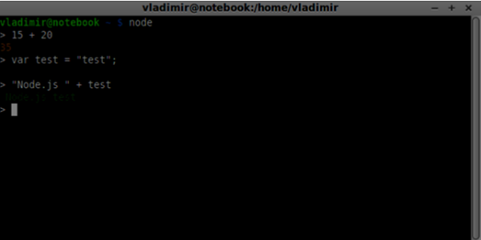

Node.js executa arquivos JavaScript, bem como comandos digitados no terminal. Crie um arquivo index.js com o seguinte conteúdo −

console.log(“Testing Node.js”);

em seguida, execute o comando do índice do nó. Você verá o seguinte:

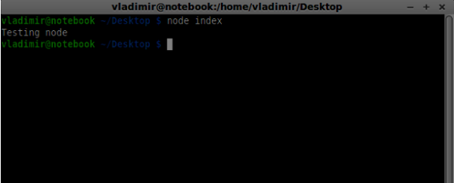

Ao construir nosso servidor de sinalização ”**signaling server**”, usaremos uma biblioteca do WebSockets para Node.js. Para instalar em run npm install ws no terminal.

Para testar o nosso servidor de sinalização, usaremos o utilitário wscat. Para instalá-lo, execute npm instale -g wscat na sua janela de terminal.

|  |  |
| --- | --- |
| **S.No** | **Protocols & Description** |
| 1 | [**WebRTC Protocols**](https://www.tutorialspoint.com/webrtc/webrtc_protocols.htm)  Os aplicativos do WebBTC usam UDP (User Datagram Protocol) como o protocolo de transporte. A maioria dos aplicativos da Web hoje são construídos com o uso do protocolo TCP (Protocolo de Controle de Transmissão) |
| 2 | [**Session Description Protocol**](https://www.tutorialspoint.com/webrtc/webrtc_session_description_protocol.htm)  O SDP é uma parte importante do WebRTC. É um protocolo destinado a descrever as sessões de comunicação de mídia. |
| 3 | [**Finding a Route**](https://www.tutorialspoint.com/webrtc/webrtc_finding_route.htm)  Para se conectar a outro usuário, você deve encontrar um caminho claro em sua própria rede e na rede do outro usuário. Mas há chances de que a rede que você está usando tenha vários níveis de controle de acesso para evitar problemas de segurança. |
| 4 | [**Stream Control Transmission Protocol**](https://www.tutorialspoint.com/webrtc/webrtc_sctp.htm)  Protocolo de transmissão de controle de fluxo  Com a conexão entre pares, temos a capacidade de enviar rapidamente dados de vídeo e áudio. O protocolo SCTP é usado hoje para enviar dados blob em cima da nossa conexão de configuração de pares no momento, usando o objeto RTCDataChannel. |

## **Summary**

Sumario

Neste capítulo, nós abordamos várias das tecnologias que permitem conexões pares, como UDP, TCP, STUN, TURN, ICE , E SCTP. Você deve agora ter uma compreensão ao nível da superfície de como o SDP funciona e seus casos de uso

# WebRTC - MediaStream APIs

The MediaStream API was designed to easy access the media streams from local cameras and microphones. The *getUserMedia()* method is the primary way to access local input devices.

The API has a few key points −

* A real-time media stream is represented by a *stream* object in the form of video or audio
* It provides a security level through user permissions asking the user before a web application can start fetching a stream
* The selection of input devices is handled by the MediaStream API (for example, when there are two cameras or microphones connected to the device)

Each MediaStream object includes several MediaStreamTrack objects. They represent video and audio from different input devices.

Each MediaStreamTrack object may include several channels (right and left audio channels). These are the smallest parts defined by the MediaStream API.

There are two ways to output MediaStream objects. First, we can render output into a video or audio element. Secondly, we can send output to the RTCPeerConnection object, which then send it to a remote peer.

## **Using the MediaStream API**

Let's create a simple WebRTC application. It will show a video element on the screen, ask the user permission to use the camera, and show a live video stream in the browser. Create an *index.html* file −

<!DOCTYPE html>

<html lang = "en">

<head>

<meta charset = "utf-8" />

</head>

<body>

<video autoplay></video>

<script src = "client.js"></script>

</body>

</html>

Then create the *client.js file* and add the following;

function hasUserMedia() {

//check if the browser supports the WebRTC

return !!(navigator.getUserMedia || navigator.webkitGetUserMedia ||

navigator.mozGetUserMedia);

}

if (hasUserMedia()) {

navigator.getUserMedia = navigator.getUserMedia || navigator.webkitGetUserMedia

|| navigator.mozGetUserMedia;

//enabling video and audio channels

navigator.getUserMedia({ video: true, audio: true }, function (stream) {

var video = document.querySelector('video');

//inserting our stream to the video tag

video.src = window.URL.createObjectURL(stream);

}, function (err) {});

} else {

alert("WebRTC is not supported");

}

Here we create the *hasUserMedia()* function which checks whether WebRTC is supported or not. Then we access the *getUserMedia* function where the second parameter is a callback that accept the stream coming from the user's device. Then we load our stream into the *video* element using *window.URL.createObjectURL* which creates a URL representing the object given in parameter.

Now refresh your page, click Allow, and you should see your face on the screen.

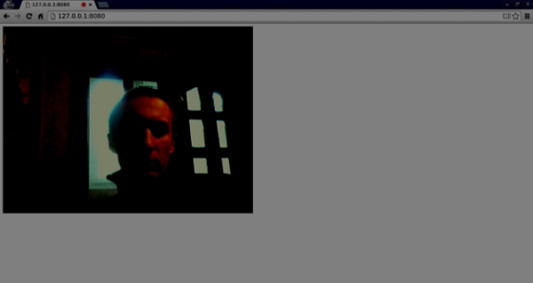

Remember to run all your scripts using the web server. We have already installed one in the WebRTC Environment Tutorial.

## **MediaStream API**

### **Properties**

* **MediaStream.active (read only)** − Returns true if the MediaStream is active, or false otherwise.
* **MediaStream.ended (read only, deprecated)** − Return true if the ended *event* has been fired on the object, meaning that the stream has been completely read, or false if the end of the stream has not been reached.
* **MediaStream.id (read only)** − A unique identifier for the object.
* **MediaStream.label (read only, deprecated)** − A unique identifier assigned by the user agent.

You can see how the above properties look in my browser −

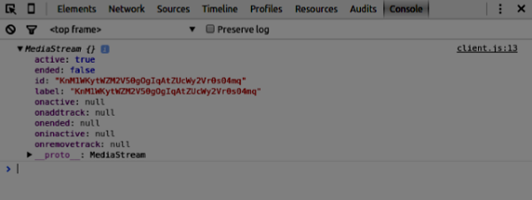

### **Event Handlers**

* **MediaStream.onactive** − A handler for an *active* event that is fired when a MediaStream object becomes active.
* **MediaStream.onaddtrack** − A handler for an *addtrack* event that is fired when a new *MediaStreamTrack* object is added.
* **MediaStream.onended (deprecated)** − A handler for an *ended*event that is fired when the streaming is terminating.
* **MediaStream.oninactive** − A handler for an *inactive* event that is fired when a *MediaStream* object becomes inactive.
* **MediaStream.onremovetrack** − A handler for a *removetrack* event that is fired when a *MediaStreamTrack* object is removed from it.

### **Methods**

* **MediaStream.addTrack()** − Adds the *MediaStreamTrack* object given as argument to the MediaStream. If the track has already been added, nothing happens.
* **MediaStream.clone()** − Returns a clone of the MediaStream object with a new ID.
* **MediaStream.getAudioTracks()** − Returns a list of the audio *MediaStreamTrack* objects from the *MediaStream* object.
* **MediaStream.getTrackById()** − Returns the track by ID. If the argument is empty or the ID is not found, it returns null. If several tracks have the same ID, it returns the first one.
* **MediaStream.getTracks()** − Returns a list of all *MediaStreamTrack*objects from the *MediaStream* object.
* **MediaStream.getVideoTracks()** − Returns a list of the video *MediaStreamTrack* objects from the *MediaStream* object.
* **MediaStream.removeTrack()** − Removes the *MediaStreamTrack*object given as argument from the MediaStream. If the track has already been removed, nothing happens.

To test the above APIs change change the *index.html* in the following way −

<!DOCTYPE html>

<html lang = "en">

<head>

<meta charset = "utf-8" />

</head>

<body>

<video autoplay></video>

<div><button id = "btnGetAudioTracks">getAudioTracks()

</button></div>

<div><button id = "btnGetTrackById">getTrackById()

</button></div>

<div><button id = "btnGetTracks">getTracks()</button></div>

<div><button id = "btnGetVideoTracks">getVideoTracks()

</button></div>

<div><button id = "btnRemoveAudioTrack">removeTrack() - audio

</button></div>

<div><button id = "btnRemoveVideoTrack">removeTrack() - video

</button></div>

<script src = "client.js"></script>

</body>

</html>

We added a few buttons to try out several MediaStream APIs. Then we should add event handlers for our newly created button. Modify the *client.js* file this way −

var stream;

function hasUserMedia() {

//check if the browser supports the WebRTC

return !!(navigator.getUserMedia || navigator.webkitGetUserMedia ||

navigator.mozGetUserMedia);

}

if (hasUserMedia()) {

navigator.getUserMedia = navigator.getUserMedia || navigator.webkitGetUserMedia

|| navigator.mozGetUserMedia;

//enabling video and audio channels

navigator.getUserMedia({ video: true, audio: true }, function (s) {

stream = s;

var video = document.querySelector('video');

//inserting our stream to the video tag

video.src = window.URL.createObjectURL(stream);

}, function (err) {});

} else {

alert("WebRTC is not supported");

}

btnGetAudioTracks.addEventListener("click", function(){

console.log("getAudioTracks");

console.log(stream.getAudioTracks());

});

btnGetTrackById.addEventListener("click", function(){

console.log("getTrackById");

console.log(stream.getTrackById(stream.getAudioTracks()[0].id));

});

btnGetTracks.addEventListener("click", function(){

console.log("getTracks()");

console.log(stream.getTracks());

});

btnGetVideoTracks.addEventListener("click", function(){

console.log("getVideoTracks()");

console.log(stream.getVideoTracks());

});

btnRemoveAudioTrack.addEventListener("click", function(){

console.log("removeAudioTrack()");

stream.removeTrack(stream.getAudioTracks()[0]);

});

btnRemoveVideoTrack.addEventListener("click", function(){

console.log("removeVideoTrack()");

stream.removeTrack(stream.getVideoTracks()[0]);

});

Now refresh your page. Click on the *getAudioTracks()* button, then click on the *removeTrack() - audio* button. The audio track should now be removed. Then do the same for the video track.

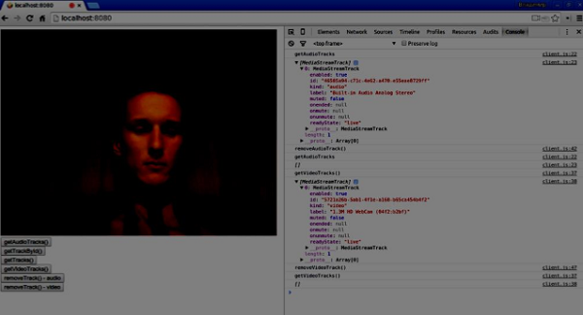

If you click the *getTracks()* button you should see all *MediaStreamTracks* (all connected video and audio inputs). Then click on the *getTrackById()* to get audio MediaStreamTrack.

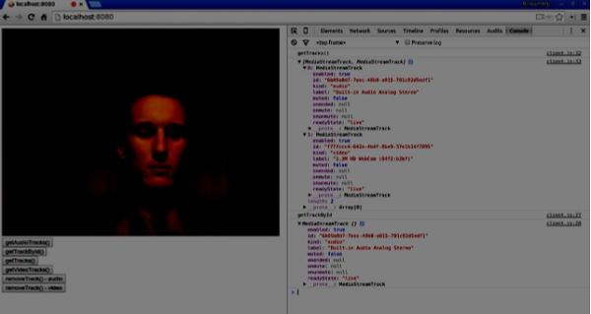

### **Summary**

In this chapter, we created a simple WebRTC application using the MediaStream API. Now you should have a clear overview of the various MediaStream APIs that make WebRTC work.

# WebRTC - RTCPeerConnection APIs

The RTCPeerConnection API is the core of the peer-to-peer connection between each of the browsers. To create the RTCPeerConnection objects simply write

var pc = RTCPeerConnection(config);

where the *config* argument contains at least on key, iceServers. It is an array of URL objects containing information about STUN and TURN servers, used during the finding of the ICE candidates. You can find a list of available public STUN servers at [code.google.com](https://code.google.com/p/natvpn/source/browse/trunk/stun_server_list)

Depending upon whether you are the caller or the callee the RTCPeerConnection object is used in a slightly different way on each side of the connection.

Here is an example of the user's flow −

* Register the *onicecandidate* handler. It sends any ICE candidates to the other peer, as they are received.
* Register the *onaddstream* handler. It handles the displaying of the video stream once it is received from the remote peer.
* Register the *message* handler. Your signaling server should also have a handler for messages received from the other peer. If the message contains the *RTCSessionDescription* object, it should be added to the *RTCPeerConnection* object using the *setRemoteDescription()* method. If the message contains the *RTCIceCandidate* object, it should be added to the *RTCPeerConnection* object using the *addIceCandidate()*method.
* Utilize *getUserMedia()* to set up your local media stream and add it to the *RTCPeerConnection* object using the *addStream()* method.
* Start offer/answer negotiation process. This is the only step where the caller's flow is different from the callee's one. The caller starts negotiation using the *createOffer()* method and registers a callback that receives the *RTCSessionDescription* object. Then this callback should add this *RTCSessionDescription* object to your *RTCPeerConnection* object using *setLocalDescription()*. And finally, the caller should send this *RTCSessionDescription* to the remote peer using the signaling server. The callee, on the other, registers the same callback, but in the *createAnswer()* method. Notice that the callee flow is initiated only after the offer is received from the caller.

## **RTCPeerConnection API**

### **Properties**

* **RTCPeerConnection.iceConnectionState (read only)** − Returns an RTCIceConnectionState enum that describes the state of the connection. An iceconnectionstatechange event is fired when this value changes. The possible values −
  + **new** − the ICE agent is waiting for remote candidates or gathering addresses
  + **checking** − the ICE agent has remote candidates, but it has not found a connection yet
  + **connected** − the ICE agent has found a usable connection, but is still checking more remote candidate for better connection.
  + **completed** − the ICE agent has found a usable connection and stopped testing remote candidates.
  + **failed** − the ICE agent has checked all the remote candidates but didn't find a match for at least one component.
  + **disconnected** − at least one component is no longer alive.
  + **closed** − the ICE agent is closed.
* **RTCPeerConnection.iceGatheringState (read only)** − Returns a RTCIceGatheringState enum that describes the ICE gathering state for the connection −
  + **new** − the object was just created.
  + **gathering** − the ICE agent is in the process of gathering candidates
  + **complete** the ICE agent has completed gathering.
* **RTCPeerConnection.localDescription (read only)** − Returns an RTCSessionDescription describing the local session. It can be null if it has not yet been set.
* **RTCPeerConnection.peerIdentity (read only)** − Returns an RTCIdentityAssertion. It consists of an idp(domain name) and a name representing the identity of the remote peer.
* **RTCPeerConnection.remoteDescription (read only)** − Return an RTCSessionDescription describing the remote session. It can be null if it has not yet been set.
* **RTCPeerConnection.signalingState (read only)** − Returns an RTCSignalingState enum that describes the signaling state of the local connection. This state describes the SDP offer. A signalingstatechange event is fired when this value changes. The possible values −
  + **stable** − The initial state. There is no SDP offer/answer exchange in progress.
  + **have-local-offer** − the local side of the connection has locally applied a SDP offer.
  + **have-remote-offer** − the remote side of the connection has locally applied a SDP offer.
  + **have-local-pranswer** − a remote SDP offer has been applied, and a SDP pranswer applied locally.
  + **have-remote-pranswer** − a local SDP has been applied, and a SDP pranswer applied remotely.
  + **closed** − the connection is closed.

### **Event Handlers**

Given below are the commonly used Event Handlers of RTCPeerConnection.

### **Methods**

Given below are the commonly used methods of RTCPeerConnection.

## **Establishing a Connection**

Now let's create an example application. Firstly, run the signaling server we created in the “signaling server” tutorial via “node server”.

There will be two text inputs on the page, one for a login and one for a username we want to connect to. Create an *index.html* file and add the following code −

<html lang = "en">

<head>

<meta charset = "utf-8" />

</head>

<body>

<div>

<input type = "text" id = "loginInput" />

<button id = "loginBtn">Login</button>

</div>

<div>

<input type = "text" id = "otherUsernameInput" />

<button id = "connectToOtherUsernameBtn">Establish connection</button>

</div>

<script src = "client2.js"></script>

</body>

</html>

You can see that we've added the text input for a login, the login button, the text input for the other peer username, and the connect-to-him button. Now create a *client.js* file and add the following code −

var connection = new WebSocket('ws://localhost:9090');

var name = "";

var loginInput = document.querySelector('#loginInput');

var loginBtn = document.querySelector('#loginBtn');

var otherUsernameInput = document.querySelector('#otherUsernameInput');

var connectToOtherUsernameBtn = document.querySelector('#connectToOtherUsernameBtn');

var connectedUser, myConnection;

//when a user clicks the login button

loginBtn.addEventListener("click", function(event){

name = loginInput.value;

if(name.length > 0){

send({

type: "login",

name: name

});

}

});

//handle messages from the server

connection.onmessage = function (message) {

console.log("Got message", message.data);

var data = JSON.parse(message.data);

switch(data.type) {

case "login":

onLogin(data.success);

break;

case "offer":

onOffer(data.offer, data.name);

break;

case "answer":

onAnswer(data.answer);

break;

case "candidate":

onCandidate(data.candidate);

break;

default:

break;

}

};

//when a user logs in

function onLogin(success) {

if (success === false) {

alert("oops...try a different username");

} else {

//creating our RTCPeerConnection object

var configuration = {

"iceServers": [{ "url": "stun:stun.1.google.com:19302" }]

};

myConnection = new webkitRTCPeerConnection(configuration);

console.log("RTCPeerConnection object was created");

console.log(myConnection);

//setup ice handling

//when the browser finds an ice candidate we send it to another peer

myConnection.onicecandidate = function (event) {

if (event.candidate) {

send({

type: "candidate",

candidate: event.candidate

});

}

};

}

};

connection.onopen = function () {

console.log("Connected");

};

connection.onerror = function (err) {

console.log("Got error", err);

};

// Alias for sending messages in JSON format

function send(message) {

if (connectedUser) {

message.name = connectedUser;

}

connection.send(JSON.stringify(message));

};

You can see that we establish a socket connection to our signaling server. When a user clicks on the login button the application sends his username to the server. If login is successful the application creates the RTCPeerConnection object and setup onicecandidate handler which sends all found icecandidates to the other peer. Now open the page and try to login. You should see the following console output −

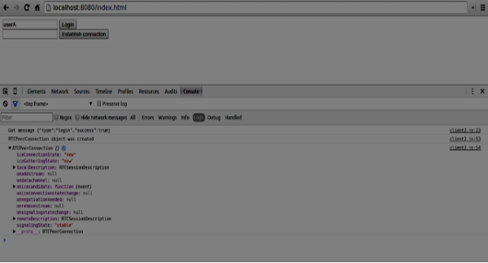

The next step is to create an offer to the other peer. Add the following code to your *client.js* file −

//setup a peer connection with another user

connectToOtherUsernameBtn.addEventListener("click", function () {

var otherUsername = otherUsernameInput.value;

connectedUser = otherUsername;

if (otherUsername.length > 0) {

//make an offer

myConnection.createOffer(function (offer) {

console.log();

send({

type: "offer",

offer: offer

});

myConnection.setLocalDescription(offer);

}, function (error) {

alert("An error has occurred.");

});

}

});

//when somebody wants to call us

function onOffer(offer, name) {

connectedUser = name;

myConnection.setRemoteDescription(new RTCSessionDescription(offer));

myConnection.createAnswer(function (answer) {

myConnection.setLocalDescription(answer);

send({

type: "answer",

answer: answer

});

}, function (error) {

alert("oops...error");

});

}

//when another user answers to our offer

function onAnswer(answer) {

myConnection.setRemoteDescription(new RTCSessionDescription(answer));

}

//when we got ice candidate from another user

function onCandidate(candidate) {

myConnection.addIceCandidate(new RTCIceCandidate(candidate));

}

You can see that when a user clicks the “Establish connection” button the application makes an SDP offer to the other peer. We also set *onAnswer* and *onCandidate* handlers. Reload your page, open it in two tabs, login with two users and try to establish a connection between them. You should see the following console output −

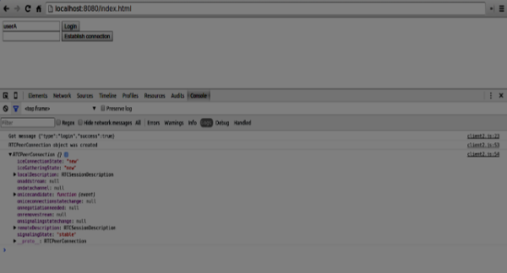

Now the peer-to-peer connection is established. In the next tutorials, we will add video and audio streams as well as text chat support.

# WebRTC - RTCDataChannel APIs

Advertisements

[Previous Page](https://www.tutorialspoint.com/webrtc/webrtc_rtcpeerconnection_apis.htm)

[Next Page](https://www.tutorialspoint.com/webrtc/webrtc_sending_messages.htm)

WebRTC is not only good at transferring audio and video streams, but any arbitrary data we might have. This is where the RTCDataChannel object comes into play.

## **RTCDataChannel API**

### **Properties**

* **RTCDataChannel.label (read only)** − Returns a string containing the data channel name.
* **RTCDataChannel.ordered (read only)** − Returns true if the order of delivery of the messages is guaranteed or false if it is not guaranteed.
* **RTCDataChannel.protocol (read only)** − Returns a string containing subprotocol name used for this channel.
* **RTCDataChannel.id (read only)** − Returns a unique id for the channel which is set at the creation of the RTCDataChannel object.
* **RTCDataChannel.readyState (read only)** − Returns the RTCDataChannelState enum representing the state of the connection. The possible values −
  + **connecting** − Indicates that the connection is not yet active. This is the initial state.
  + **open** − Indicates that the connection is running.
  + **closing** − Indicates that the connection is in the process of shutting down. The cached messages are in the process of being sent or received, but no newly created task is accepting.
  + **closed** − Indicates that the connection could not be established or has been shut down.
* **RTCDataChannel.bufferedAmount (read only)** − Returns the amount of bytes that have been queued for sending. This is the amount of data that has not been sent yet via RTCDataChannel.send().
* **RTCDataChannel.bufferedAmountLowThreshold** − Returns the number of bytes at which the RTCDataChannel.bufferedAmount is taken up as low. When the RTCDataChannel.bufferedAmount decreases below this threshold, the bufferedamountlow event is fired.
* **RTCDataChannel.binaryType** − Returns the type of the binary data transmitted by the connection. Can be “blob” or “arraybuffer”.
* **RTCDataChannel.maxPacketLifeType (read only)** − Returns an unsigned short that indicates the length in milliseconds of the window in when messaging is going in unreliable mode.
* **RTCDataChannel.maxRetransmits (read only)** − Returns an unsigned short that indicates the maximum number of times a channel will retransmit data if it is not delivered.
* **RTCDataChannel.negotiated (read only)** − Returns a boolean that indicates if the channel has been negotiated by the user-agent, or by the application.
* **RTCDataChannel.reliable (read only)** − Returns a boolean that indicates of the connection can send messages in unreliable mode.
* **RTCDataChannel.stream (read only)** − Synonym for RTCDataChannel.id

### **Event Handlers**

* **RTCDataChannel.onopen** − This event handler is called when the open event is fired. This event is sent when the data connection has been established.
* **RTCDataChannel.onmessage** − This event handler is called when the message event is fired. The event is sent when a message is available on the data channel.
* **RTCDataChannel.onbufferedamountlow** − This event handler is called when the bufferedamoutlow event is fired. This event is sent when RTCDataChannel.bufferedAmount decreases below the RTCDataChannel.bufferedAmountLowThreshold property.
* **RTCDataChannel.onclose** − This event handler is called when the close event is fired. This event is sent when the data connection has been closed.
* **RTCDataChannel.onerror** − This event handler is called when the error event is fired. This event is sent when an error has been encountered.

### **Methods**

* **RTCDataChannel.close()** − Closes the data channel.
* **RTCDataChannel.send()** − Sends the data in the parameter over the channel. The data can be a blob, a string, an ArrayBuffer or an ArrayBufferView.

# WebRTC - Sending Messages

Advertisements

[Previous Page](https://www.tutorialspoint.com/webrtc/webrtc_rtcdatachannel_apis.htm)

[Next Page](https://www.tutorialspoint.com/webrtc/webrtc_signaling.htm)

Now let's create a simple example. Firstly, run the signaling server we created in the “signaling server” tutorial via “node server”.

There will be three text inputs on the page, one for a login, one for a username, and one for the message we want to send to the other peer. Create an *index.html* file and add the following code −

<html lang = "en">

<head>

<meta charset = "utf-8" />

</head>

<body>

<div>

<input type = "text" id = "loginInput" />

<button id = "loginBtn">Login</button>

</div>

<div>

<input type = "text" id = "otherUsernameInput" />

<button id = "connectToOtherUsernameBtn">Establish connection</button>

</div>

<div>

<input type = "text" id = "msgInput" />

<button id = "sendMsgBtn">Send text message</button>

</div>

<script src = "client.js"></script>

</body>

</html>

We've also added three buttons for login, establishing a connection and sending a message. Now create a *client.js* file and add the following code −

var connection = new WebSocket('ws://localhost:9090');

var name = "";

var loginInput = document.querySelector('#loginInput');

var loginBtn = document.querySelector('#loginBtn');

var otherUsernameInput = document.querySelector('#otherUsernameInput');

var connectToOtherUsernameBtn = document.querySelector('#connectToOtherUsernameBtn');

var msgInput = document.querySelector('#msgInput');

var sendMsgBtn = document.querySelector('#sendMsgBtn');

var connectedUser, myConnection, dataChannel;

//when a user clicks the login button

loginBtn.addEventListener("click", function(event) {

name = loginInput.value;

if(name.length > 0) {

send({

type: "login",

name: name

});

}

});

//handle messages from the server

connection.onmessage = function (message) {

console.log("Got message", message.data);

var data = JSON.parse(message.data);

switch(data.type) {

case "login":

onLogin(data.success);

break;

case "offer":

onOffer(data.offer, data.name);

break;

case "answer":

onAnswer(data.answer);

break;

case "candidate":

onCandidate(data.candidate);

break;

default:

break;

}

};

//when a user logs in

function onLogin(success) {

if (success === false) {

alert("oops...try a different username");

} else {

//creating our RTCPeerConnection object

var configuration = {

"iceServers": [{ "url": "stun:stun.1.google.com:19302" }]

};

myConnection = new webkitRTCPeerConnection(configuration, {

optional: [{RtpDataChannels: true}]

});

console.log("RTCPeerConnection object was created");

console.log(myConnection);

//setup ice handling

//when the browser finds an ice candidate we send it to another peer

myConnection.onicecandidate = function (event) {

if (event.candidate) {

send({

type: "candidate",

candidate: event.candidate

});

}

};

openDataChannel();

}

};

connection.onopen = function () {

console.log("Connected");

};

connection.onerror = function (err) {

console.log("Got error", err);

};

// Alias for sending messages in JSON format

function send(message) {

if (connectedUser) {

message.name = connectedUser;

}

connection.send(JSON.stringify(message));

};

You can see that we establish a socket connection to our signaling server. When a user clicks on the login button the application sends his username to the server. If login is successful the application creates the *RTCPeerConnection* object and setup *onicecandidate* handler which sends all found icecandidates to the other peer. It also runs the openDataChannel() function which creates a dataChannel. Notice that when creating the RTCPeerConnection object the second argument in the constructor optional: [{RtpDataChannels: true}] is mandatory if you are using Chrome or Opera. The next step is to create an offer to the other peer. Add the following code to your *client.js* file−

//setup a peer connection with another user

connectToOtherUsernameBtn.addEventListener("click", function () {

var otherUsername = otherUsernameInput.value;

connectedUser = otherUsername;

if (otherUsername.length > 0) {

//make an offer

myConnection.createOffer(function (offer) {

console.log();

send({

type: "offer",

offer: offer

});

myConnection.setLocalDescription(offer);

}, function (error) {

alert("An error has occurred.");

});

}

});

//when somebody wants to call us

function onOffer(offer, name) {

connectedUser = name;

myConnection.setRemoteDescription(new RTCSessionDescription(offer));

myConnection.createAnswer(function (answer) {

myConnection.setLocalDescription(answer);

send({

type: "answer",

answer: answer

});

}, function (error) {

alert("oops...error");

});

}

//when another user answers to our offer

function onAnswer(answer) {

myConnection.setRemoteDescription(new RTCSessionDescription(answer));

}

//when we got ice candidate from another user

function onCandidate(candidate) {

myConnection.addIceCandidate(new RTCIceCandidate(candidate));

}

You can see that when a user clicks the “Establish connection” button the application makes an SDP offer to the other peer. We also set *onAnswer* and *onCandidate* handlers. Finally, let's implement the *openDataChannel()* function which creates our dataChannel. Add the following code to your *client.js* file −

//creating data channel

function openDataChannel() {

var dataChannelOptions = {

reliable:true

};

dataChannel = myConnection.createDataChannel("myDataChannel", dataChannelOptions);

dataChannel.onerror = function (error) {

console.log("Error:", error);

};

dataChannel.onmessage = function (event) {

console.log("Got message:", event.data);

};

}

//when a user clicks the send message button

sendMsgBtn.addEventListener("click", function (event) {

console.log("send message");

var val = msgInput.value;

dataChannel.send(val);

});

Here we create the dataChannel for our connection and add the event handler for the “send message” button. Now open this page in two tabs, login with two users, establish a connection, and try to send messages. You should see them in the console output. Notice that the above example is tested in Opera.

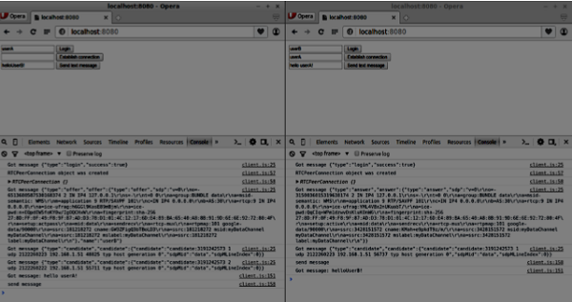

Now you may see that RTCDataChannel is extremely powerful part of the WebRTC API. There are a lot of other use cases for this object, like peer-to-peer gaming or torrent-based file sharing.

# WebRTC - Signaling

Advertisements

[Previous Page](https://www.tutorialspoint.com/webrtc/webrtc_sending_messages.htm)

[Next Page](https://www.tutorialspoint.com/webrtc/webrtc_browser_support.htm)

Most WebRTC applications are not just being able to communicate through video and audio. They need many other features. In this chapter, we are going to build a basic signaling server.

## **Signaling and Negotiation**

To connect to another user you should know where he is located on the Web. The IP address of your device allows Internet-enabled devices to send data directly between each other. The *RTCPeerConnection* object is responsible for this. As soon as devices know how to find each other over the Internet, they start exchanging data about which protocols and codecs each device supports.

To communicate with another user you simply need to exchange contact information and the rest will be done by WebRTC. The process of connecting to the other user is also known as signaling and negotiation. It consists of a few steps −

* Create a list of potential candidates for a peer connection.
* The user or an application selects a user to make a connection with.
* The signaling layer notifies another user that someone want to connect to him. He can accept or decline.
* The first user is notified of the acceptance of the offer.
* The first user initiates *RTCPeerConnection* with another user.
* Both users exchange software and hardware information through the signaling server.
* Both users exchange location information.
* The connection succeeds or fails.

The WebRTC specification does not contain any standards about exchanging information. So keep in mind that the above is just an example of how signaling may happen. You can use any protocol or technology you like.

## **Building the Server**

The server we are going to build will be able to connect two users together who are not located on the same computer. We will create our own signaling mechanism. Our signaling server will allow one user to call another. Once a user has called another, the server passes the offer, answer, ICE candidates between them and setup a WebRTC connection.

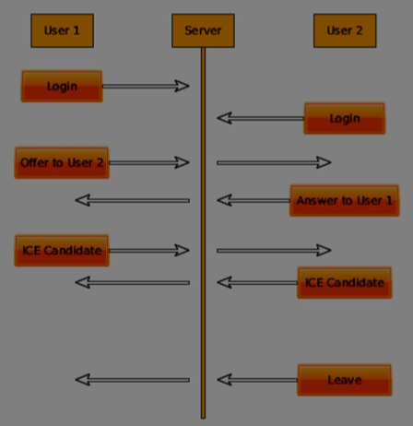

The above diagram is the messaging flow between users when using the signaling server. First of all, each user registers with the server. In our case, this will be a simple string username. Once users have registered, they are able to call each other. User 1 makes an offer with the user identifier he wishes to call. The other user should answers. Finally, ICE candidates are sent between users until they can make a connection.

To create a WebRTC connection clients have to be able to transfer messages without using a WebRTC peer connection. This is where we will use HTML5 WebSockets – a bidirectional socket connection between two endpoints – a web server and a web browser. Now let's start using the WebSocket library. Create the *server.js* file and insert the following code −

//require our websocket library

var WebSocketServer = require('ws').Server;

//creating a websocket server at port 9090

var wss = new WebSocketServer({port: 9090});

//when a user connects to our sever

wss.on('connection', function(connection) {

console.log("user connected");

//when server gets a message from a connected user

connection.on('message', function(message){

console.log("Got message from a user:", message);

});

connection.send("Hello from server");

});

The first line requires the WebSocket library which we have already installed. Then we create a socket server on the port 9090. Next, we listen to the *connection* event. This code will be executed when a user makes a WebSocket connection to the server. We then listen to any messages sent by the user. Finally, we send a response to the connected user saying “Hello from server”.

Now run *node server* and the server should start listening for socket connections.

To test our server, we'll use the *wscat* utility which we also have already installed. This tool helps in connecting directly to the WebSocket server and test out commands. Run our server in one terminal window, then open another and run the *wscat -c ws://localhost:9090* command. You should see the following on the client side −

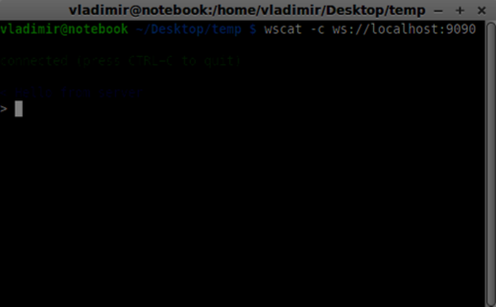

The server should also log the connected user −

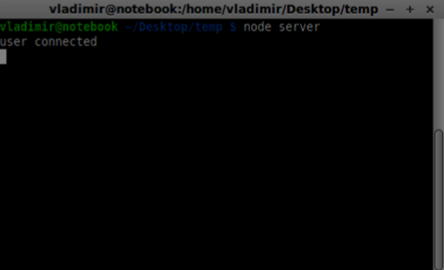

## **User Registration**

In our signaling server, we will use a string-based username for each connection so we know where to send messages. Let's change our *connection*handler a bit −

connection.on('message', function(message) {

var data;

//accepting only JSON messages

try {

data = JSON.parse(message);

} catch (e) {

console.log("Invalid JSON");

data = {};

}

});

This way we accept only JSON messages. Next, we need to store all connected users somewhere. We will use a simple Javascript object for it. Change the top of our file −

//require our websocket library

var WebSocketServer = require('ws').Server;

//creating a websocket server at port 9090

var wss = new WebSocketServer({port: 9090});

//all connected to the server users

var users = {};

We are going to add a *type* field for every message coming from the client. For example if a user wants to login, he sends the *login* type message. Let's define it −

connection.on('message', function(message){

var data;

//accepting only JSON messages

try {

data = JSON.parse(message);

} catch (e) {

console.log("Invalid JSON");

data = {};

}

//switching type of the user message

switch (data.type) {

//when a user tries to login

case "login":

console.log("User logged:", data.name);

//if anyone is logged in with this username then refuse

if(users[data.name]) {

sendTo(connection, {

type: "login",

success: false

});

} else {

//save user connection on the server

users[data.name] = connection;

connection.name = data.name;

sendTo(connection, {

type: "login",

success: true

});

}

break;

default:

sendTo(connection, {

type: "error",

message: "Command no found: " + data.type

});

break;

}

});

If the user sends a message with the *login* type, we −

* Check if anyone has already logged in with this username
* If so, then tell the user that he hasn't successfully logged in
* If no one is using this username, we add username as a key to the connection object.
* If a command is not recognized we send an error.

The following code is a helper function for sending messages to a connection. Add it to the *server.js* file −

function sendTo(connection, message) {

connection.send(JSON.stringify(message));

}

The above function ensures that all our messages are sent in the JSON format.

When the user disconnects we should clean up its connection. We can delete the user when the *close* event is fired. Add the following code to the *connection* handler −

connection.on("close", function() {

if(connection.name) {

delete users[connection.name];

}

});

Now let's test our server with the login command. Keep in mind that all messages must be encoded in the JSON format. Run our server and try to login. You should see something like this −

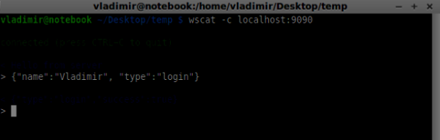

## **Making a Call**

After successful login the user wants to call another. He should make an *offer*to another user to achieve it. Add the *offer* handler −

case "offer":

//for ex. UserA wants to call UserB

console.log("Sending offer to: ", data.name);

//if UserB exists then send him offer details

var conn = users[data.name];

if(conn != null){

//setting that UserA connected with UserB

connection.otherName = data.name;

sendTo(conn, {

type: "offer",

offer: data.offer,

name: connection.name

});

}

break;

Firstly, we get the *connection* of the user we are trying to call. If it exists we send him *offer* details. We also add *otherName* to the *connection* object. This is made for the simplicity of finding it later.

## **Answering**

Answering to the response has a similar pattern that we used in the *offer*handler. Our server just passes through all messages as *answer* to another user. Add the following code after the *offer* hander −

case "answer":

console.log("Sending answer to: ", data.name);

//for ex. UserB answers UserA

var conn = users[data.name];

if(conn != null) {

connection.otherName = data.name;

sendTo(conn, {

type: "answer",

answer: data.answer

});

}

break;

You can see how this is similar to the *offer* handler. Notice this code follows the *createOffer* and *createAnswer* functions on the *RTCPeerConnection* object.

Now we can test our offer/answer mechanism. Connect two clients at the same time and try to make offer and answer. You should see the following −

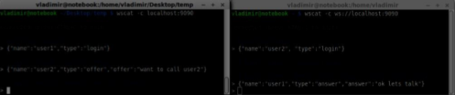

In this example, **offer** and **answer** are simple strings, but in a real application they will be filled in with the SDP data.

## **ICE Candidates**

The final part is handling ICE candidate between users. We use the same technique just passing messages between users. The main difference is that candidate messages might happen multiple times per user in any order. Add the *candidate* handler −

case "candidate":

console.log("Sending candidate to:",data.name);

var conn = users[data.name];

if(conn != null) {

sendTo(conn, {

type: "candidate",

candidate: data.candidate

});

}

break;

It should work similarly to the *offer* and *answer* handlers.

## **Leaving the Connection**

To allow our users to disconnect from another user we should implement the hanging up function. It will also tell the server to delete all user references. Add the **leave** handler −

case "leave":

console.log("Disconnecting from", data.name);

var conn = users[data.name];

conn.otherName = null;

//notify the other user so he can disconnect his peer connection

if(conn != null) {

sendTo(conn, {

type: "leave"

});

}

break;

This will also send the other user the *leave* event so he can disconnect his peer connection accordingly. We should also handle the case when a user drops his connection from the signaling server. Let's modify our *close* handler −

connection.on("close", function() {

if(connection.name) {

delete users[connection.name];

if(connection.otherName) {

console.log("Disconnecting from ", connection.otherName);

var conn = users[connection.otherName];

conn.otherName = null;

if(conn != null) {

sendTo(conn, {

type: "leave"

});

}

}

}

});

Now if the connection terminates our users will be disconnected. The *close*event will be fired when a user closes his browser window while we are still in *offer*, *answer* or *candidate* state.

## **Complete Signaling Server**

Here is the entire code of our signaling server −

//require our websocket library

var WebSocketServer = require('ws').Server;

//creating a websocket server at port 9090

var wss = new WebSocketServer({port: 9090});

//all connected to the server users

var users = {};

//when a user connects to our sever

wss.on('connection', function(connection) {

console.log("User connected");

//when server gets a message from a connected user

connection.on('message', function(message) {

var data;

//accepting only JSON messages

try {

data = JSON.parse(message);

} catch (e) {

console.log("Invalid JSON");

data = {};

}

//switching type of the user message

switch (data.type) {

//when a user tries to login

case "login":

console.log("User logged", data.name);

//if anyone is logged in with this username then refuse

if(users[data.name]) {

sendTo(connection, {

type: "login",

success: false

});

} else {

//save user connection on the server

users[data.name] = connection;

connection.name = data.name;

sendTo(connection, {

type: "login",

success: true

});

}

break;

case "offer":

//for ex. UserA wants to call UserB

console.log("Sending offer to: ", data.name);

//if UserB exists then send him offer details

var conn = users[data.name];

if(conn != null) {

//setting that UserA connected with UserB

connection.otherName = data.name;

sendTo(conn, {

type: "offer",

offer: data.offer,

name: connection.name

});

}

break;

case "answer":

console.log("Sending answer to: ", data.name);

//for ex. UserB answers UserA

var conn = users[data.name];

if(conn != null) {

connection.otherName = data.name;

sendTo(conn, {

type: "answer",

answer: data.answer

});

}

break;

case "candidate":

console.log("Sending candidate to:",data.name);

var conn = users[data.name];

if(conn != null) {

sendTo(conn, {

type: "candidate",

candidate: data.candidate

});

}

break;

case "leave":

console.log("Disconnecting from", data.name);

var conn = users[data.name];

conn.otherName = null;

//notify the other user so he can disconnect his peer connection

if(conn != null) {

sendTo(conn, {

type: "leave"

});

}

break;

default:

sendTo(connection, {

type: "error",

message: "Command not found: " + data.type

});

break;

}

});

//when user exits, for example closes a browser window

//this may help if we are still in "offer","answer" or "candidate" state

connection.on("close", function() {

if(connection.name) {

delete users[connection.name];

if(connection.otherName) {

console.log("Disconnecting from ", connection.otherName);

var conn = users[connection.otherName];

conn.otherName = null;

if(conn != null) {

sendTo(conn, {

type: "leave"

});

}

}

}

});

connection.send("Hello world");

});

function sendTo(connection, message) {

connection.send(JSON.stringify(message));

}

So the work is done and our signaling server is ready. Remember that doing things out of order when making a WebRTC connection can cause issues.

## **Summary**

In this chapter, we built simple and straightforward signaling server. We walked through the signaling process, user registration and offer/answer mechanism. We also implemented sending candidates between users.

# WebRTC - Browser Support

Advertisements

[Previous Page](https://www.tutorialspoint.com/webrtc/webrtc_signaling.htm)

[Next Page](https://www.tutorialspoint.com/webrtc/webrtc_mobile_support.htm)

The Web is moving so fast and it is always improving. New standards are created every day. Browsers allow updates to be installed without the user ever knowing, so you should keep up with what is going on in the world of the Web and WebRTC. Here is an overview of what this is up to today.

## **Browser Support**

Every browser doesn't have all the same WebRTC features at the same time. Different browsers may be ahead of the curve, which makes some WebRTC features work in one browser and not another. The current support for WebRTC in the browser is shown in the following picture.

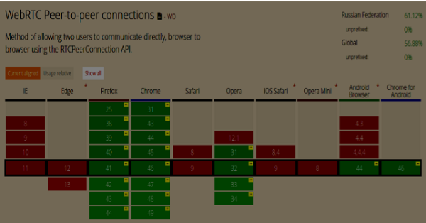

You can check an up-to-date WebRTC support status at [http://caniuse.com/#feat=rtcpeerconnection.](http://caniuse.com/#feat=rtcpeerconnection)

### **Chrome, Firefox, and Opera**

The latest versions of Chrome, Firefox, and Opera on mainstream PC operating systems such as Mac OS X, Windows, and Linux, all support WebRTC out-of-the-box. And most importantly, the engineers from Chrome and Firefox developer teams have been working together to fix issues so these two browsers could communicate with each other easily.

### **Android OS**

On Android operating systems, WebRTC applications for Chrome and Firefox should work outof-the-box. They are able to work with other browsers after Android Ice Cream Sandwich version (4.0). This is due to the code sharing between desktop and mobile versions.

### **Apple**

Apple has not yet made any announcement about their plans to support WebRTC in Safari on OS X. One of the possible workarounds for hybrid native iOS applications os to embed the WebRTC code directly into the application and load this app into a WebView.

### **Internet Explorer**

Microsoft doesn't support WebRTC on desktops. But they have officially confirmed that they are going to implement ORTC (Object Realtime Communications) in future versions of IE(Edge). They are not planning to support WebRTC 1.0. They labeled their ORTC as WebRTC 1.1, although it is just a community enhancement and not the official standard. Recently they've added the ORTC support to the latest Microsoft Edge version. You may learn more at [https://blogs.windows.com/msedgedev/2015/09/18/ortc-api-is-now-available-in-microsoftedge/.](https://blogs.windows.com/msedgedev/2015/09/18/ortc-api-is-now-available-in-microsoft-edge/)

### **Summary**

Notice that WebRTC is a collection of APIs and protocols, not a single API. The support for each of these is developing on different browsers and operating systems at a different level. A great way to check the latest level of support is through [http://canisue.com.](http://canisue.com/) It tracks adoption of modern APIs across multiple browsers. You can also find the latest information on browser supports as well as WebRTC demos at [http://www.webrtc.org,](http://www.webrtc.org/) which is supported by Mozilla, Google, and Opera.

# WebRTC - Mobile Support

Advertisements

[Previous Page](https://www.tutorialspoint.com/webrtc/webrtc_browser_support.htm)

[Next Page](https://www.tutorialspoint.com/webrtc/webrtc_video_demo.htm)

In the mobile world, the WebRTC support is not on the same level as it is on desktops. Mobile devices have their own way, so WebRTC is also something different on the mobile platforms.

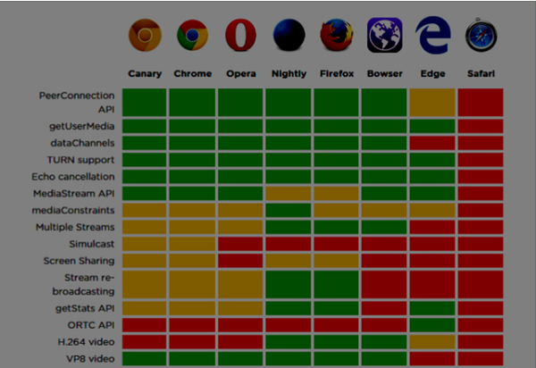

When developing a WebRTC application for desktop, we consider using Chrome, Firefox or Opera. All of them support WebRTC out of the box. In general, you just need a browser and not bother about the desktop's hardware.

In the mobile world there are three possible modes for WebRTC today −

* The native application
* The browser application
* The native browser

## **Android**

In 2013, the Firefox web browser for Android was presented with WebRTC support out of the box. Now you can make video calls on Android devices using the Firefox mobile browser.

It has three main WebRTC components −

* **PeerConnection** − enables calls between browsers
* **getUserMedia** − provides access to the camera and microphone
* **DataChannels** − provides peer-to-peer data transfer

Google Chrome for Android provides WebRTC support as well. As you've already noticed, the most interesting features usually first appear in Chrome.

In the past year, the Opera mobile browser appeared with WebRTC support. So for Android you have Chrome, Firefox, and Opera. Other browsers don't support WebRTC.

## **iOS**

Unfortunately, WebRTC is not supported on iOS now. Although WebRTC works well on Mac when using Firefox, Opera, or Chrome, it is not supported on iOS.

Nowadays, your WebRTC application won't work on Apple mobile devices out of the box. But there is a browser − Bowser. It is a web browser developed by Ericsson and it supports WebRTC out of the box. You can check its homepage at [http://www.openwebrtc.org/bowser/.](http://www.openwebrtc.org/bowser/)

Today, it is the only friendly way to support your WebRTC application on iOS. Another way is to develop a native application yourself.

## **Windows Phones**

Microsoft doesn't support WebRTC on mobile platforms. But they have officially confirmed that they are going to implement ORTC (Object Realtime Communications) in future versions of IE. They are not planning to support WebRTC 1.0. They labeled their ORTC as WebRTC 1.1, although it is just a community enhancement and not the official standard.

So today Window Phone users can't use WebRTC applications and there is no way to beat this situation.

## **Blackberry**

WebRTC applications are not supported on Blackberry either, in any way.

## **Using a WebRTC Native Browser**

The most convenient and comfortable case for users to utilize WebRTC is using the native browser of the device. In this case, the device is ready to work any additional configurations.

Today only Android devices that are version 4 or higher provide this feature. Apple still doesn't show any activity with WebRTC support. So Safari users can't use WebRTC applications. Microsoft also did not introduce it in Windows Phone 8.

## **Using WebRTC via Browser Applications**

This means using a third-party applications (non-native web browsers) in order to provide the WebRTC features. For now, there are two such third-party applications. Bowser, which is the only way to bring WebRTC features to the iOS device and Opera, which is a nice alternative for Android platform. The rest of the available mobile browsers don't support WebRTC.

## **Native Mobile Applications**

As you can see, WebRTC does not have a large support in the mobile world yet. So, one of the possible solutions is to develop a native applications that utilize the WebRTC API. But it is not the better choice because the main WebRTC feature is a cross-platform solution. Anyway, in some cases this is the only way because a native application can utilize device-specific functions or features that are not supported by HTML5 browsers.

## **Constraining Video Stream for Mobile and Desktop Devices**

The first parameter of the *getUserMedia* API expects an object of keys and values telling the browser how to process streams. You can check the full set of constraints at [https://tools.ietf.org/html/draft-alvestrand-constraints-resolution-03.](https://tools.ietf.org/html/draft-alvestrand-constraints-resolution-03) You can setup video aspect ration, frameRate, and other optional parameters.

Supporting mobile devices is one of the biggest pains because mobile devices have limited screen space along with limited resources. You might want the mobile device to only capture a 480x320 resolution or smaller video stream to save power and bandwidth. Using the user agent string in the browser is a good way to test whether the user is on a mobile device or not. Let's see an example. Create the *index.html* file −

<!DOCTYPE html>

<html lang = "en">

<head>

<meta charset = "utf-8" />

</head>

<body>

<video autoplay></video>

<script src = "client.js"></script>

</body>

</html>

Then create the following *client.js* file −

//constraints for desktop browser

var desktopConstraints = {

video: {

mandatory: {

maxWidth:800,

maxHeight:600

}

},

audio: true

};

//constraints for mobile browser

var mobileConstraints = {

video: {

mandatory: {

maxWidth: 480,

maxHeight: 320,

}

},

audio: true

}

//if a user is using a mobile browser

if(/Android|iPhone|iPad/i.test(navigator.userAgent)) {

var constraints = mobileConstraints;

} else {

var constraints = desktopConstraints;

}

function hasUserMedia() {

//check if the browser supports the WebRTC

return !!(navigator.getUserMedia || navigator.webkitGetUserMedia ||

navigator.mozGetUserMedia);

}

if (hasUserMedia()) {

navigator.getUserMedia = navigator.getUserMedia || navigator.webkitGetUserMedia ||

navigator.mozGetUserMedia;

//enabling video and audio channels

navigator.getUserMedia(constraints, function (stream) {

var video = document.querySelector('video');

//inserting our stream to the video tag

video.src = window.URL.createObjectURL(stream);

}, function (err) {});

} else {

alert("WebRTC is not supported");

}

Run the web server using the *static* command and open the page. You should see it is 800x600. Then open this page in a mobile viewport using chrome tools and check the resolution. It should be 480x320.

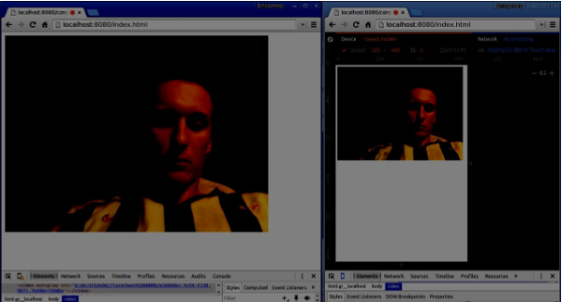

Constraints are the easiest way to increase the performance of your WebRTC application.

## **Summary**

In this chapter, we learned about the issues that can occur when developing WebRTC applications for mobile devices. We discovered different limitations of supporting the WebRTC API on mobile platforms. We also launched a demo application where we set different constraints for desktop and mobile browsers.

# WebRTC - Video Demo

Advertisements

[Previous Page](https://www.tutorialspoint.com/webrtc/webrtc_mobile_support.htm)

[Next Page](https://www.tutorialspoint.com/webrtc/webrtc_voice_demo.htm)

In this chapter, we are going to build a client application that allows two users on separate devices to communicate using WebRTC. Our application will have two pages. One for login and the other for calling another user.

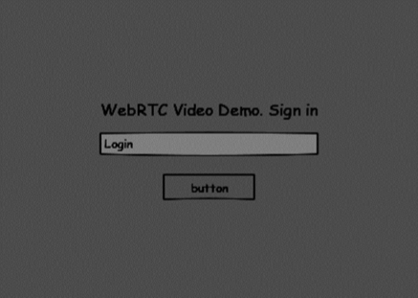

The two pages will be the *div* tags. Most input is done through simple event handlers.

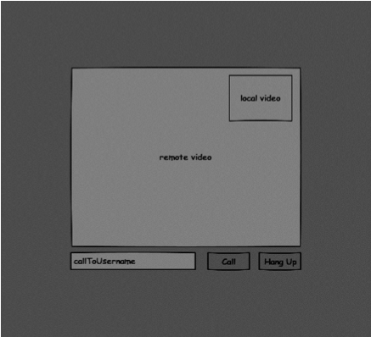

## **Signaling Server**

To create a WebRTC connection clients have to be able to transfer messages without using a WebRTC peer connection. This is where we will use HTML5 WebSockets − a bidirectional socket connection between two endpoints − a web server and a web browser. Now let's start using the WebSocket library. Create the *server.js* file and insert the following code −

//require our websocket library

var WebSocketServer = require('ws').Server;

//creating a websocket server at port 9090

var wss = new WebSocketServer({port: 9090});

//when a user connects to our sever

wss.on('connection', function(connection) {

console.log("user connected");

//when server gets a message from a connected user

connection.on('message', function(message) {

console.log("Got message from a user:", message);

});

connection.send("Hello from server");

});

The first line requires the WebSocket library which we have already installed. Then we create a socket server on the port 9090. Next, we listen to the *connection* event. This code will be executed when a user makes a WebSocket connection to the server. We then listen to any messages sent by the user. Finally, we send a response to the connected user saying “Hello from server”.

In our signaling server, we will use a string-based username for each connection so we know where to send messages. Let's change our connection *handler* a bit −

connection.on('message', function(message) {

var data;

//accepting only JSON messages

try {

data = JSON.parse(message);

} catch (e) {

console.log("Invalid JSON");

data = {};

}

});

This way we accept only JSON messages. Next, we need to store all connected users somewhere. We will use a simple Javascript object for it. Change the top of our file −

//require our websocket library

var WebSocketServer = require('ws').Server;

//creating a websocket server at port 9090

var wss = new WebSocketServer({port: 9090});

//all connected to the server users

var users = {};

We are going to add a *type* field for every message coming from the client. For example if a user wants to login, he sends the *login* type message. Let's define it −

connection.on('message', function(message) {

var data;

//accepting only JSON messages

try {

data = JSON.parse(message);

} catch (e) {

console.log("Invalid JSON");

data = {};

}

//switching type of the user message

switch (data.type) {

//when a user tries to login

case "login":

console.log("User logged:", data.name);

//if anyone is logged in with this username then refuse

if(users[data.name]) {

sendTo(connection, {

type: "login",

success: false

});

} else {

//save user connection on the server

users[data.name] = connection;

connection.name = data.name;

sendTo(connection, {

type: "login",

success: true

});

}

break;

default:

sendTo(connection, {

type: "error",

message: "Command no found: " + data.type

});

break;

}

});

If the user sends a message with the *login* type, we −

* Check if anyone has already logged in with this username
* If so, then tell the user that he hasn't successfully logged in
* If no one is using this username, we add username as a key to the connection object.
* If a command is not recognized we send an error.

The following code is a helper function for sending messages to a connection. Add it to the *server.js* file −

function sendTo(connection, message) {

connection.send(JSON.stringify(message));

}

When the user disconnects we should clean up its connection. We can delete the user when the *close* event is fired. Add the following code to the *connection* handler −

connection.on("close", function() {

if(connection.name) {

delete users[connection.name];

}

});

After successful login the user wants to call another. He should make an *offer*to another user to achieve it. Add the *offer* handler −

case "offer":

//for ex. UserA wants to call UserB

console.log("Sending offer to: ", data.name);

//if UserB exists then send him offer details

var conn = users[data.name];

if(conn != null) {

//setting that UserA connected with UserB

connection.otherName = data.name;

sendTo(conn, {

type: "offer",

offer: data.offer,

name: connection.name

});

}

break;

Firstly, we get the *connection* of the user we are trying to call. If it exists we send him *offer* details. We also add *otherName* to the *connection* object. This is made for the simplicity of finding it later.

Answering to the response has a similar pattern that we used in the *offer*handler. Our server just passes through all messages as *answer* to another user. Add the following code after the *offer* handler −

case "answer":

console.log("Sending answer to: ", data.name);

//for ex. UserB answers UserA

var conn = users[data.name];

if(conn != null) {

connection.otherName = data.name;

sendTo(conn, {

type: "answer",

answer: data.answer

});

}

break;

The final part is handling ICE candidate between users. We use the same technique just passing messages between users. The main difference is that candidate messages might happen multiple times per user in any order. Add the *candidate* handler −

case "candidate":

console.log("Sending candidate to:",data.name);

var conn = users[data.name];

if(conn != null) {

sendTo(conn, {

type: "candidate",

candidate: data.candidate

});

}

break;

To allow our users to disconnect from another user we should implement the hanging up function. It will also tell the server to delete all user references. Add the *leave* handler −

case "leave":

console.log("Disconnecting from", data.name);

var conn = users[data.name];

conn.otherName = null;

//notify the other user so he can disconnect his peer connection

if(conn != null) {

sendTo(conn, {

type: "leave"

});

}

break;

This will also send the other user the *leave* event so he can disconnect his peer connection accordingly. We should also handle the case when a user drops his connection from the signaling server. Let's modify our *close* handler −

connection.on("close", function() {

if(connection.name) {

delete users[connection.name];

if(connection.otherName) {

console.log("Disconnecting from ", connection.otherName);

var conn = users[connection.otherName];

conn.otherName = null;

if(conn != null) {

sendTo(conn, {

type: "leave"

});

}

}

}

});

The following is the entire code of our signaling server −

//require our websocket library

var WebSocketServer = require('ws').Server;

//creating a websocket server at port 9090

var wss = new WebSocketServer({port: 9090});

//all connected to the server users

var users = {};

//when a user connects to our sever

wss.on('connection', function(connection) {

console.log("User connected");

//when server gets a message from a connected user

connection.on('message', function(message) {

var data;

//accepting only JSON messages

try {

data = JSON.parse(message);

} catch (e) {

console.log("Invalid JSON");

data = {};

}

//switching type of the user message

switch (data.type) {

//when a user tries to login

case "login":

console.log("User logged", data.name);

//if anyone is logged in with this username then refuse

if(users[data.name]) {

sendTo(connection, {

type: "login",

success: false

});

} else {

//save user connection on the server

users[data.name] = connection;

connection.name = data.name;

sendTo(connection, {

type: "login",

success: true

});

}

break;

case "offer":

//for ex. UserA wants to call UserB

console.log("Sending offer to: ", data.name);

//if UserB exists then send him offer details

var conn = users[data.name];

if(conn != null) {

//setting that UserA connected with UserB

connection.otherName = data.name;

sendTo(conn, {

type: "offer",

offer: data.offer,

name: connection.name

});

}

break;

case "answer":

console.log("Sending answer to: ", data.name);

//for ex. UserB answers UserA

var conn = users[data.name];

if(conn != null) {

connection.otherName = data.name;

sendTo(conn, {

type: "answer",

answer: data.answer

});

}

break;

case "candidate":

console.log("Sending candidate to:",data.name);

var conn = users[data.name];

if(conn != null) {

sendTo(conn, {

type: "candidate",

candidate: data.candidate

});

}

break;

case "leave":

console.log("Disconnecting from", data.name);

var conn = users[data.name];

conn.otherName = null;

//notify the other user so he can disconnect his peer connection

if(conn != null) {

sendTo(conn, {

type: "leave"

});

}

break;

default:

sendTo(connection, {

type: "error",

message: "Command not found: " + data.type

});

break;

}

});

//when user exits, for example closes a browser window

//this may help if we are still in "offer","answer" or "candidate" state

connection.on("close", function() {

if(connection.name) {

delete users[connection.name];

if(connection.otherName) {

console.log("Disconnecting from ", connection.otherName);

var conn = users[connection.otherName];

conn.otherName = null;

if(conn != null) {

sendTo(conn, {

type: "leave"

});

}

}

}

});

connection.send("Hello world");

});

function sendTo(connection, message) {

connection.send(JSON.stringify(message));

}

## **Client Application**

One way to test this application is opening two browser tabs and trying to call each other.

First of all, we need to install the *bootstrap* library. Bootstrap is a frontend framework for developing web applications. You can learn more at [http://getbootstrap.com/.](http://getbootstrap.com/) Create a folder called, for example, “videochat”. This will be our root application folder. Inside this folder create a file *package.json* (it is necessary for managing npm dependencies) and add the following −

{

"name": "webrtc-videochat",

"version": "0.1.0",

"description": "webrtc-videochat",

"author": "Author",

"license": "BSD-2-Clause"

}

Then run *npm install bootstrap*. This will install the bootstrap library in the *videochat/node_modules* folder.

Now we need to create a basic HTML page. Create an *index.html* file in the root folder with the following code −

<html>

<head>

<title>WebRTC Video Demo</title>

<link rel = "stylesheet" href = "node_modules/bootstrap/dist/css/bootstrap.min.css"/>

</head>

<style>

body {

background: #eee;

padding: 5% 0;

}

video {

background: black;

border: 1px solid gray;

}

.call-page {

position: relative;

display: block;

margin: 0 auto;

width: 500px;

height: 500px;

}

#localVideo {

width: 150px;

height: 150px;

position: absolute;

top: 15px;

right: 15px;

}

#remoteVideo {

width: 500px;

height: 500px;

}

</style>

<body>

<div id = "loginPage" class = "container text-center">

<div class = "row">

<div class = "col-md-4 col-md-offset-4">

<h2>WebRTC Video Demo. Please sign in</h2>

<label for = "usernameInput" class = "sr-only">Login</label>

<input type = "email" id = "usernameInput" c

lass = "form-control formgroup" placeholder = "Login"

required = "" autofocus = "">

<button id = "loginBtn" class = "btn btn-lg btn-primary btnblock">

Sign in</button>

</div>

</div>

</div>

<div id = "callPage" class = "call-page">

<video id = "localVideo" autoplay></video>

<video id = "remoteVideo" autoplay></video>

<div class = "row text-center">

<div class = "col-md-12">

<input id = "callToUsernameInput" type = "text"

placeholder = "username to call" />

<button id = "callBtn" class = "btn-success btn">Call</button>

<button id = "hangUpBtn" class = "btn-danger btn">Hang Up</button>

</div>

</div>

</div>

<script src = "client.js"></script>

</body>

</html>

This page should be familiar to you. We have added the *bootstrap* css file. We have also defined two pages. Finally, we have created several text fields and buttons for getting information from the user. You should see the two video elements for local and remote video streams. Notice that we have added a link to a *client.js* file.

Now we need to establish a connection with our signaling server. Create the *client.js* file in the root folder with the following code −

//our username

var name;

var connectedUser;

//connecting to our signaling server

var conn = new WebSocket('ws://localhost:9090');

conn.onopen = function () {

console.log("Connected to the signaling server");

};

//when we got a message from a signaling server

conn.onmessage = function (msg) {

console.log("Got message", msg.data);

var data = JSON.parse(msg.data);

switch(data.type) {

case "login":

handleLogin(data.success);

break;

//when somebody wants to call us

case "offer":

handleOffer(data.offer, data.name);

break;

case "answer":

handleAnswer(data.answer);

break;

//when a remote peer sends an ice candidate to us

case "candidate":

handleCandidate(data.candidate);

break;

case "leave":

handleLeave();

break;

default:

break;

}

};

conn.onerror = function (err) {

console.log("Got error", err);

};

//alias for sending JSON encoded messages

function send(message) {

//attach the other peer username to our messages

if (connectedUser) {

message.name = connectedUser;

}

conn.send(JSON.stringify(message));

};

Now run our signaling server via *node server*. Then, inside the root folder run the *static* command and open the page inside the browser. You should see the following console output −

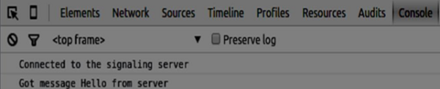

The next step is implementing a user log in with a unique username. We simply send a username to the server, which then tell us whether it is taken or not. Add the following code to your *client.js* file −

//******

//UI selectors block

//******

var loginPage = document.querySelector('#loginPage');

var usernameInput = document.querySelector('#usernameInput');

var loginBtn = document.querySelector('#loginBtn');

var callPage = document.querySelector('#callPage');

var callToUsernameInput = document.querySelector('#callToUsernameInput');

var callBtn = document.querySelector('#callBtn');

var hangUpBtn = document.querySelector('#hangUpBtn');

//hide call page

callPage.style.display = "none";

// Login when the user clicks the button

loginBtn.addEventListener("click", function (event) {

name = usernameInput.value;

if (name.length > 0) {

send({

type: "login",

name: name

});

}

});

function handleLogin(success) {

if (success === false) {

alert("Ooops...try a different username");

} else {

//display the call page if login is successful

loginPage.style.display = "none";

callPage.style.display = "block";

//start peer connection

}

};

Firstly, we select some references to the elements on the page. The we hide the call page. Then, we add an event listener on the login button. When the user clicks it, we send his username to the server. Finally, we implement the handleLogin callback. If the login was successful, we show the call page and starting to set up a peer connection.

To start a peer connection we need −

* Obtain a stream from the web camera.
* Create the RTCPeerConnection object.

Add the following code to the “UI selectors block” −

var localVideo = document.querySelector('#localVideo');

var remoteVideo = document.querySelector('#remoteVideo');

var yourConn;

var stream;

Modify the *handleLogin* function −

function handleLogin(success) {

if (success === false) {

alert("Ooops...try a different username");

} else {

loginPage.style.display = "none";

callPage.style.display = "block";

//**********************

//Starting a peer connection

//**********************

//getting local video stream

navigator.webkitGetUserMedia({ video: true, audio: true }, function (myStream) {

stream = myStream;

//displaying local video stream on the page

localVideo.src = window.URL.createObjectURL(stream);

//using Google public stun server

var configuration = {

"iceServers": [{ "url": "stun:stun2.1.google.com:19302" }]

};

yourConn = new webkitRTCPeerConnection(configuration);

// setup stream listening

yourConn.addStream(stream);

//when a remote user adds stream to the peer connection, we display it

yourConn.onaddstream = function (e) {

remoteVideo.src = window.URL.createObjectURL(e.stream);

};

// Setup ice handling

yourConn.onicecandidate = function (event) {

if (event.candidate) {

send({

type: "candidate",

candidate: event.candidate

});

}

};

}, function (error) {

console.log(error);

});

}

};

Now if you run the code, the page should allow you to log in and display your local video stream on the page.

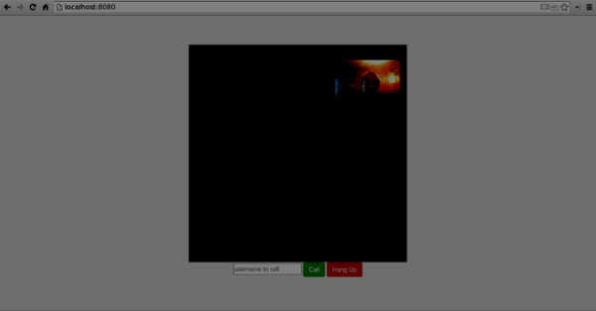

Now we are ready to initiate a call. Firstly, we send an *offer* to another user. Once a user gets the offer, he creates an *answer* and start trading ICE candidates. Add the following code to the *client.js* file −

//initiating a call

callBtn.addEventListener("click", function () {

var callToUsername = callToUsernameInput.value;

if (callToUsername.length > 0) {

connectedUser = callToUsername;

// create an offer

yourConn.createOffer(function (offer) {

send({

type: "offer",

offer: offer

});

yourConn.setLocalDescription(offer);

}, function (error) {

alert("Error when creating an offer");

});

}

});

//when somebody sends us an offer

function handleOffer(offer, name) {

connectedUser = name;

yourConn.setRemoteDescription(new RTCSessionDescription(offer));

//create an answer to an offer

yourConn.createAnswer(function (answer) {

yourConn.setLocalDescription(answer);

send({

type: "answer",

answer: answer

});

}, function (error) {

alert("Error when creating an answer");

});

};

//when we got an answer from a remote user

function handleAnswer(answer) {

yourConn.setRemoteDescription(new RTCSessionDescription(answer));

};

//when we got an ice candidate from a remote user

function handleCandidate(candidate) {

yourConn.addIceCandidate(new RTCIceCandidate(candidate));

};

We add a *click* handler to the Call button, which initiates an offer. Then we implement several handlers expected by the *onmessage* handler. They will be processed asynchronously until both the users have made a connection.

The last step is implementing the hang-up feature. This will stop transmitting data and tell the other user to close the call. Add the following code −

//hang up

hangUpBtn.addEventListener("click", function () {

send({

type: "leave"

});

handleLeave();

});

function handleLeave() {

connectedUser = null;

remoteVideo.src = null;

yourConn.close();

yourConn.onicecandidate = null;

yourConn.onaddstream = null;

};

When the user clicks on the Hang Up button −

* It will send a “leave” message to the other user
* It will close the RTCPeerConnection and destroy the connection locally

Now run the code. You should be able to log in to the server using two browser tabs. You can then call the tab and hang up the call.

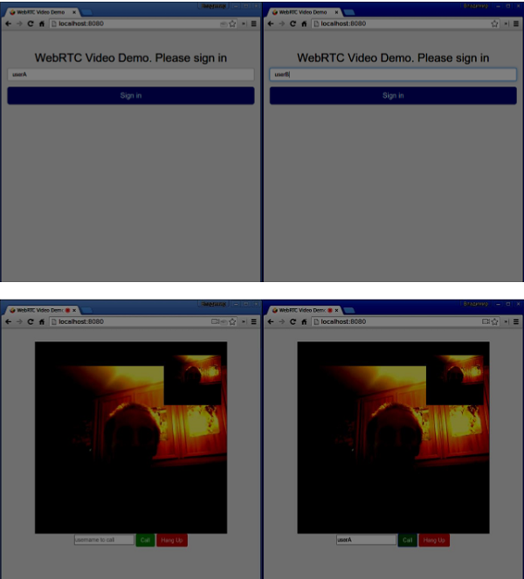

The following is the entire *client.js* file −

//our username

var name;

var connectedUser;

//connecting to our signaling server

var conn = new WebSocket('ws://localhost:9090');

conn.onopen = function () {

console.log("Connected to the signaling server");

};

//when we got a message from a signaling server

conn.onmessage = function (msg) {

console.log("Got message", msg.data);

var data = JSON.parse(msg.data);

switch(data.type) {

case "login":

handleLogin(data.success);

break;

//when somebody wants to call us

case "offer":

handleOffer(data.offer, data.name);

break;

case "answer":

handleAnswer(data.answer);

break;

//when a remote peer sends an ice candidate to us

case "candidate":

handleCandidate(data.candidate);

break;

case "leave":

handleLeave();

break;

default:

break;

}

};

conn.onerror = function (err) {

console.log("Got error", err);

};

//alias for sending JSON encoded messages

function send(message) {

//attach the other peer username to our messages

if (connectedUser) {

message.name = connectedUser;

}

conn.send(JSON.stringify(message));

};

//******

//UI selectors block

//******

var loginPage = document.querySelector('#loginPage');

var usernameInput = document.querySelector('#usernameInput');

var loginBtn = document.querySelector('#loginBtn');

var callPage = document.querySelector('#callPage');

var callToUsernameInput = document.querySelector('#callToUsernameInput');

var callBtn = document.querySelector('#callBtn');

var hangUpBtn = document.querySelector('#hangUpBtn');

var localVideo = document.querySelector('#localVideo');

var remoteVideo = document.querySelector('#remoteVideo');

var yourConn;

var stream;

callPage.style.display = "none";

// Login when the user clicks the button

loginBtn.addEventListener("click", function (event) {

name = usernameInput.value;

if (name.length > 0) {

send({

type: "login",

name: name

});

}

});

function handleLogin(success) {

if (success === false) {

alert("Ooops...try a different username");

} else {

loginPage.style.display = "none";

callPage.style.display = "block";

//**********************

//Starting a peer connection

//**********************

//getting local video stream

navigator.webkitGetUserMedia({ video: true, audio: true }, function (myStream) {

stream = myStream;

//displaying local video stream on the page

localVideo.src = window.URL.createObjectURL(stream);

//using Google public stun server

var configuration = {

"iceServers": [{ "url": "stun:stun2.1.google.com:19302" }]

};

yourConn = new webkitRTCPeerConnection(configuration);

// setup stream listening

yourConn.addStream(stream);

//when a remote user adds stream to the peer connection, we display it

yourConn.onaddstream = function (e) {

remoteVideo.src = window.URL.createObjectURL(e.stream);

};

// Setup ice handling

yourConn.onicecandidate = function (event) {

if (event.candidate) {

send({

type: "candidate",

candidate: event.candidate

});

}

};

}, function (error) {

console.log(error);

});

}

};

//initiating a call

callBtn.addEventListener("click", function () {

var callToUsername = callToUsernameInput.value;

if (callToUsername.length > 0) {

connectedUser = callToUsername;

// create an offer

yourConn.createOffer(function (offer) {

send({

type: "offer",

offer: offer

});

yourConn.setLocalDescription(offer);

}, function (error) {

alert("Error when creating an offer");

});

}

});

//when somebody sends us an offer

function handleOffer(offer, name) {

connectedUser = name;

yourConn.setRemoteDescription(new RTCSessionDescription(offer));

//create an answer to an offer

yourConn.createAnswer(function (answer) {

yourConn.setLocalDescription(answer);

send({

type: "answer",

answer: answer

});

}, function (error) {

alert("Error when creating an answer");

});

};

//when we got an answer from a remote user

function handleAnswer(answer) {

yourConn.setRemoteDescription(new RTCSessionDescription(answer));

};

//when we got an ice candidate from a remote user

function handleCandidate(candidate) {

yourConn.addIceCandidate(new RTCIceCandidate(candidate));

};

//hang up

hangUpBtn.addEventListener("click", function () {

send({

type: "leave"

});

handleLeave();

});

function handleLeave() {

connectedUser = null;

remoteVideo.src = null;

yourConn.close();

yourConn.onicecandidate = null;

yourConn.onaddstream = null;

};

## **Summary**

This demo provides a baseline of features that every WebRTC application needs. To improve this demo you can add user identification through platforms like Facebook or Google, handle user input for invalid data. Also, the WebRTC connection can fail because of several reasons like not supporting the technology or not being able to traverse firewalls. A worth of work has gone into making any WebRTC application stable.

# WebRTC - Voice Demo

Advertisements

[Previous Page](https://www.tutorialspoint.com/webrtc/webrtc_video_demo.htm)

[Next Page](https://www.tutorialspoint.com/webrtc/webrtc_text_demo.htm)

In this chapter, we are going to build a client application that allows two users on separate devices to communicate using WebRTC audio streams. Our application will have two pages. One for login and the other for making an audio call to another user.

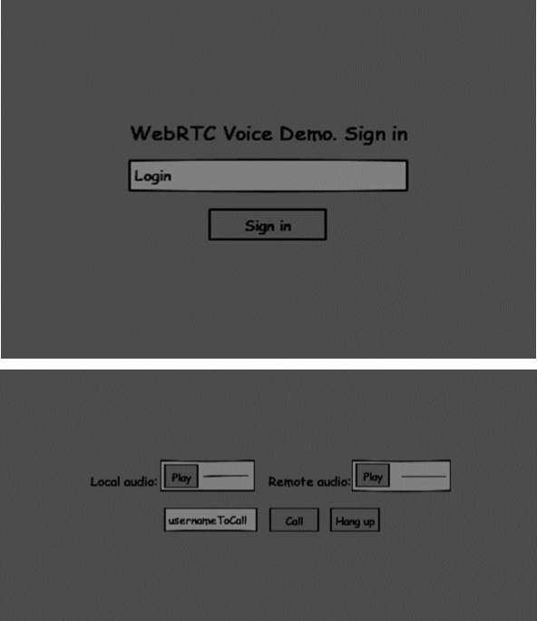

The two pages will be the *div* tags. Most input is done through simple event handlers.

## **Signaling Server**

To create a WebRTC connection clients have to be able to transfer messages without using a WebRTC peer connection. This is where we will use HTML5 WebSockets − a bidirectional socket connection between two endpoints − a web server and a web browser. Now let's start using the WebSocket library. Create the *server.js* file and insert the following code −

//require our websocket library

var WebSocketServer = require('ws').Server;

//creating a websocket server at port 9090

var wss = new WebSocketServer({port: 9090});

//when a user connects to our sever

wss.on('connection', function(connection) {

console.log("user connected");

//when server gets a message from a connected user

connection.on('message', function(message) {

console.log("Got message from a user:", message);

});

connection.send("Hello from server");

});

The first line requires the WebSocket library which we have already installed. Then we create a socket server on the port 9090. Next, we listen to the *connection* event. This code will be executed when a user makes a WebSocket connection to the server. We then listen to any messages sent by the user. Finally, we send a response to the connected user saying “Hello from server”.

In our signaling server, we will use a string-based username for each connection so we know where to send messages. Let's change our *connection*handler a bit −

connection.on('message', function(message) {

var data;

//accepting only JSON messages

try {

data = JSON.parse(message);

} catch (e) {

console.log("Invalid JSON");

data = {};

}

});

This way we accept only JSON messages. Next, we need to store all connected users somewhere. We will use a simple Javascript object for it. Change the top of our file −

//require our websocket library

var WebSocketServer = require('ws').Server;

//creating a websocket server at port 9090

var wss = new WebSocketServer({port: 9090});

//all connected to the server users

var users = {};

We are going to add a *type* field for every message coming from the client. For example if a user wants to login, he sends the *login* type message. Let's define it −

connection.on('message', function(message) {

var data;

//accepting only JSON messages

try {

data = JSON.parse(message);

} catch (e) {

console.log("Invalid JSON");

data = {};

}

//switching type of the user message

switch (data.type) {

//when a user tries to login

case "login":

console.log("User logged:", data.name);

//if anyone is logged in with this username then refuse

if(users[data.name]) {

sendTo(connection, {

type: "login",

success: false

});

} else {

//save user connection on the server

users[data.name] = connection;

connection.name = data.name;

sendTo(connection, {

type: "login",

success: true

});

}

break;

default:

sendTo(connection, {

type: "error",

message: "Command no found: " + data.type

});

break;

}

});

If the user sends a message with the *login* type, we −

* Check if anyone has already logged in with this username.
* If so, then tell the user that he hasn't successfully logged in.
* If no one is using this username, we add username as a key to the connection object.
* If a command is not recognized we send an error.

The following code is a helper function for sending messages to a connection. Add it to the *server.js* file −

function sendTo(connection, message) {

connection.send(JSON.stringify(message));

}

When the user disconnects we should clean up its connection. We can delete the user when the *close* event is fired. Add the following code to the *connection* handler−

connection.on("close", function() {

if(connection.name) {

delete users[connection.name];

}

});

After successful login the user wants to call another. He should make an *offer*to another user to achieve it. Add the *offer* handler −

case "offer":

//for ex. UserA wants to call UserB

console.log("Sending offer to: ", data.name);

//if UserB exists then send him offer details

var conn = users[data.name];

if(conn != null) {

//setting that UserA connected with UserB

connection.otherName = data.name;

sendTo(conn, {

type: "offer",

offer: data.offer,

name: connection.name

});

}

break;

Firstly, we get the *connection* of the user we are trying to call. If it exists we send him *offer* details. We also add *otherName* to the *connection* object. This is made for the simplicity of finding it later.

Answering to the response has a similar pattern that we used in the *offer*handler. Our server just passes through all messages as *answer* to another user. Add the following code after the *offer* handler −

case "answer":

console.log("Sending answer to: ", data.name);

//for ex. UserB answers UserA

var conn = users[data.name];

if(conn != null) {

connection.otherName = data.name;

sendTo(conn, {

type: "answer",

answer: data.answer

});

}

break;

The final part is handling ICE candidate between users. We use the same technique just passing messages between users. The main difference is that candidate messages might happen multiple times per user in any order. Add the *candidate* handler −

case "candidate":

console.log("Sending candidate to:",data.name);

var conn = users[data.name];

if(conn != null) {

sendTo(conn, {

type: "candidate",

candidate: data.candidate

});

}

break;

To allow our users to disconnect from another user we should implement the hanging up function. It will also tell the server to delete all user references. Add the *leave* handler −

case "leave":

console.log("Disconnecting from", data.name);

var conn = users[data.name];

conn.otherName = null;

//notify the other user so he can disconnect his peer connection

if(conn != null) {

sendTo(conn, {

type: "leave"

});

}

break;

This will also send the other user the *leave* event so he can disconnect his peer connection accordingly. We should also handle the case when a user drops his connection from the signaling server. Let's modify our *close* handler −

connection.on("close", function() {

if(connection.name) {

delete users[connection.name];

if(connection.otherName) {

console.log("Disconnecting from ", connection.otherName);

var conn = users[connection.otherName];

conn.otherName = null;

if(conn != null) {

sendTo(conn, {

type: "leave"

});

}

}

}

});

The following is the entire code of our signaling server −

//require our websocket library

var WebSocketServer = require('ws').Server;

//creating a websocket server at port 9090

var wss = new WebSocketServer({port: 9090});

//all connected to the server users

var users = {};

//when a user connects to our sever

wss.on('connection', function(connection) {

console.log("User connected");

//when server gets a message from a connected user

connection.on('message', function(message) {

var data;

//accepting only JSON messages

try {

data = JSON.parse(message);

} catch (e) {

console.log("Invalid JSON");

data = {};

}

//switching type of the user message

switch (data.type) {

//when a user tries to login

case "login":

console.log("User logged", data.name);

//if anyone is logged in with this username then refuse

if(users[data.name]) {

sendTo(connection, {

type: "login",

success: false

});

} else {

//save user connection on the server

users[data.name] = connection;

connection.name = data.name;

sendTo(connection, {

type: "login",

success: true

});

}

break;

case "offer":

//for ex. UserA wants to call UserB

console.log("Sending offer to: ", data.name);

//if UserB exists then send him offer details

var conn = users[data.name];

if(conn != null) {

//setting that UserA connected with UserB

connection.otherName = data.name;

sendTo(conn, {

type: "offer",

offer: data.offer,

name: connection.name

});

}

break;

case "answer":

console.log("Sending answer to: ", data.name);

//for ex. UserB answers UserA

var conn = users[data.name];

if(conn != null) {

connection.otherName = data.name;

sendTo(conn, {

type: "answer",

answer: data.answer

});

}

break;

case "candidate":

console.log("Sending candidate to:",data.name);

var conn = users[data.name];

if(conn != null) {

sendTo(conn, {

type: "candidate",

candidate: data.candidate

});

}

break;

case "leave":

console.log("Disconnecting from", data.name);

var conn = users[data.name];

conn.otherName = null;

//notify the other user so he can disconnect his peer connection

if(conn != null) {

sendTo(conn, {

type: "leave"

});

}

break;

default:

sendTo(connection, {

type: "error",

message: "Command not found: " + data.type

});

break;

}

});

//when user exits, for example closes a browser window

//this may help if we are still in "offer","answer" or "candidate" state

connection.on("close", function() {

if(connection.name) {

delete users[connection.name];

if(connection.otherName) {

console.log("Disconnecting from ", connection.otherName);

var conn = users[connection.otherName];

conn.otherName = null;

if(conn != null) {

sendTo(conn, {

type: "leave"

});

}

}

}

});

connection.send("Hello world");

});

function sendTo(connection, message) {

connection.send(JSON.stringify(message));

}

## **Client Application**

One way to test this application is opening two browser tabs and trying to make an audio call to each other.

First of all, we need to install the *bootstrap* library. Bootstrap is a frontend framework for developing web applications. You can learn more at [http://getbootstrap.com/.](http://getbootstrap.com/) Create a folder called, for example, “audiochat”. This will be our root application folder. Inside this folder create a file *package.json* (it is necessary for managing npm dependencies) and add the following −

{

"name": "webrtc-audiochat",

"version": "0.1.0",

"description": "webrtc-audiochat",

"author": "Author",

"license": "BSD-2-Clause"

}

Then run *npm install bootstrap*. This will install the bootstrap library in the *audiochat/node_modules* folder.

Now we need to create a basic HTML page. Create an *index.html* file in the root folder with the following code −

<html>

<head>

<title>WebRTC Voice Demo</title>

<link rel = "stylesheet" href = "node_modules/bootstrap/dist/css/bootstrap.min.css"/>

</head>

<style>

body {

background: #eee;

padding: 5% 0;

}

</style>

<body>

<div id = "loginPage" class = "container text-center">

<div class = "row">

<div class = "col-md-4 col-md-offset-4">

<h2>WebRTC Voice Demo. Please sign in</h2>

<label for = "usernameInput" class = "sr-only">Login</label>

<input type = "email" id = "usernameInput"

class = "form-control formgroup"

placeholder = "Login" required = "" autofocus = "">

<button id = "loginBtn" class = "btn btn-lg btn-primary btnblock">

Sign in</button>

</div>

</div>

</div>

<div id = "callPage" class = "call-page">

<div class = "row">

<div class = "col-md-6 text-right">

Local audio: <audio id = "localAudio"

controls autoplay></audio>

</div>

<div class = "col-md-6 text-left">

Remote audio: <audio id = "remoteAudio"

controls autoplay></audio>

</div>

</div>

<div class = "row text-center">

<div class = "col-md-12">

<input id = "callToUsernameInput"

type = "text" placeholder = "username to call" />

<button id = "callBtn" class = "btn-success btn">Call</button>

<button id = "hangUpBtn" class = "btn-danger btn">Hang Up</button>

</div>

</div>

</div>

<script src = "client.js"></script>

</body>

</html>

This page should be familiar to you. We have added the *bootstrap* css file. We have also defined two pages. Finally, we have created several text fields and buttons for getting information from the user. You should see the two audio elements for local and remote audio streams. Notice that we have added a link to a *client.js* file.

Now we need to establish a connection with our signaling server. Create the *client.js* file in the root folder with the following code −

//our username

var name;

var connectedUser;

//connecting to our signaling server

var conn = new WebSocket('ws://localhost:9090');

conn.onopen = function () {

console.log("Connected to the signaling server");

};

//when we got a message from a signaling server

conn.onmessage = function (msg) {

console.log("Got message", msg.data);

var data = JSON.parse(msg.data);

switch(data.type) {

case "login":

handleLogin(data.success);

break;

//when somebody wants to call us

case "offer":

handleOffer(data.offer, data.name);

break;

case "answer":

handleAnswer(data.answer);

break;

//when a remote peer sends an ice candidate to us

case "candidate":

handleCandidate(data.candidate);

break;

case "leave":

handleLeave();

break;

default:

break;

}

};

conn.onerror = function (err) {

console.log("Got error", err);

};

//alias for sending JSON encoded messages

function send(message) {

//attach the other peer username to our messages

if (connectedUser) {

message.name = connectedUser;

}

conn.send(JSON.stringify(message));

};

Now run our signaling server via *node server*. Then, inside the root folder run the *static* command and open the page inside the browser. You should see the following console output −

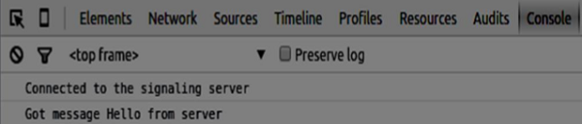

The next step is implementing a user log in with a unique username. We simply send a username to the server, which then tell us whether it is taken or not. Add the following code to your *client.js* file −

//******

//UI selectors block

//******

var loginPage = document.querySelector('#loginPage');

var usernameInput = document.querySelector('#usernameInput');

var loginBtn = document.querySelector('#loginBtn');

var callPage = document.querySelector('#callPage');

var callToUsernameInput = document.querySelector('#callToUsernameInput');

var callBtn = document.querySelector('#callBtn');

var hangUpBtn = document.querySelector('#hangUpBtn');

callPage.style.display = "none";

// Login when the user clicks the button

loginBtn.addEventListener("click", function (event) {

name = usernameInput.value;

if (name.length > 0) {

send({

type: "login",

name: name

});

}

});

function handleLogin(success) {

if (success === false) {

alert("Ooops...try a different username");

} else {

loginPage.style.display = "none";

callPage.style.display = "block";

//**********************

//Starting a peer connection

//**********************

}

};

Firstly, we select some references to the elements on the page. The we hide the call page. Then, we add an event listener on the login button. When the user clicks it, we send his username to the server. Finally, we implement the handleLogin callback. If the login was successful, we show the call page and starting to set up a peer connection.

To start a peer connection we need −

* Obtain an audio stream from a microphone
* Create the RTCPeerConnection object

Add the following code to the “UI selectors block” −

var localAudio = document.querySelector('#localAudio');

var remoteAudio = document.querySelector('#remoteAudio');

var yourConn;

var stream;

Modify the *handleLogin* function −

function handleLogin(success) {

if (success === false) {

alert("Ooops...try a different username");

} else {

loginPage.style.display = "none";

callPage.style.display = "block";

//**********************

//Starting a peer connection

//**********************

//getting local audio stream

navigator.webkitGetUserMedia({ video: false, audio: true }, function (myStream) {

stream = myStream;

//displaying local audio stream on the page

localAudio.src = window.URL.createObjectURL(stream);

//using Google public stun server

var configuration = {

"iceServers": [{ "url": "stun:stun2.1.google.com:19302" }]

};

yourConn = new webkitRTCPeerConnection(configuration);

// setup stream listening

yourConn.addStream(stream);

//when a remote user adds stream to the peer connection, we display it

yourConn.onaddstream = function (e) {

remoteAudio.src = window.URL.createObjectURL(e.stream);

};

// Setup ice handling

yourConn.onicecandidate = function (event) {

if (event.candidate) {

send({

type: "candidate",

});

}

};

}, function (error) {

console.log(error);

});

}

};

Now if you run the code, the page should allow you to log in and display your local audio stream on the page.

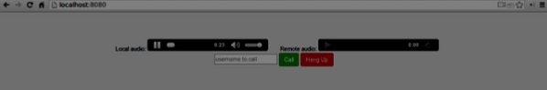

Now we are ready to initiate a call. Firstly, we send an *offer* to another user. Once a user gets the offer, he creates an *answer* and start trading ICE candidates. Add the following code to the *client.js* file −

//initiating a call

callBtn.addEventListener("click", function () {

var callToUsername = callToUsernameInput.value;

if (callToUsername.length > 0) {

connectedUser = callToUsername;

// create an offer

yourConn.createOffer(function (offer) {

send({

type: "offer",

offer: offer

});

yourConn.setLocalDescription(offer);

}, function (error) {

alert("Error when creating an offer");

});

}

});

//when somebody sends us an offer

function handleOffer(offer, name) {

connectedUser = name;

yourConn.setRemoteDescription(new RTCSessionDescription(offer));

//create an answer to an offer

yourConn.createAnswer(function (answer) {

yourConn.setLocalDescription(answer);

send({

type: "answer",

answer: answer

});

}, function (error) {

alert("Error when creating an answer");

});

};

//when we got an answer from a remote user

function handleAnswer(answer) {

yourConn.setRemoteDescription(new RTCSessionDescription(answer));

};

//when we got an ice candidate from a remote user

function handleCandidate(candidate) {

yourConn.addIceCandidate(new RTCIceCandidate(candidate));

};

We add a *click* handler to the Call button, which initiates an offer. Then we implement several handlers expected by the *onmessage* handler. They will be processed asynchronously until both the users have made a connection.

The last step is implementing the hang-up feature. This will stop transmitting data and tell the other user to close the call. Add the following code −

//hang up

hangUpBtn.addEventListener("click", function () {

send({

type: "leave"

});

handleLeave();

});

function handleLeave() {

connectedUser = null;

remoteAudio.src = null;

yourConn.close();

yourConn.onicecandidate = null;

yourConn.onaddstream = null;

};

When the user clicks on the Hang Up button −

* It will send a “leave” message to the other user
* It will close the RTCPeerConnection and destroy the connection locally

Now run the code. You should be able to log in to the server using two browser tabs. You can then make an audio call to the tab and hang up the call.

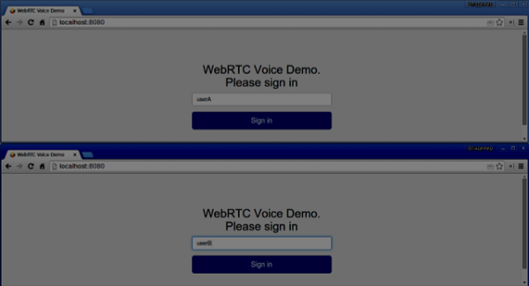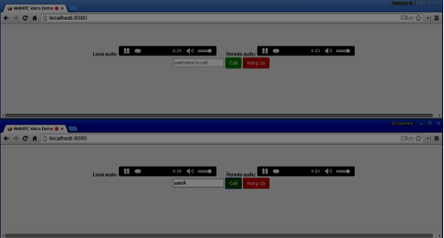

The following is the entire *client.js* file −

//our username

var name;

var connectedUser;

//connecting to our signaling server

var conn = new WebSocket('ws://localhost:9090');

conn.onopen = function () {

console.log("Connected to the signaling server");

};

//when we got a message from a signaling server

conn.onmessage = function (msg) {

console.log("Got message", msg.data);

var data = JSON.parse(msg.data);

switch(data.type) {

case "login":

handleLogin(data.success);

break;

//when somebody wants to call us

case "offer":

handleOffer(data.offer, data.name);

break;

case "answer":

handleAnswer(data.answer);

break;

//when a remote peer sends an ice candidate to us

case "candidate":

handleCandidate(data.candidate);

break;

case "leave":

handleLeave();

break;

default:

break;

}

};

conn.onerror = function (err) {

console.log("Got error", err);

};

//alias for sending JSON encoded messages

function send(message) {

//attach the other peer username to our messages

if (connectedUser) {

message.name = connectedUser;

}

conn.send(JSON.stringify(message));

};

//******

//UI selectors block

//******

var loginPage = document.querySelector('#loginPage');

var usernameInput = document.querySelector('#usernameInput');

var loginBtn = document.querySelector('#loginBtn');

var callPage = document.querySelector('#callPage');

var callToUsernameInput = document.querySelector('#callToUsernameInput');

var callBtn = document.querySelector('#callBtn');

var hangUpBtn = document.querySelector('#hangUpBtn');

var localAudio = document.querySelector('#localAudio');

var remoteAudio = document.querySelector('#remoteAudio');

var yourConn;

var stream;

callPage.style.display = "none";

// Login when the user clicks the button

loginBtn.addEventListener("click", function (event) {

name = usernameInput.value;

if (name.length > 0) {

send({

type: "login",

name: name

});

}

});

function handleLogin(success) {

if (success === false) {

alert("Ooops...try a different username");

} else {

loginPage.style.display = "none";

callPage.style.display = "block";

//**********************

//Starting a peer connection

//**********************

//getting local audio stream

navigator.webkitGetUserMedia({ video: false, audio: true }, function (myStream) {

stream = myStream;

//displaying local audio stream on the page

localAudio.src = window.URL.createObjectURL(stream);

//using Google public stun server

var configuration = {

"iceServers": [{ "url": "stun:stun2.1.google.com:19302" }]

};

yourConn = new webkitRTCPeerConnection(configuration);

// setup stream listening

yourConn.addStream(stream);

//when a remote user adds stream to the peer connection, we display it

yourConn.onaddstream = function (e) {

remoteAudio.src = window.URL.createObjectURL(e.stream);

};

// Setup ice handling

yourConn.onicecandidate = function (event) {

if (event.candidate) {

send({

type: "candidate",

candidate: event.candidate

});

}

};

}, function (error) {

console.log(error);

});

}

};

//initiating a call

callBtn.addEventListener("click", function () {

var callToUsername = callToUsernameInput.value;

if (callToUsername.length > 0) {

connectedUser = callToUsername;

// create an offer

yourConn.createOffer(function (offer) {

send({

type: "offer",

offer: offer

});

yourConn.setLocalDescription(offer);

}, function (error) {

alert("Error when creating an offer");

});

}

});

//when somebody sends us an offer

function handleOffer(offer, name) {

connectedUser = name;

yourConn.setRemoteDescription(new RTCSessionDescription(offer));

//create an answer to an offer

yourConn.createAnswer(function (answer) {

yourConn.setLocalDescription(answer);

send({

type: "answer",

answer: answer

});

}, function (error) {

alert("Error when creating an answer");

});

};

//when we got an answer from a remote user

function handleAnswer(answer) {

yourConn.setRemoteDescription(new RTCSessionDescription(answer));

};

//when we got an ice candidate from a remote user

function handleCandidate(candidate) {

yourConn.addIceCandidate(new RTCIceCandidate(candidate));

};

//hang up

hangUpBtn.addEventListener("click", function () {

send({

type: "leave"

});

handleLeave();

});

function handleLeave() {

connectedUser = null;

remoteAudio.src = null;

yourConn.close();

yourConn.onicecandidate = null;

yourConn.onaddstream = null;

};

# WebRTC - Text Demo

Advertisements

[Previous Page](https://www.tutorialspoint.com/webrtc/webrtc_voice_demo.htm)

[Next Page](https://www.tutorialspoint.com/webrtc/webrtc_security.htm)

In this chapter, we are going to build a client application that allows two users on separate devices to send messages each other using WebRTC. Our application will have two pages. One for login and the other for sending messages to another user.

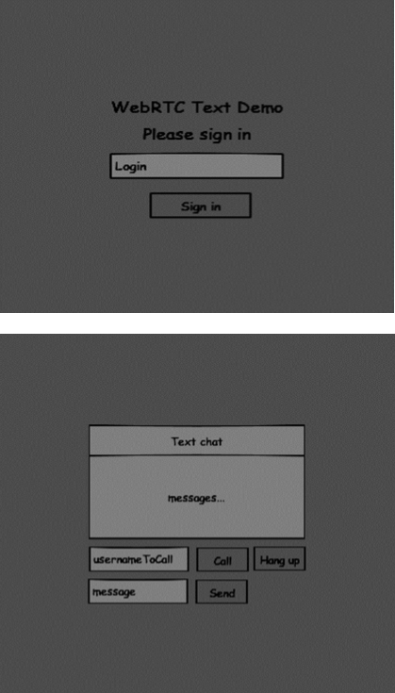

The two pages will be the *div* tags. Most input is done through simple event handlers.

## **Signaling Server**

To create a WebRTC connection clients have to be able to transfer messages without using a WebRTC peer connection. This is where we will use HTML5 WebSockets − a bidirectional socket connection between two endpoints − a web server and a web browser. Now let's start using the WebSocket library. Create the *server.js* file and insert the following code −

//require our websocket library

var WebSocketServer = require('ws').Server;

//creating a websocket server at port 9090

var wss = new WebSocketServer({port: 9090});

//when a user connects to our sever

wss.on('connection', function(connection) {

console.log("user connected");

//when server gets a message from a connected user

connection.on('message', function(message) {

console.log("Got message from a user:", message);

});

connection.send("Hello from server");

});

The first line requires the WebSocket library which we have already installed. Then we create a socket server on the port 9090. Next, we listen to the *connection* event. This code will be executed when a user makes a WebSocket connection to the server. We then listen to any messages sent by the user. Finally, we send a response to the connected user saying “Hello from server”.

In our signaling server, we will use a string-based username for each connection so we know where to send messages. Let's change our *connection*handler a bit −

connection.on('message', function(message) {

var data;

//accepting only JSON messages

try {

data = JSON.parse(message);

} catch (e) {

console.log("Invalid JSON");

data = {};

}

});

This way we accept only JSON messages. Next, we need to store all connected users somewhere. We will use a simple Javascript object for it. Change the top of our file −

//require our websocket library

var WebSocketServer = require('ws').Server;

//creating a websocket server at port 9090

var wss = new WebSocketServer({port: 9090});

//all connected to the server users

var users = {};

We are going to add a *type* field for every message coming from the client. For example if a user wants to login, he sends the *login* type message. Let's define it −

connection.on('message', function(message) {

var data;

//accepting only JSON messages

try {

data = JSON.parse(message);

} catch (e) {

console.log("Invalid JSON");

data = {};

}

//switching type of the user message

switch (data.type) {

//when a user tries to login

case "login":

console.log("User logged:", data.name);

//if anyone is logged in with this username then refuse

if(users[data.name]) {

sendTo(connection, {

type: "login",

success: false

});

} else {

//save user connection on the server

users[data.name] = connection;

connection.name = data.name;

sendTo(connection, {

type: "login",

success: true

});

}

break;

default:

sendTo(connection, {

type: "error",

message: "Command no found: " + data.type

});

break;

}

});

If the user sends a message with the *login* type, we −

* Check if anyone has already logged in with this username.
* If so, then tell the user that he hasn't successfully logged in.
* If no one is using this username, we add username as a key to the connection object.
* If a command is not recognized we send an error.

The following code is a helper function for sending messages to a connection. Add it to the *server.js* file −

function sendTo(connection, message) {

connection.send(JSON.stringify(message));

}

When the user disconnects we should clean up its connection. We can delete the user when the *close* event is fired. Add the following code to the *connection* handler −

connection.on("close", function() {

if(connection.name) {

delete users[connection.name];

}

});

After successful login the user wants to call another. He should make an *offer*to another user to achieve it. Add the *offer* handler −

case "offer":

//for ex. UserA wants to call UserB

console.log("Sending offer to: ", data.name);

//if UserB exists then send him offer details

var conn = users[data.name];

if(conn != null){

//setting that UserA connected with UserB

connection.otherName = data.name;

sendTo(conn, {

type: "offer",

offer: data.offer,

name: connection.name

});

break;

Firstly, we get the *connection* of the user we are trying to call. If it exists we send him *offer* details. We also add *otherName* to the *connection* object. This is made for the simplicity of finding it later.

Answering to the response has a similar pattern that we used in the *offer*handler. Our server just passes through all messages as *answer* to another user. Add the following code after the *offer* handler −

case "answer":

console.log("Sending answer to: ", data.name);

//for ex. UserB answers UserA

var conn = users[data.name];

if(conn != null) {

connection.otherName = data.name;

sendTo(conn, {

type: "answer",

answer: data.answer

});

}

break;

The final part is handling ICE candidate between users. We use the same technique just passing messages between users. The main difference is that candidate messages might happen multiple times per user in any order. Add the *candidate* handler −

case "candidate":

console.log("Sending candidate to:",data.name);

var conn = users[data.name];

if(conn != null) {

sendTo(conn, {

type: "candidate",

candidate: data.candidate

});

}

break;

To allow our users to disconnect from another user we should implement the hanging up function. It will also tell the server to delete all user references. Add the *leave* handler −

case "leave":

console.log("Disconnecting from", data.name);

var conn = users[data.name];

conn.otherName = null;

//notify the other user so he can disconnect his peer connection

if(conn != null) {

sendTo(conn, {

type: "leave"

});

}

break;

This will also send the other user the *leave* event so he can disconnect his peer connection accordingly. We should also handle the case when a user drops his connection from the signaling server. Let's modify our *close* handler −

connection.on("close", function() {

if(connection.name) {

delete users[connection.name];

if(connection.otherName) {

console.log("Disconnecting from ", connection.otherName);

var conn = users[connection.otherName];

conn.otherName = null;

if(conn != null) {

sendTo(conn, {

type: "leave"

});

}

}

}

});

The following is the entire code of our signaling server −

//require our websocket library

var WebSocketServer = require('ws').Server;

//creating a websocket server at port 9090

var wss = new WebSocketServer({port: 9090});

//all connected to the server users

var users = {};

//when a user connects to our sever

wss.on('connection', function(connection) {

console.log("User connected");

//when server gets a message from a connected user

connection.on('message', function(message) {

var data;

//accepting only JSON messages

try {

data = JSON.parse(message);

} catch (e) {

console.log("Invalid JSON");

data = {};

}

//switching type of the user message

switch (data.type) {

//when a user tries to login

case "login":

console.log("User logged", data.name);

//if anyone is logged in with this username then refuse

if(users[data.name]) {

sendTo(connection, {

type: "login",

success: false

});

} else {

//save user connection on the server

users[data.name] = connection;

connection.name = data.name;

sendTo(connection, {

type: "login",

success: true

});

}

break;

case "offer":

//for ex. UserA wants to call UserB

console.log("Sending offer to: ", data.name);

//if UserB exists then send him offer details

var conn = users[data.name];

if(conn != null) {

//setting that UserA connected with UserB

connection.otherName = data.name;

sendTo(conn, {

type: "offer",

offer: data.offer,

name: connection.name

});

}

break;

case "answer":

console.log("Sending answer to: ", data.name);

//for ex. UserB answers UserA

var conn = users[data.name];

if(conn != null) {

connection.otherName = data.name;

sendTo(conn, {

type: "answer",

answer: data.answer

});

}

break;

case "candidate":

console.log("Sending candidate to:",data.name);

var conn = users[data.name];

if(conn != null) {

sendTo(conn, {

type: "candidate",

candidate: data.candidate

});

}

break;

case "leave":

console.log("Disconnecting from", data.name);

var conn = users[data.name];

conn.otherName = null;

//notify the other user so he can disconnect his peer connection

if(conn != null) {

sendTo(conn, {

type: "leave"

});

}

break;

default:

sendTo(connection, {

type: "error",

message: "Command not found: " + data.type

});

break;

}

});

//when user exits, for example closes a browser window

//this may help if we are still in "offer","answer" or "candidate" state

connection.on("close", function() {

if(connection.name) {

delete users[connection.name];

if(connection.otherName) {

console.log("Disconnecting from ", connection.otherName);

var conn = users[connection.otherName];

conn.otherName = null;

if(conn != null) {

sendTo(conn, {

type: "leave"

});

}

}

}

});

connection.send("Hello world");

});

function sendTo(connection, message) {

connection.send(JSON.stringify(message));

}

## **Client Application**

One way to test this application is opening two browser tabs and trying to send a message each other.

First of all, we need to install the *bootstrap* library. Bootstrap is a frontend framework for developing web applications. You can learn more at [http://getbootstrap.com/.](http://getbootstrap.com/)Create a folder called, for example, “textchat”. This will be our root application folder. Inside this folder create a file *package.json* (it is necessary for managing npm dependencies) and add the following −

{

"name": "webrtc-textochat",

"version": "0.1.0",

"description": "webrtc-textchat",

"author": "Author",

"license": "BSD-2-Clause"

}

Then run *npm install bootstrap*. This will install the bootstrap library in the *textchat/node_modules* folder.

Now we need to create a basic HTML page. Create an *index.html* file in the root folder with the following code −

<html>

<head>

<title>WebRTC Text Demo</title>

<link rel = "stylesheet" href = "node_modules/bootstrap/dist/css/bootstrap.min.css"/>

</head>

<style>

body {

background: #eee;

padding: 5% 0;

}

</style>

<body>

<div id = "loginPage" class = "container text-center">

<div class = "row">

<div class = "col-md-4 col-md-offset-4">

<h2>WebRTC Text Demo. Please sign in</h2>

<label for = "usernameInput" class = "sr-only">Login</label>

<input type = "email" id = "usernameInput"

class = "form-control formgroup" placeholder = "Login"

required = "" autofocus = "">

<button id = "loginBtn" class = "btn btn-lg btn-primary btnblock">

Sign in</button>

</div>

</div>

</div>

<div id = "callPage" class = "call-page container">

<div class = "row">

<div class = "col-md-4 col-md-offset-4 text-center">

<div class = "panel panel-primary">

<div class = "panel-heading">Text chat</div>

<div id = "chatarea" class = "panel-body text-left"></div>

</div>

</div>

</div>

<div class = "row text-center form-group">

<div class = "col-md-12">

<input id = "callToUsernameInput" type = "text"

placeholder = "username to call" />

<button id = "callBtn" class = "btn-success btn">Call</button>

<button id = "hangUpBtn" class = "btn-danger btn">Hang Up</button>

</div>

</div>

<div class = "row text-center">

<div class = "col-md-12">

<input id = "msgInput" type = "text" placeholder = "message" />

<button id = "sendMsgBtn" class = "btn-success btn">Send</button>

</div>

</div>

</div>

<script src = "client.js"></script>

</body>

</html>

This page should be familiar to you. We have added the *bootstrap* css file. We have also defined two pages. Finally, we have created several text fields and buttons for getting information from the user. On the “chat” page you should see the div tag with the “chatarea” ID where all our messages will be displayed. Notice that we have added a link to a *client.js* file.

Now we need to establish a connection with our signaling server. Create the *client.js* file in the root folder with the following code −

//our username

var name;

var connectedUser;

//connecting to our signaling server

var conn = new WebSocket('ws://localhost:9090');

conn.onopen = function () {

console.log("Connected to the signaling server");

};

//when we got a message from a signaling server

conn.onmessage = function (msg) {

console.log("Got message", msg.data);

var data = JSON.parse(msg.data);

switch(data.type) {

case "login":

handleLogin(data.success);

break;

//when somebody wants to call us

case "offer":

handleOffer(data.offer, data.name);

break;

case "answer":

handleAnswer(data.answer);

break;

//when a remote peer sends an ice candidate to us

case "candidate":

handleCandidate(data.candidate);

break;

case "leave":

handleLeave();

break;

default:

break;

}

};

conn.onerror = function (err) {

console.log("Got error", err);

};

//alias for sending JSON encoded messages

function send(message) {

//attach the other peer username to our messages

if (connectedUser) {

message.name = connectedUser;

}

conn.send(JSON.stringify(message));

};

Now run our signaling server via *node server*. Then, inside the root folder run the *static* command and open the page inside the browser. You should see the following console output −

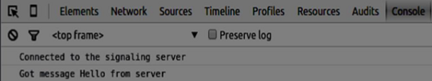

The next step is implementing a user log in with a unique username. We simply send a username to the server, which then tell us whether it is taken or not. Add the following code to your *client.js* file −

//******

//UI selectors block

//******

var loginPage = document.querySelector('#loginPage');

var usernameInput = document.querySelector('#usernameInput');

var loginBtn = document.querySelector('#loginBtn');

var callPage = document.querySelector('#callPage');

var callToUsernameInput = document.querySelector('#callToUsernameInput');

var callBtn = document.querySelector('#callBtn');

var hangUpBtn = document.querySelector('#hangUpBtn');

callPage.style.display = "none";

// Login when the user clicks the button

loginBtn.addEventListener("click", function (event) {

name = usernameInput.value;

if (name.length > 0) {

send({

type: "login",

name: name

});

}

});

function handleLogin(success) {

if (success === false) {

alert("Ooops...try a different username");

} else {

loginPage.style.display = "none";

callPage.style.display = "block";

//**********************

//Starting a peer connection

//**********************

}

};

Firstly, we select some references to the elements on the page. The we hide the call page. Then, we add an event listener on the login button. When the user clicks it, we send his username to the server. Finally, we implement the handleLogin callback. If the login was successful, we show the call page, set up a peer connection, and create a data channel.

To start a peer connection with a data channel we need −

* Create the RTCPeerConnection object
* Create a data channel inside our RTCPeerConnection object

Add the following code to the “UI selectors block” −

var msgInput = document.querySelector('#msgInput');

var sendMsgBtn = document.querySelector('#sendMsgBtn');

var chatArea = document.querySelector('#chatarea');

var yourConn;

var dataChannel;

Modify the *handleLogin* function −

function handleLogin(success) {

if (success === false) {

alert("Ooops...try a different username");

} else {

loginPage.style.display = "none";

callPage.style.display = "block";

//**********************

//Starting a peer connection

//**********************

//using Google public stun server

var configuration = {

"iceServers": [{ "url": "stun:stun2.1.google.com:19302" }]

};

yourConn = new webkitRTCPeerConnection(configuration, {optional: [{RtpDataChannels: true}]});

// Setup ice handling

yourConn.onicecandidate = function (event) {

if (event.candidate) {

send({

type: "candidate",

candidate: event.candidate

});

}

};

//creating data channel

dataChannel = yourConn.createDataChannel("channel1", {reliable:true});

dataChannel.onerror = function (error) {

console.log("Ooops...error:", error);

};

//when we receive a message from the other peer, display it on the screen

dataChannel.onmessage = function (event) {

chatArea.innerHTML += connectedUser + ": " + event.data + "<br />";

};

dataChannel.onclose = function () {

console.log("data channel is closed");

};

}

};

If login was successful the application creates the *RTCPeerConnection* object and setup *onicecandidate* handler which sends all found icecandidates to the other peer. It also creates a dataChannel. Notice, that when creating the RTCPeerConnection object the second argument in the constructor optional: [{RtpDataChannels: true}] is mandatory if you are using Chrome or Opera. The next step is to create an offer to the other peer. Once a user gets the offer, he creates an *answer* and start trading ICE candidates. Add the following code to the *client.js* file −

//initiating a call

callBtn.addEventListener("click", function () {

var callToUsername = callToUsernameInput.value;

if (callToUsername.length > 0) {

connectedUser = callToUsername;

// create an offer

yourConn.createOffer(function (offer) {

send({

type: "offer",

offer: offer

});

yourConn.setLocalDescription(offer);

}, function (error) {

alert("Error when creating an offer");

});

}

});

//when somebody sends us an offer

function handleOffer(offer, name) {

connectedUser = name;

yourConn.setRemoteDescription(new RTCSessionDescription(offer));

//create an answer to an offer

yourConn.createAnswer(function (answer) {

yourConn.setLocalDescription(answer);

send({

type: "answer",

answer: answer

});

}, function (error) {

alert("Error when creating an answer");

});

};

//when we got an answer from a remote user

function handleAnswer(answer) {

yourConn.setRemoteDescription(new RTCSessionDescription(answer));

};

//when we got an ice candidate from a remote user

function handleCandidate(candidate) {

yourConn.addIceCandidate(new RTCIceCandidate(candidate));

};

We add a *click* handler to the Call button, which initiates an offer. Then we implement several handlers expected by the *onmessage* handler. They will be processed asynchronously until both the users have made a connection.

The next step is implementing the hang-up feature. This will stop transmitting data and tell the other user to close the data channel. Add the following code −

//hang up

hangUpBtn.addEventListener("click", function () {

send({

type: "leave"

});

handleLeave();

});

function handleLeave() {

connectedUser = null;

yourConn.close();

yourConn.onicecandidate = null;

};

When the user clicks on the Hang Up button −

* It will send a “leave” message to the other user.
* It will close the RTCPeerConnection and as well as data channel.

The last step is sending a message to another peer. Add the “click” handler to the “send message” button −

//when user clicks the "send message" button

sendMsgBtn.addEventListener("click", function (event) {

var val = msgInput.value;

chatArea.innerHTML += name + ": " + val + "<br />";

//sending a message to a connected peer

dataChannel.send(val);

msgInput.value = "";

});

Now run the code. You should be able to log in to the server using two browser tabs. You can then set up a peer connection to the other user and send him a message as well as close the data channel by clicking the “Hang Up” button.

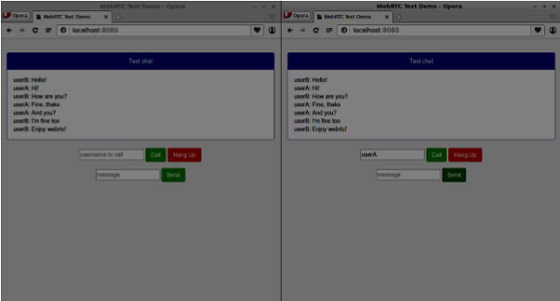

The following is the entire *client.js* file −

//our username

var name;

var connectedUser;

//connecting to our signaling server

var conn = new WebSocket('ws://localhost:9090');

conn.onopen = function () {

console.log("Connected to the signaling server");

};

//when we got a message from a signaling server

conn.onmessage = function (msg) {

console.log("Got message", msg.data);

var data = JSON.parse(msg.data);

switch(data.type) {

case "login":

handleLogin(data.success);

break;

//when somebody wants to call us

case "offer":

handleOffer(data.offer, data.name);

break;

case "answer":

handleAnswer(data.answer);

break;

//when a remote peer sends an ice candidate to us

case "candidate":

handleCandidate(data.candidate);

break;

case "leave":

handleLeave();

break;

default:

break;

}

};

conn.onerror = function (err) {

console.log("Got error", err);

};

//alias for sending JSON encoded messages

function send(message) {

//attach the other peer username to our messages

if (connectedUser) {

message.name = connectedUser;

}

conn.send(JSON.stringify(message));

};

//******

//UI selectors block

//******

var loginPage = document.querySelector('#loginPage');

var usernameInput = document.querySelector('#usernameInput');

var loginBtn = document.querySelector('#loginBtn');

var callPage = document.querySelector('#callPage');

var callToUsernameInput = document.querySelector('#callToUsernameInput');

var callBtn = document.querySelector('#callBtn');

var hangUpBtn = document.querySelector('#hangUpBtn');

var msgInput = document.querySelector('#msgInput');

var sendMsgBtn = document.querySelector('#sendMsgBtn');

var chatArea = document.querySelector('#chatarea');

var yourConn;

var dataChannel;

callPage.style.display = "none";

// Login when the user clicks the button

loginBtn.addEventListener("click", function (event) {

name = usernameInput.value;

if (name.length > 0) {

send({

type: "login",

name: name

});

}

});

function handleLogin(success) {

if (success === false) {

alert("Ooops...try a different username");

} else {

loginPage.style.display = "none";

callPage.style.display = "block";

//**********************

//Starting a peer connection

//**********************

//using Google public stun server

var configuration = {

"iceServers": [{ "url": "stun:stun2.1.google.com:19302" }]

};

yourConn = new webkitRTCPeerConnection(configuration, {optional: [{RtpDataChannels: true}]});

// Setup ice handling

yourConn.onicecandidate = function (event) {

if (event.candidate) {

send({

type: "candidate",

candidate: event.candidate

});

}

};

//creating data channel

dataChannel = yourConn.createDataChannel("channel1", {reliable:true});

dataChannel.onerror = function (error) {

console.log("Ooops...error:", error);

};

//when we receive a message from the other peer, display it on the screen

dataChannel.onmessage = function (event) {

chatArea.innerHTML += connectedUser + ": " + event.data + "<br />";

};

dataChannel.onclose = function () {

console.log("data channel is closed");

};

}

};

//initiating a call

callBtn.addEventListener("click", function () {

var callToUsername = callToUsernameInput.value;

if (callToUsername.length > 0) {

connectedUser = callToUsername;

// create an offer

yourConn.createOffer(function (offer) {

send({

type: "offer",

offer: offer

});

yourConn.setLocalDescription(offer);

}, function (error) {

alert("Error when creating an offer");

});

}

});

//when somebody sends us an offer

function handleOffer(offer, name) {

connectedUser = name;

yourConn.setRemoteDescription(new RTCSessionDescription(offer));

//create an answer to an offer

yourConn.createAnswer(function (answer) {

yourConn.setLocalDescription(answer);

send({

type: "answer",

answer: answer

});

}, function (error) {

alert("Error when creating an answer");

});

};

//when we got an answer from a remote user

function handleAnswer(answer) {

yourConn.setRemoteDescription(new RTCSessionDescription(answer));

};

//when we got an ice candidate from a remote user

function handleCandidate(candidate) {

yourConn.addIceCandidate(new RTCIceCandidate(candidate));

};

//hang up

hangUpBtn.addEventListener("click", function () {

send({

type: "leave"

});

handleLeave();

});

function handleLeave() {

connectedUser = null;

yourConn.close();

yourConn.onicecandidate = null;

};

//when user clicks the "send message" button

sendMsgBtn.addEventListener("click", function (event) {

var val = msgInput.value;

chatArea.innerHTML += name + ": " + val + "<br />";

//sending a message to a connected peer

dataChannel.send(val);

msgInput.value = "";

});

WebRTC - Security

Advertisements

[Previous Page](https://www.tutorialspoint.com/webrtc/webrtc_text_demo.htm)

[Next Page](https://www.tutorialspoint.com/webrtc/webrtc_quick_guide.htm)

In this chapter, we are going to add security features to the signaling server we created in the “WebRTC Signaling” chapter. There will be two enhancements −

* User authentication using Redis database
* Enabling secure socket connection

Firstly, you should install Redis.

* Download the latest stable release at <http://redis.io/download>(3.05 in my case)
* Unpack it
* Inside the downloaded folder run *sudo make install*
* After the installation is finished, run *make test* to check whether everything is working correctly.

Redis has two executable commands −

* **redis-cli** − command line interface for Redis (client part)
* **redis-server** − Redis data store

To run the Redis server type *redis-server* in the terminal console. You should see the following −

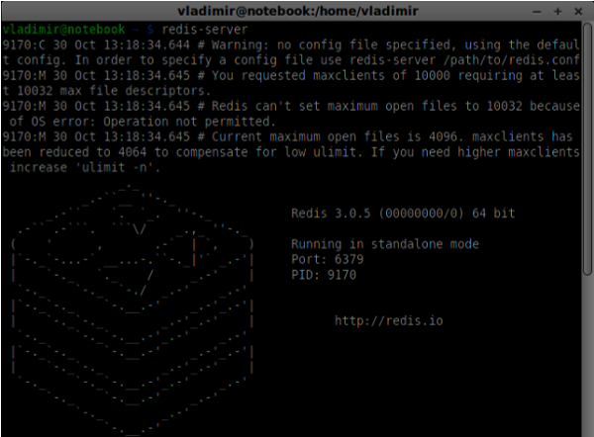

Now open a new terminal window and run *redis-cli* to open a client application.

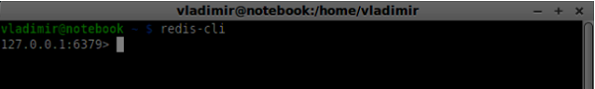

Basically, Redis is a key-value database. To create a key with a string value, you should use the SET command. To read the key value you should use the GET command. Let's add two users and passwords for them. Keys will be the usernames and values of these keys will be the corresponding passwords.

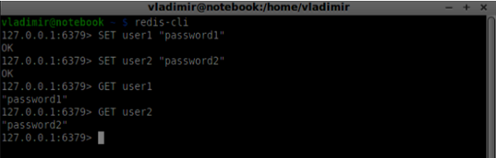

Now we should modify our signaling server to add a user authentication. Add the following code to the top of the *server.js* file −

//require the redis library in Node.js

var redis = require("redis");

//creating the redis client object

var redisClient = redis.createClient();

In the above code, we require the Redis library for Node.js and creating a redis client for our server.

To add the authentication modify the *message* handler on the connection object −

//when a user connects to our sever

wss.on('connection', function(connection) {

console.log("user connected");

//when server gets a message from a connected user

connection.on('message', function(message) {

var data;

//accepting only JSON messages

try {

data = JSON.parse(message);

} catch (e) {

console.log("Invalid JSON");

data = {};

}

//check whether a user is authenticated

if(data.type != "login") {

//if user is not authenticated

if(!connection.isAuth) {

sendTo(connection, {

type: "error",

message: "You are not authenticated"

});

return;

}

}

//switching type of the user message

switch (data.type) {

//when a user tries to login

case "login":

console.log("User logged:", data.name);

//get password for this username from redis database

redisClient.get(data.name, function(err, reply) {

//check if password matches with the one stored in redis

var loginSuccess = reply === data.password;

//if anyone is logged in with this username or incorrect password

then refuse

if(users[data.name] || !loginSuccess) {

sendTo(connection, {

type: "login",

success: false

});

} else {

//save user connection on the server

users[data.name] = connection;

connection.name = data.name;

connection.isAuth = true;

sendTo(connection, {

type: "login",

success: true

});

}

});

break;

}

});

}

//...

//*****other handlers*******

In the above code if a user tries to login we get from Redis his password, check if it matches with the stored one, and if it successful we store his username on the server. We also add the *isAuth* flag to the connection to check whether the user is authenticated. Notice this code −

//check whether a user is authenticated

if(data.type != "login") {

//if user is not authenticated

if(!connection.isAuth) {

sendTo(connection, {

type: "error",

message: "You are not authenticated"

});

return;

}

}

If an unauthenticated user tries to send offer or leave the connection we simply send an error back.

The next step is enabling a secure socket connection. It is highly recommended for WebRTC applications. PKI (Public Key Infrastructure) is a digital signature from a CA (Certificate Authority). Users then check that the private key used to sign a certificate matches the public key of the CA's certificate. For the development purposes. we will use a self-signed security certificate.

We will use the openssl. It is an open source tool that implements SSL (Secure Sockets Layer) and TLS (Transport Layer Security) protocols. It is often installed by default on Unix systems. Run *openssl version -a* to check whether it is installed.

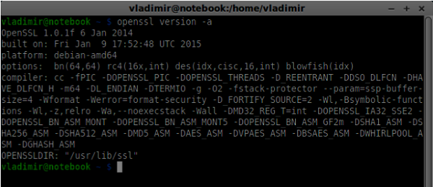

To generate public and private security certificate keys, you should follow the steps given below −

* **Generate a temporary server password key**

openssl genrsa -des3 -passout pass:x -out server.pass.key 2048

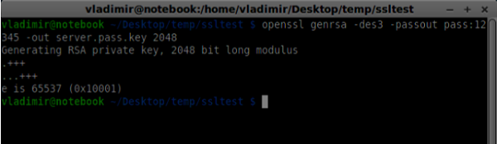

* **Generate a server private key**

openssl rsa -passin pass:12345 -in server.pass.key -out server.key

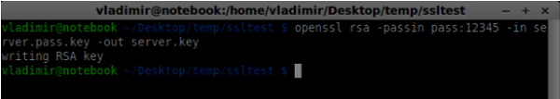

* **Generate a signing request. You will be asked additional questions about your company. Just hit the “Enter” button all the time.**

openssl req -new -key server.key -out server.csr

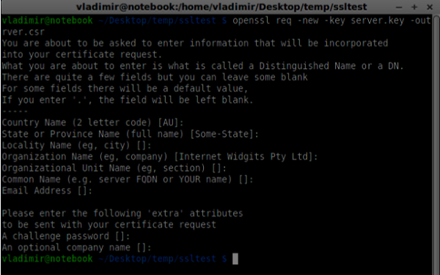

* **Generate the certificate**

openssl x509 -req -days 1095 -in server.csr -signkey server.key -out server.crt

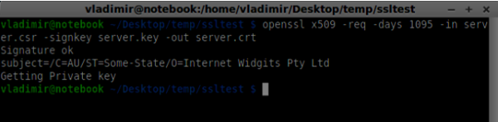

Now you have two files, the certificate (server.crt) and the private key (server.key). Copy them into the signaling server root folder.

To enable the secure socket connection modify our signaling server.

//require file system module

var fs = require('fs');

var httpServ = require('https');

//https://github.com/visionmedia/superagent/issues/205

process.env.NODE_TLS_REJECT_UNAUTHORIZED = "0";

//out secure server will bind to the port 9090

var cfg = {

port: 9090,

ssl_key: 'server.key',

ssl_cert: 'server.crt'

};

//in case of http request just send back "OK"

var processRequest = function(req, res) {

res.writeHead(200);

res.end("OK");

};

//create our server with SSL enabled

var app = httpServ.createServer({

key: fs.readFileSync(cfg.ssl_key),

cert: fs.readFileSync(cfg.ssl_cert)

}, processRequest).listen(cfg.port);

//require our websocket library

var WebSocketServer = require('ws').Server;

//creating a websocket server at port 9090

var wss = new WebSocketServer({server: app});

//all connected to the server users

var users = {};

//require the redis library in Node.js

var redis = require("redis");

//creating the redis client object

var redisClient = redis.createClient();

//when a user connects to our sever

wss.on('connection', function(connection){

//...other code

In the above code, we require the *fs* library to read private key and certificate, create the *cfg* object with the binding port and paths for private key and certificate. Then, we create an HTTPS server with our keys along with WebSocket server on the port 9090.

Now open **https://localhost:9090** in Opera. You should see the following −

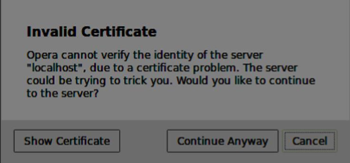

Click the “continue anyway” button. You should see the “OK” message.

To test our secure signaling server, we will modify the chat application we created in the “WebRTC Text Demo” tutorial. We just need to add a password field. The following is the entire *index.html* file −

<html>

<head>

<title>WebRTC Text Demo</title>

<link rel = "stylesheet" href = "node_modules/bootstrap/dist/css/bootstrap.min.css"/>

</head>

<style>

body {

background: #eee;

padding: 5% 0;

}

</style>

<body>

<div id = "loginPage" class = "container text-center">

<div class = "row">

<div class = "col-md-4 col-md-offset-4">

<h2>WebRTC Text Demo. Please sign in</h2>

<label for = "usernameInput" class = "sr-only">Login</label>

<input type = "email" id = "usernameInput"

class = "form-control formgroup" placeholder = "Login"

required = "" autofocus = "">

<input type = "text" id = "passwordInput"

class = "form-control form-group" placeholder = "Password"

required = "" autofocus = "">

<button id = "loginBtn" class = "btn btn-lg btn-primary btnblock"

>Sign in</button>

</div>

</div>

</div>

<div id = "callPage" class = "call-page container">

<div class = "row">

<div class = "col-md-4 col-md-offset-4 text-center">

<div class = "panel panel-primary">

<div class = "panel-heading">Text chat</div>

<div id = "chatarea" class = "panel-body text-left"></div>

</div>

</div>

</div>

<div class = "row text-center form-group">

<div class = "col-md-12">

<input id = "callToUsernameInput" type = "text"

placeholder = "username to call" />

<button id = "callBtn" class = "btn-success btn">Call</button>

<button id = "hangUpBtn" class = "btn-danger btn">Hang Up</button>

</div>

</div>

<div class = "row text-center">

<div class = "col-md-12">

<input id = "msgInput" type = "text" placeholder = "message" />

<button id = "sendMsgBtn" class = "btn-success btn">Send</button>

</div>

</div>

</div>

<script src = "client.js"></script>

</body>

</html>

We also need to enable a secure socket connection in the *client.js* file through this line *var conn = new WebSocket('wss://localhost:9090');*. Notice the *wss*protocol. Then, the login button hander must modified to send password along with username −

loginBtn.addEventListener("click", function (event) {

name = usernameInput.value;

var pwd = passwordInput.value;

if (name.length > 0) {

send({

type: "login",

name: name,

password: pwd

});

}

});

The following is the entire *client.js* file −

//our username

var name;

var connectedUser;

//connecting to our signaling server

var conn = new WebSocket('wss://localhost:9090');

conn.onopen = function () {

console.log("Connected to the signaling server");

};

//when we got a message from a signaling server

conn.onmessage = function (msg) {

console.log("Got message", msg.data);

var data = JSON.parse(msg.data);

switch(data.type) {

case "login":

handleLogin(data.success);

break;

//when somebody wants to call us

case "offer":

handleOffer(data.offer, data.name);

break;

case "answer":

handleAnswer(data.answer);

break;

//when a remote peer sends an ice candidate to us

case "candidate":

handleCandidate(data.candidate);

break;

case "leave":

handleLeave();

break;

default:

break;

}

};

conn.onerror = function (err) {

console.log("Got error", err);

};

//alias for sending JSON encoded messages

function send(message) {

//attach the other peer username to our messages

if (connectedUser) {

message.name = connectedUser;

}

conn.send(JSON.stringify(message));

};

//******

//UI selectors block

//******

var loginPage = document.querySelector('#loginPage');

var usernameInput = document.querySelector('#usernameInput');

var passwordInput = document.querySelector('#passwordInput');

var loginBtn = document.querySelector('#loginBtn');

var callPage = document.querySelector('#callPage');

var callToUsernameInput = document.querySelector('#callToUsernameInput');

var callBtn = document.querySelector('#callBtn');

var hangUpBtn = document.querySelector('#hangUpBtn');

var msgInput = document.querySelector('#msgInput');

var sendMsgBtn = document.querySelector('#sendMsgBtn');

var chatArea = document.querySelector('#chatarea');

var yourConn;

var dataChannel;

callPage.style.display = "none";

// Login when the user clicks the button

loginBtn.addEventListener("click", function (event) {

name = usernameInput.value;

var pwd = passwordInput.value;

if (name.length > 0) {

send({

type: "login",

name: name,

password: pwd

});

}

});

function handleLogin(success) {

if (success === false) {

alert("Ooops...incorrect username or password");

} else {

loginPage.style.display = "none";

callPage.style.display = "block";

//**********************

//Starting a peer connection

//**********************

//using Google public stun server

var configuration = {

"iceServers": [{ "url": "stun:stun2.1.google.com:19302" }]

};

yourConn = new webkitRTCPeerConnection(configuration, {optional: [{RtpDataChannels: true}]});

// Setup ice handling

yourConn.onicecandidate = function (event) {

if (event.candidate) {

send({

type: "candidate",

candidate: event.candidate

});

}

};

//creating data channel

dataChannel = yourConn.createDataChannel("channel1", {reliable:true});

dataChannel.onerror = function (error) {

console.log("Ooops...error:", error);

};

//when we receive a message from the other peer, display it on the screen

dataChannel.onmessage = function (event) {

chatArea.innerHTML += connectedUser + ": " + event.data + "<br />";

};

dataChannel.onclose = function () {

console.log("data channel is closed");

};

}

};

//initiating a call

callBtn.addEventListener("click", function () {

var callToUsername = callToUsernameInput.value;

if (callToUsername.length > 0) {

connectedUser = callToUsername;

// create an offer

yourConn.createOffer(function (offer) {

send({

type: "offer",

offer: offer

});

yourConn.setLocalDescription(offer);

}, function (error) {

alert("Error when creating an offer");

});

}

});

//when somebody sends us an offer

function handleOffer(offer, name) {

connectedUser = name;

yourConn.setRemoteDescription(new RTCSessionDescription(offer));

//create an answer to an offer

yourConn.createAnswer(function (answer) {

yourConn.setLocalDescription(answer);

send({

type: "answer",

answer: answer

});

}, function (error) {

alert("Error when creating an answer");

});

};

//when we got an answer from a remote user

function handleAnswer(answer) {

yourConn.setRemoteDescription(new RTCSessionDescription(answer));

};

//when we got an ice candidate from a remote user

function handleCandidate(candidate) {

yourConn.addIceCandidate(new RTCIceCandidate(candidate));

};

//hang up

hangUpBtn.addEventListener("click", function () {

send({

type: "leave"

});

handleLeave();

});

function handleLeave() {

connectedUser = null;

yourConn.close();

yourConn.onicecandidate = null;

};

//when user clicks the "send message" button

sendMsgBtn.addEventListener("click", function (event) {

var val = msgInput.value;

chatArea.innerHTML += name + ": " + val + "<br />";

//sending a message to a connected peer

dataChannel.send(val);

msgInput.value = "";

});

Now run our secure signaling server via *node server*. Run *node static* inside the modified chat demo folder. Open **localhost:8080** in two browser tabs. Try to log in. Remember only “user1” with “password1” and “user2” with “password2” are allowed to login. Then establish the RTCPeerConnection(call another user) and try to send a message.

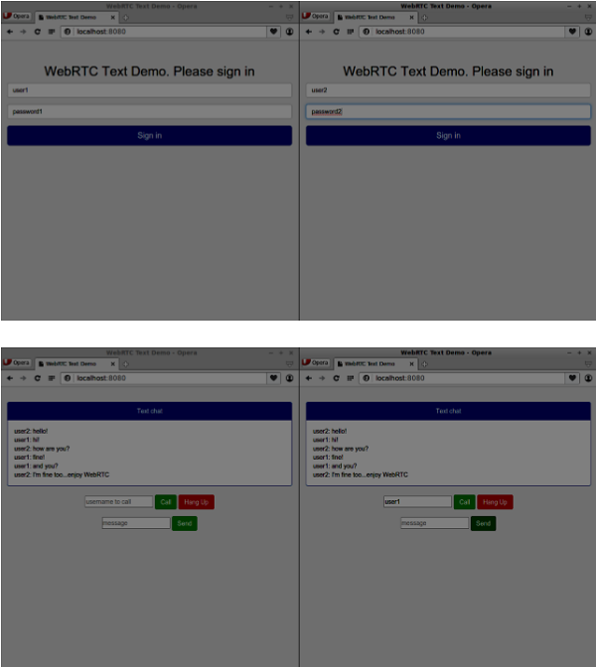

The following is the entire code of our secure signaling server −

//require file system module

var fs = require('fs');

var httpServ = require('https');

//https://github.com/visionmedia/superagent/issues/205

process.env.NODE_TLS_REJECT_UNAUTHORIZED = "0";

//out secure server will bind to the port 9090

var cfg = {

port: 9090,

ssl_key: 'server.key',

ssl_cert: 'server.crt'

};

//in case of http request just send back "OK"

var processRequest = function(req, res){

res.writeHead(200);

res.end("OK");

};

//create our server with SSL enabled

var app = httpServ.createServer({

key: fs.readFileSync(cfg.ssl_key),

cert: fs.readFileSync(cfg.ssl_cert)

}, processRequest).listen(cfg.port);

//require our websocket library

var WebSocketServer = require('ws').Server;

//creating a websocket server at port 9090

var wss = new WebSocketServer({server: app});

//all connected to the server users

var users = {};

//require the redis library in Node.js

var redis = require("redis");

//creating the redis client object

var redisClient = redis.createClient();

//when a user connects to our sever

wss.on('connection', function(connection) {

console.log("user connected");

//when server gets a message from a connected user

connection.on('message', function(message) {

var data;

//accepting only JSON messages

try {

data = JSON.parse(message);

} catch (e) {

console.log("Invalid JSON");

data = {};

}

//check whether a user is authenticated

if(data.type != "login") {

//if user is not authenticated

if(!connection.isAuth) {

sendTo(connection, {

type: "error",

message: "You are not authenticated"

});

return;

}

}

//switching type of the user message

switch (data.type) {

//when a user tries to login

case "login":

console.log("User logged:", data.name);

//get password for this username from redis database

redisClient.get(data.name, function(err, reply) {

//check if password matches with the one stored in redis

var loginSuccess = reply === data.password;

//if anyone is logged in with this username or incorrect password

then refuse

if(users[data.name] || !loginSuccess) {

sendTo(connection, {

type: "login",

success: false

});

} else {

//save user connection on the server

users[data.name] = connection;

connection.name = data.name;

connection.isAuth = true;

sendTo(connection, {

type: "login",

success: true

});

}

});

break;

case "offer":

//for ex. UserA wants to call UserB

console.log("Sending offer to: ", data.name);

//if UserB exists then send him offer details

var conn = users[data.name];

if(conn != null) {

//setting that UserA connected with UserB

connection.otherName = data.name;

sendTo(conn, {

type: "offer",

offer: data.offer,

name: connection.name

});

}

break;

case "answer":

console.log("Sending answer to: ", data.name);

//for ex. UserB answers UserA

var conn = users[data.name];

if(conn != null) {

connection.otherName = data.name;

sendTo(conn, {

type: "answer",

answer: data.answer

});

}

break;

case "candidate":

console.log("Sending candidate to:",data.name);

var conn = users[data.name];

if(conn != null) {

sendTo(conn, {

type: "candidate",

candidate: data.candidate

});

}

break;

case "leave":

console.log("Disconnecting from", data.name);

var conn = users[data.name];

conn.otherName = null;

//notify the other user so he can disconnect his peer connection

if(conn != null) {

sendTo(conn, {

type: "leave"

});

}

break;

connection.on("close", function() {

if(connection.name) {

delete users[connection.name];

if(connection.otherName) {

console.log("Disconnecting from ", connection.otherName);

var conn = users[connection.otherName];

conn.otherName = null;

if(conn != null) {

sendTo(conn, {

type: "leave"

});

}

}

}

});

default:

sendTo(connection, {

type: "error",

message: "Command no found: " + data.type

});

break;

}

});

//when user exits, for example closes a browser window

//this may help if we are still in "offer","answer" or "candidate" state

connection.on("close", function() {

if(connection.name) {

delete users[connection.name];

}

});

connection.send("Hello from server");

});

function sendTo(connection, message) {

connection.send(JSON.stringify(message));

}

Summary

In this chapter, we added user authentication to our signaling server. We also learned how to create self-signed SSL certificates and use them in the scope of WebRTC applications.

# WebRTC - Quick Guide

Advertisements

[Previous Page](https://www.tutorialspoint.com/webrtc/webrtc_security.htm)

[Next Page](https://www.tutorialspoint.com/webrtc/webrtc_useful_resources.htm)

# WebRTC - Overview

The Web is no more a stranger to real-time communication as **WebRTC (Web Real-Time Communication)** comes into play. Although it was released in May 2011, it is still developing and its standards are changing. A set of protocols is standardized by *Real-Time Communication in WEB-browsers Working group* at <http://tools.ietf.org/wg/rtcweb/> of the **IETF (Internet Engineering Task Force)** while new sets of APIs are standardized by the *Web Real-Time Communications Working Groupe* at <http://www.w3.org/2011/04/webrtc/> of the **W3C (World Wide Web Consortium)**. With the appearance of WebRTC, modern web applications can easily stream audio and video content to millions of people.

## **Basic Scheme**

WebRTC allows you to set up peer-to-peer connections to other web browsers quickly and easily. To build such an application from scratch, you would need a wealth of frameworks and libraries dealing with typical issues like data loss, connection dropping, and NAT traversal. With WebRTC, all of this comes built-in into the browser out-of-the-box. This technology doesn't need any plugins or third-party software. It is open-sourced and its source code is freely available at [http://www.webrtc.org/.](http://www.webrtc.org/)

The WebRTC API includes media capture, encoding and decoding audio and video, transportation layer, and session management.



### **Media Capture**

The first step is to get access to the camera and microphone of the user's device. We detect the type of devices available, get user permission to access these devices and manage the stream.

### **Encoding and Decoding Audio and Video**

It is not an easy task to send a stream of audio and video data over the Internet. This is where encoding and decoding are used. This is the process of splitting up video frames and audio waves into smaller chunks and compressing them. This algorithm is called **codec**. There is an enormous amount of different codecs, which are maintained by different companies with different business goals. There are also many codecs inside WebRTC like H.264, iSAC, Opus and VP8. When two browsers connect together, they choose the most optimal supported codec between two users. Fortunately, WebRTC does most of the encoding behind the scenes.

### **Transportation Layer**

The transportation layer manages the order of packets, deal with packet loss and connecting to other users. Again the WebRTC API gives us an easy access to events that tell us when there are issues with the connection.

### **Session Management**

The session management deals with managing, opening and organizing connections. This is commonly called **signaling**. If you transfer audio and video streams to the user it also makes sense to transfer collateral data. This is done by the **RTCDataChannel API**.

Engineers from companies like Google, Mozilla, Opera and others have done a great job to bring this real-time experience to the Web.

## **Browser Compatibility**

The WebRTC standards are one of the fastest evolving on the web, so it doesn't mean that every browser supports all the same features at the same time. To check whether your browser supports WebRTC or not, you may visit [http://caniuse.com/#feat=rtcpeerconnection.](http://caniuse.com/#feat=rtcpeerconnection) Throughout all the tutorials, I recommend you to use Chrome for all the examples.

### **Trying out WebRTC**

Let's get started using WebRTC right now. Navigate your browser to the demo site at <https://apprtc.appspot.com/>



Click the “JOIN” button. You should see a drop-down notification.



Click the “Allow” button to start streaming your video and audio to the web page. You should see a video stream of yourself.



Now open the URL you are currently on in a new browser tab and click on “JOIN”. You should see two video streams − one from your first client and another from the second one.



Now you should understand why WebRTC is a powerful tool.

## **Use Cases**

The real-time web opens the door to a whole new range of applications, including text-based chat, screen and file sharing, gaming, video chat, and more. Besides communication you can use WebRTC for other purposes like −

* real-time marketing
* real-time advertising
* back office communications (CRM, ERP, SCM, FFM)
* HR management
* social networking
* dating services
* online medical consultations
* financial services
* surveillance
* multiplayer games
* live broadcasting
* e-learning

### **Summary**

Now you should have a clear understanding of the term WebRTC. You should also have an idea of what types of applications can be built with WebRTC, as you have already tried it in your browser. To sum up, WebRTC is quite a useful technology.

# WebRTC - Architecture

The overall WebRTC architecture has a great level of complexity.



Here you can find three different layers −

* **API for web developers** − this layer contains all the APIs web developer needed, including RTCPeerConnection, RTCDataChannel, and MediaStrean objects.
* API for browser makers
* Overridable API, which browser makers can hook.

Transport components allow establishing connections across various types of networks while voice and video engines are frameworks responsible for transferring audio and video streams from a sound card and camera to the network. For Web developers, the most important part is WebRTC API.

If we look at the WebRTC architecture from the client-server side we can see that one of the most commonly used models is inspired by the SIP(Session Initiation Protocol) Trapezoid.



In this model, both devices are running a web application from different servers. The RTCPeerConnection object configures streams so they could connect to each other, peer-to-peer. This signaling is done via HTTP or WebSockets.

But the most commonly used model is Triangle −



In this model both devices use the same web application. It gives web developer more flexibility when managing user connections.

## **The WebRTC API**

It consists of a few main javascript objects −

* RTCPeerConnection
* MediaStream
* RTCDataChannel

### **The RTCPeerConnection object**

This object is the main entry point to the WebRTC API. It helps us connect to peers, initialize connections and attach media streams. It also manages a UDP connection with another user.

The main task of the RTCPeerConnection object is to setup and create a peer connection. We can easily hook keys points of the connection because this object fires a set of events when they appear. These events give you access to the configuration of our connection −



The RTCPeerConnection is a simple javascript object, which you can simply create this way −

[code]

var conn = new RTCPeerConnection(conf);

conn.onaddstream = function(stream) {

// use stream here

};

[/code]

The RTCPeerConnection object accepts a *conf* parameter, which we will cover later in these tutorials. The *onaddstream* event is fired when the remote user adds a video or audio stream to their peer connection.

### **MediaStream API**

Modern browsers give a developer access to the *getUserMedia* API, also known as the *MediaStream* API. There are three key points of functionality −

* It gives a developer access to a *stream* object that represent video and audio streams
* It manages the selection of input user devices in case a user has multiple cameras or microphones on his device
* It provides a security level asking user all the time he wants to fetch s stream

To test this API let's create a simple HTML page. It will show a single <video> element, ask the user's permission to use the camera and show a live stream from the camera on the page. Create an *index.html* file and add −

[code]

<html>

<head>

<meta charset = "utf-8">

</head>

<body>

<video autoplay></video>

<script src = "client.js"></script>

</body>

</html>

[/code]

Then add a *client.js* file −

[code]

//checks if the browser supports WebRTC

function hasUserMedia() {

navigator.getUserMedia = navigator.getUserMedia || navigator.webkitGetUserMedia

|| navigator.mozGetUserMedia || navigator.msGetUserMedia;

return !!navigator.getUserMedia;

}

if (hasUserMedia()) {

navigator.getUserMedia = navigator.getUserMedia || navigator.webkitGetUserMedia

|| navigator.mozGetUserMedia || navigator.msGetUserMedia;

//get both video and audio streams from user's camera

navigator.getUserMedia({ video: true, audio: true }, function (stream) {

var video = document.querySelector('video');

//insert stream into the video tag

video.src = window.URL.createObjectURL(stream);

}, function (err) {});

}else {

alert("Error. WebRTC is not supported!");

}

[/code]

Now open the *index.html* and you should see the video stream displaying your face.

But be careful, because WebRTC works only on the server side. If you simply open this page with the browser it won't work. You need to host these files on the Apache or Node servers, or which one you prefer.

### **The RTCDataChannel object**

As well as sending media streams between peers, you may also send additional data using *DataChannel* API. This API is as simple as MediaStream API. The main job is to create a channel coming from an existing RTCPeerConnection object −

[code]

var peerConn = new RTCPeerConnection();

//establishing peer connection

//...

//end of establishing peer connection

var dataChannel = peerConnection.createDataChannel("myChannel", dataChannelOptions);

// here we can start sending direct messages to another peer

[/code]

This is all you needed, just two lines of code. Everything else is done on the browser's internal layer. You can create a channel at any peer connection until the *RTCPeerConnectionobject* is closed.

### **Summary**

You should now have a firm grasp of the WebRTC architecture. We also covered MediaStream, RTCPeerConnection, and RTCDataChannel APIs. The WebRTC API is a moving target, so always keep up with the latest specifications.

# WebRTC - Environment

Before we start building our WebRTC applications, we should set our coding environment. First of all, you should have a text editor or IDE where you can edit HTML and Javascript. There are chances that you have already chosen the preferred one as you are reading this tutorial. As for me, I'm using WebStorm IDE. You can download its trial version at <https://www.jetbrains.com/webstorm/>. I'm also using Linux Mint as my OS of choice.

The other requirement for common WebRTC applications is having a server to host the HTML and Javascript files. The code will not work just by double-clicking on the files because the browser is not allowed to connect to cameras and microphones unless the files are being served by an actual server. This is done obviously due to the security issues.

There are tons of different web servers, but in this tutorial, we are going to use Node.js with node-static −

* Visit <https://nodejs.org/en/> and download the latest Node.js version.
* Unpack it to the /usr/local/nodejs directory.
* Open the /home/YOUR_USERNAME/.profile file and add the following line to the end − *export PATH=$PATH:/usr/local/nodejs/bin*
* The you can restart your computer or run source */home/YOUR_USERNAME/.profile*
* Now the *node* command should be available from the command line. The *npm* command is also available. NMP is the package manager for Node.js. You can learn more at <https://www.npmjs.com/>.
* Open up a terminal and run *sudo npm install -g node-static*. This will install the static web server for Node.js.
* Now navigate to any directory containing the HTML files and run the *static* command inside the directory to start your web server.
* You can navigate to **http://localhost:8080** to see your files.

There is another way to install nodejs. Just run *sudo apt-get install nodejs* in the terminal window.

To test your Node.js installation open up your terminal and run the *node*command. Type a few commands to check how it works −



Node.js runs Javascript files as well as commands typed in the terminal. Create an *index.js* file with the following content −

console.log(“Testing Node.js”);

Then run the *node index* command. You will see the following −



When building our signaling server we will use a WebSockets library for Node.js. To install in run *npm install ws* in the terminal.

For testing our signaling server, we will use the wscat utility. To install it run *npm install -g wscat* in your terminal window.

|  |  |
| --- | --- |
| **S.No** | **Protocols & Description** |
| 1 | [**WebRTC Protocols**](https://www.tutorialspoint.com/webrtc/webrtc_protocols.htm)  WebRTC applications use UDP (User Datagram Protocol) as the transport protocol. Most web applications today are built with the using of the TCP (Transmission Control Protocol) |
| 2 | [**Session Description Protocol**](https://www.tutorialspoint.com/webrtc/webrtc_session_description_protocol.htm)  The SDP is an important part of the WebRTC. It is a protocol that is intended to describe media communication sessions. |
| 3 | [**Finding a Route**](https://www.tutorialspoint.com/webrtc/webrtc_finding_route.htm)  In order to connect to another user, you should find a clear path around your own network and the other user's network. But there are chances that the network you are using has several levels of access control to avoid security issues. |
| 4 | [**Stream Control Transmission Protocol**](https://www.tutorialspoint.com/webrtc/webrtc_sctp.htm)  With the peer connection, we have the ability to send quickly video and audio data. The SCTP protocol is used today to send blob data on top of our currently setup peer connection when using the RTCDataChannel object. |

## **Summary**

In this chapter, we covered several of the technologies that enable peer connections, such as UDP, TCP, STUN, TURN, ICE, and SCTP. You should now have a surface-level understanding of how SDP works and its use cases.

# WebRTC - MediaStream APIs

The MediaStream API was designed to easy access the media streams from local cameras and microphones. The *getUserMedia()* method is the primary way to access local input devices.

The API has a few key points −

* A real-time media stream is represented by a *stream* object in the form of video or audio
* It provides a security level through user permissions asking the user before a web application can start fetching a stream
* The selection of input devices is handled by the MediaStream API (for example, when there are two cameras or microphones connected to the device)

Each MediaStream object includes several MediaStreamTrack objects. They represent video and audio from different input devices.

Each MediaStreamTrack object may include several channels (right and left audio channels). These are the smallest parts defined by the MediaStream API.

There are two ways to output MediaStream objects. First, we can render output into a video or audio element. Secondly, we can send output to the RTCPeerConnection object, which then send it to a remote peer.

## **Using the MediaStream API**

Let's create a simple WebRTC application. It will show a video element on the screen, ask the user permission to use the camera, and show a live video stream in the browser. Create an *index.html* file −

<!DOCTYPE html>

<html lang = "en">

<head>

<meta charset = "utf-8" />

</head>

<body>

<video autoplay></video>

<script src = "client.js"></script>

</body>

</html>

Then create the *client.js file* and add the following;

function hasUserMedia() {

//check if the browser supports the WebRTC

return !!(navigator.getUserMedia || navigator.webkitGetUserMedia ||

navigator.mozGetUserMedia);

}

if (hasUserMedia()) {

navigator.getUserMedia = navigator.getUserMedia || navigator.webkitGetUserMedia

|| navigator.mozGetUserMedia;

//enabling video and audio channels

navigator.getUserMedia({ video: true, audio: true }, function (stream) {

var video = document.querySelector('video');

//inserting our stream to the video tag

video.src = window.URL.createObjectURL(stream);

}, function (err) {});

} else {

alert("WebRTC is not supported");

}

Here we create the *hasUserMedia()* function which checks whether WebRTC is supported or not. Then we access the *getUserMedia* function where the second parameter is a callback that accept the stream coming from the user's device. Then we load our stream into the *video* element using *window.URL.createObjectURL* which creates a URL representing the object given in parameter.

Now refresh your page, click Allow, and you should see your face on the screen.



Remember to run all your scripts using the web server. We have already installed one in the WebRTC Environment Tutorial.

## **MediaStream API**

### **Properties**

* **MediaStream.active (read only)** − Returns true if the MediaStream is active, or false otherwise.
* **MediaStream.ended (read only, deprecated)** − Return true if the ended *event* has been fired on the object, meaning that the stream has been completely read, or false if the end of the stream has not been reached.
* **MediaStream.id (read only)** − A unique identifier for the object.
* **MediaStream.label (read only, deprecated)** − A unique identifier assigned by the user agent.

You can see how the above properties look in my browser −



### **Event Handlers**

* **MediaStream.onactive** − A handler for an *active* event that is fired when a MediaStream object becomes active.
* **MediaStream.onaddtrack** − A handler for an *addtrack* event that is fired when a new *MediaStreamTrack* object is added.
* **MediaStream.onended (deprecated)** − A handler for an *ended*event that is fired when the streaming is terminating.
* **MediaStream.oninactive** − A handler for an *inactive* event that is fired when a *MediaStream* object becomes inactive.
* **MediaStream.onremovetrack** − A handler for a *removetrack* event that is fired when a *MediaStreamTrack* object is removed from it.

### **Methods**

* **MediaStream.addTrack()** − Adds the *MediaStreamTrack* object given as argument to the MediaStream. If the track has already been added, nothing happens.
* **MediaStream.clone()** − Returns a clone of the MediaStream object with a new ID.
* **MediaStream.getAudioTracks()** − Returns a list of the audio *MediaStreamTrack* objects from the *MediaStream* object.
* **MediaStream.getTrackById()** − Returns the track by ID. If the argument is empty or the ID is not found, it returns null. If several tracks have the same ID, it returns the first one.
* **MediaStream.getTracks()** − Returns a list of all *MediaStreamTrack*objects from the *MediaStream* object.
* **MediaStream.getVideoTracks()** − Returns a list of the video *MediaStreamTrack* objects from the *MediaStream* object.
* **MediaStream.removeTrack()** − Removes the *MediaStreamTrack*object given as argument from the MediaStream. If the track has already been removed, nothing happens.

To test the above APIs change change the *index.html* in the following way −

<!DOCTYPE html>

<html lang = "en">

<head>

<meta charset = "utf-8" />

</head>

<body>

<video autoplay></video>

<div><button id = "btnGetAudioTracks">getAudioTracks()

</button></div>

<div><button id = "btnGetTrackById">getTrackById()

</button></div>

<div><button id = "btnGetTracks">getTracks()</button></div>

<div><button id = "btnGetVideoTracks">getVideoTracks()

</button></div>

<div><button id = "btnRemoveAudioTrack">removeTrack() - audio

</button></div>

<div><button id = "btnRemoveVideoTrack">removeTrack() - video

</button></div>

<script src = "client.js"></script>

</body>

</html>

We added a few buttons to try out several MediaStream APIs. Then we should add event handlers for our newly created button. Modify the *client.js* file this way −

var stream;

function hasUserMedia() {

//check if the browser supports the WebRTC

return !!(navigator.getUserMedia || navigator.webkitGetUserMedia ||

navigator.mozGetUserMedia);

}

if (hasUserMedia()) {

navigator.getUserMedia = navigator.getUserMedia || navigator.webkitGetUserMedia

|| navigator.mozGetUserMedia;

//enabling video and audio channels

navigator.getUserMedia({ video: true, audio: true }, function (s) {

stream = s;

var video = document.querySelector('video');

//inserting our stream to the video tag

video.src = window.URL.createObjectURL(stream);

}, function (err) {});

} else {

alert("WebRTC is not supported");

}

btnGetAudioTracks.addEventListener("click", function(){

console.log("getAudioTracks");

console.log(stream.getAudioTracks());

});

btnGetTrackById.addEventListener("click", function(){

console.log("getTrackById");

console.log(stream.getTrackById(stream.getAudioTracks()[0].id));

});

btnGetTracks.addEventListener("click", function(){

console.log("getTracks()");

console.log(stream.getTracks());

});

btnGetVideoTracks.addEventListener("click", function(){

console.log("getVideoTracks()");

console.log(stream.getVideoTracks());

});

btnRemoveAudioTrack.addEventListener("click", function(){

console.log("removeAudioTrack()");

stream.removeTrack(stream.getAudioTracks()[0]);

});

btnRemoveVideoTrack.addEventListener("click", function(){

console.log("removeVideoTrack()");

stream.removeTrack(stream.getVideoTracks()[0]);

});

Now refresh your page. Click on the *getAudioTracks()* button, then click on the *removeTrack() - audio* button. The audio track should now be removed. Then do the same for the video track.



If you click the *getTracks()* button you should see all *MediaStreamTracks* (all connected video and audio inputs). Then click on the *getTrackById()* to get audio MediaStreamTrack.



### **Summary**

In this chapter, we created a simple WebRTC application using the MediaStream API. Now you should have a clear overview of the various MediaStream APIs that make WebRTC work.

# WebRTC - RTCPeerConnection APIs

The RTCPeerConnection API is the core of the peer-to-peer connection between each of the browsers. To create the RTCPeerConnection objects simply write

var pc = RTCPeerConnection(config);

where the *config* argument contains at least on key, iceServers. It is an array of URL objects containing information about STUN and TURN servers, used during the finding of the ICE candidates. You can find a list of available public STUN servers at [code.google.com](https://code.google.com/p/natvpn/source/browse/trunk/stun_server_list)

Depending upon whether you are the caller or the callee the RTCPeerConnection object is used in a slightly different way on each side of the connection.

Here is an example of the user's flow −

* Register the *onicecandidate* handler. It sends any ICE candidates to the other peer, as they are received.
* Register the *onaddstream* handler. It handles the displaying of the video stream once it is received from the remote peer.
* Register the *message* handler. Your signaling server should also have a handler for messages received from the other peer. If the message contains the *RTCSessionDescription* object, it should be added to the *RTCPeerConnection* object using the *setRemoteDescription()* method. If the message contains the *RTCIceCandidate* object, it should be added to the *RTCPeerConnection* object using the *addIceCandidate()*method.
* Utilize *getUserMedia()* to set up your local media stream and add it to the *RTCPeerConnection* object using the *addStream()* method.
* Start offer/answer negotiation process. This is the only step where the caller's flow is different from the callee's one. The caller starts negotiation using the *createOffer()* method and registers a callback that receives the *RTCSessionDescription* object. Then this callback should add this *RTCSessionDescription* object to your *RTCPeerConnection* object using *setLocalDescription()*. And finally, the caller should send this *RTCSessionDescription* to the remote peer using the signaling server. The callee, on the other, registers the same callback, but in the *createAnswer()* method. Notice that the callee flow is initiated only after the offer is received from the caller.

## **RTCPeerConnection API**

### **Properties**

* **RTCPeerConnection.iceConnectionState (read only)** − Returns an RTCIceConnectionState enum that describes the state of the connection. An iceconnectionstatechange event is fired when this value changes. The possible values −
  + **new** − the ICE agent is waiting for remote candidates or gathering addresses
  + **checking** − the ICE agent has remote candidates, but it has not found a connection yet
  + **connected** − the ICE agent has found a usable connection, but is still checking more remote candidate for better connection.
  + **completed** − the ICE agent has found a usable connection and stopped testing remote candidates.
  + **failed** − the ICE agent has checked all the remote candidates but didn't find a match for at least one component.
  + **disconnected** − at least one component is no longer alive.
  + **closed** − the ICE agent is closed.
* **RTCPeerConnection.iceGatheringState (read only)** − Returns a RTCIceGatheringState enum that describes the ICE gathering state for the connection −
  + **new** − the object was just created.
  + **gathering** − the ICE agent is in the process of gathering candidates
  + **complete** the ICE agent has completed gathering.
* **RTCPeerConnection.localDescription (read only)** − Returns an RTCSessionDescription describing the local session. It can be null if it has not yet been set.
* **RTCPeerConnection.peerIdentity (read only)** − Returns an RTCIdentityAssertion. It consists of an idp(domain name) and a name representing the identity of the remote peer.
* **RTCPeerConnection.remoteDescription (read only)** − Return an RTCSessionDescription describing the remote session. It can be null if it has not yet been set.
* **RTCPeerConnection.signalingState (read only)** − Returns an RTCSignalingState enum that describes the signaling state of the local connection. This state describes the SDP offer. A signalingstatechange event is fired when this value changes. The possible values −
  + **stable** − The initial state. There is no SDP offer/answer exchange in progress.
  + **have-local-offer** − the local side of the connection has locally applied a SDP offer.
  + **have-remote-offer** − the remote side of the connection has locally applied a SDP offer.
  + **have-local-pranswer** − a remote SDP offer has been applied, and a SDP pranswer applied locally.
  + **have-remote-pranswer** − a local SDP has been applied, and a SDP pranswer applied remotely.
  + **closed** − the connection is closed.

### **Event Handlers**

Given below are the commonly used Event Handlers of RTCPeerConnection.

### **Methods**

Given below are the commonly used methods of RTCPeerConnection.

## **Establishing a Connection**

Now let's create an example application. Firstly, run the signaling server we created in the “signaling server” tutorial via “node server”.

There will be two text inputs on the page, one for a login and one for a username we want to connect to. Create an *index.html* file and add the following code −

<html lang = "en">

<head>

<meta charset = "utf-8" />

</head>

<body>

<div>

<input type = "text" id = "loginInput" />

<button id = "loginBtn">Login</button>

</div>

<div>

<input type = "text" id = "otherUsernameInput" />

<button id = "connectToOtherUsernameBtn">Establish connection</button>

</div>

<script src = "client2.js"></script>

</body>

</html>

You can see that we've added the text input for a login, the login button, the text input for the other peer username, and the connect-to-him button. Now create a *client.js* file and add the following code −

var connection = new WebSocket('ws://localhost:9090');

var name = "";

var loginInput = document.querySelector('#loginInput');

var loginBtn = document.querySelector('#loginBtn');

var otherUsernameInput = document.querySelector('#otherUsernameInput');

var connectToOtherUsernameBtn = document.querySelector('#connectToOtherUsernameBtn');

var connectedUser, myConnection;

//when a user clicks the login button

loginBtn.addEventListener("click", function(event){

name = loginInput.value;

if(name.length > 0){

send({

type: "login",

name: name

});

}

});

//handle messages from the server

connection.onmessage = function (message) {

console.log("Got message", message.data);

var data = JSON.parse(message.data);

switch(data.type) {

case "login":

onLogin(data.success);

break;

case "offer":

onOffer(data.offer, data.name);

break;

case "answer":

onAnswer(data.answer);

break;

case "candidate":

onCandidate(data.candidate);

break;

default:

break;

}

};

//when a user logs in

function onLogin(success) {

if (success === false) {

alert("oops...try a different username");

} else {

//creating our RTCPeerConnection object

var configuration = {

"iceServers": [{ "url": "stun:stun.1.google.com:19302" }]

};

myConnection = new webkitRTCPeerConnection(configuration);

console.log("RTCPeerConnection object was created");

console.log(myConnection);

//setup ice handling

//when the browser finds an ice candidate we send it to another peer

myConnection.onicecandidate = function (event) {

if (event.candidate) {

send({

type: "candidate",

candidate: event.candidate

});

}

};

}

};

connection.onopen = function () {

console.log("Connected");

};

connection.onerror = function (err) {

console.log("Got error", err);

};

// Alias for sending messages in JSON format

function send(message) {

if (connectedUser) {

message.name = connectedUser;

}

connection.send(JSON.stringify(message));

};

You can see that we establish a socket connection to our signaling server. When a user clicks on the login button the application sends his username to the server. If login is successful the application creates the RTCPeerConnection object and setup onicecandidate handler which sends all found icecandidates to the other peer. Now open the page and try to login. You should see the following console output −



The next step is to create an offer to the other peer. Add the following code to your *client.js* file −

//setup a peer connection with another user

connectToOtherUsernameBtn.addEventListener("click", function () {

var otherUsername = otherUsernameInput.value;

connectedUser = otherUsername;

if (otherUsername.length > 0) {

//make an offer

myConnection.createOffer(function (offer) {

console.log();

send({

type: "offer",

offer: offer

});

myConnection.setLocalDescription(offer);

}, function (error) {

alert("An error has occurred.");

});

}

});

//when somebody wants to call us

function onOffer(offer, name) {

connectedUser = name;

myConnection.setRemoteDescription(new RTCSessionDescription(offer));

myConnection.createAnswer(function (answer) {

myConnection.setLocalDescription(answer);

send({

type: "answer",

answer: answer

});

}, function (error) {

alert("oops...error");

});

}

//when another user answers to our offer

function onAnswer(answer) {

myConnection.setRemoteDescription(new RTCSessionDescription(answer));

}

//when we got ice candidate from another user

function onCandidate(candidate) {

myConnection.addIceCandidate(new RTCIceCandidate(candidate));

}

You can see that when a user clicks the “Establish connection” button the application makes an SDP offer to the other peer. We also set *onAnswer* and *onCandidate* handlers. Reload your page, open it in two tabs, login with two users and try to establish a connection between them. You should see the following console output −



Now the peer-to-peer connection is established. In the next tutorials, we will add video and audio streams as well as text chat support.

# WebRTC - RTCDataChannel APIs

WebRTC is not only good at transferring audio and video streams, but any arbitrary data we might have. This is where the RTCDataChannel object comes into play.

## **RTCDataChannel API**

### **Properties**

* **RTCDataChannel.label (read only)** − Returns a string containing the data channel name.
* **RTCDataChannel.ordered (read only)** − Returns true if the order of delivery of the messages is guaranteed or false if it is not guaranteed.
* **RTCDataChannel.protocol (read only)** − Returns a string containing subprotocol name used for this channel.
* **RTCDataChannel.id (read only)** − Returns a unique id for the channel which is set at the creation of the RTCDataChannel object.
* **RTCDataChannel.readyState (read only)** − Returns the RTCDataChannelState enum representing the state of the connection. The possible values −
  + **connecting** − Indicates that the connection is not yet active. This is the initial state.
  + **open** − Indicates that the connection is running.
  + **closing** − Indicates that the connection is in the process of shutting down. The cached messages are in the process of being sent or received, but no newly created task is accepting.
  + **closed** − Indicates that the connection could not be established or has been shut down.
* **RTCDataChannel.bufferedAmount (read only)** − Returns the amount of bytes that have been queued for sending. This is the amount of data that has not been sent yet via RTCDataChannel.send().
* **RTCDataChannel.bufferedAmountLowThreshold** − Returns the number of bytes at which the RTCDataChannel.bufferedAmount is taken up as low. When the RTCDataChannel.bufferedAmount decreases below this threshold, the bufferedamountlow event is fired.
* **RTCDataChannel.binaryType** − Returns the type of the binary data transmitted by the connection. Can be “blob” or “arraybuffer”.
* **RTCDataChannel.maxPacketLifeType (read only)** − Returns an unsigned short that indicates the length in milliseconds of the window in when messaging is going in unreliable mode.
* **RTCDataChannel.maxRetransmits (read only)** − Returns an unsigned short that indicates the maximum number of times a channel will retransmit data if it is not delivered.
* **RTCDataChannel.negotiated (read only)** − Returns a boolean that indicates if the channel has been negotiated by the user-agent, or by the application.
* **RTCDataChannel.reliable (read only)** − Returns a boolean that indicates of the connection can send messages in unreliable mode.
* **RTCDataChannel.stream (read only)** − Synonym for RTCDataChannel.id

### **Event Handlers**

* **RTCDataChannel.onopen** − This event handler is called when the open event is fired. This event is sent when the data connection has been established.
* **RTCDataChannel.onmessage** − This event handler is called when the message event is fired. The event is sent when a message is available on the data channel.
* **RTCDataChannel.onbufferedamountlow** − This event handler is called when the bufferedamoutlow event is fired. This event is sent when RTCDataChannel.bufferedAmount decreases below the RTCDataChannel.bufferedAmountLowThreshold property.
* **RTCDataChannel.onclose** − This event handler is called when the close event is fired. This event is sent when the data connection has been closed.
* **RTCDataChannel.onerror** − This event handler is called when the error event is fired. This event is sent when an error has been encountered.

### **Methods**

* **RTCDataChannel.close()** − Closes the data channel.
* **RTCDataChannel.send()** − Sends the data in the parameter over the channel. The data can be a blob, a string, an ArrayBuffer or an ArrayBufferView.

# WebRTC - Sending Messages

Now let's create a simple example. Firstly, run the signaling server we created in the “signaling server” tutorial via “node server”.

There will be three text inputs on the page, one for a login, one for a username, and one for the message we want to send to the other peer. Create an *index.html* file and add the following code −

<html lang = "en">

<head>

<meta charset = "utf-8" />

</head>

<body>

<div>

<input type = "text" id = "loginInput" />

<button id = "loginBtn">Login</button>

</div>

<div>

<input type = "text" id = "otherUsernameInput" />

<button id = "connectToOtherUsernameBtn">Establish connection</button>

</div>

<div>

<input type = "text" id = "msgInput" />

<button id = "sendMsgBtn">Send text message</button>

</div>

<script src = "client.js"></script>

</body>

</html>

We've also added three buttons for login, establishing a connection and sending a message. Now create a *client.js* file and add the following code −

var connection = new WebSocket('ws://localhost:9090');

var name = "";

var loginInput = document.querySelector('#loginInput');

var loginBtn = document.querySelector('#loginBtn');

var otherUsernameInput = document.querySelector('#otherUsernameInput');

var connectToOtherUsernameBtn = document.querySelector('#connectToOtherUsernameBtn');

var msgInput = document.querySelector('#msgInput');

var sendMsgBtn = document.querySelector('#sendMsgBtn');

var connectedUser, myConnection, dataChannel;

//when a user clicks the login button

loginBtn.addEventListener("click", function(event) {

name = loginInput.value;

if(name.length > 0) {

send({

type: "login",

name: name

});

}

});

//handle messages from the server

connection.onmessage = function (message) {

console.log("Got message", message.data);

var data = JSON.parse(message.data);

switch(data.type) {

case "login":

onLogin(data.success);

break;

case "offer":

onOffer(data.offer, data.name);

break;

case "answer":

onAnswer(data.answer);

break;

case "candidate":

onCandidate(data.candidate);

break;

default:

break;

}

};

//when a user logs in

function onLogin(success) {

if (success === false) {

alert("oops...try a different username");

} else {

//creating our RTCPeerConnection object

var configuration = {

"iceServers": [{ "url": "stun:stun.1.google.com:19302" }]

};

myConnection = new webkitRTCPeerConnection(configuration, {

optional: [{RtpDataChannels: true}]

});

console.log("RTCPeerConnection object was created");

console.log(myConnection);

//setup ice handling

//when the browser finds an ice candidate we send it to another peer

myConnection.onicecandidate = function (event) {

if (event.candidate) {

send({

type: "candidate",

candidate: event.candidate

});

}

};

openDataChannel();

}

};

connection.onopen = function () {

console.log("Connected");

};

connection.onerror = function (err) {

console.log("Got error", err);

};

// Alias for sending messages in JSON format

function send(message) {

if (connectedUser) {

message.name = connectedUser;

}

connection.send(JSON.stringify(message));

};

You can see that we establish a socket connection to our signaling server. When a user clicks on the login button the application sends his username to the server. If login is successful the application creates the *RTCPeerConnection* object and setup *onicecandidate* handler which sends all found icecandidates to the other peer. It also runs the openDataChannel() function which creates a dataChannel. Notice that when creating the RTCPeerConnection object the second argument in the constructor optional: [{RtpDataChannels: true}] is mandatory if you are using Chrome or Opera. The next step is to create an offer to the other peer. Add the following code to your *client.js* file−

//setup a peer connection with another user

connectToOtherUsernameBtn.addEventListener("click", function () {

var otherUsername = otherUsernameInput.value;

connectedUser = otherUsername;

if (otherUsername.length > 0) {

//make an offer

myConnection.createOffer(function (offer) {

console.log();

send({

type: "offer",

offer: offer

});

myConnection.setLocalDescription(offer);

}, function (error) {

alert("An error has occurred.");

});

}

});

//when somebody wants to call us

function onOffer(offer, name) {

connectedUser = name;

myConnection.setRemoteDescription(new RTCSessionDescription(offer));

myConnection.createAnswer(function (answer) {

myConnection.setLocalDescription(answer);

send({

type: "answer",

answer: answer

});

}, function (error) {

alert("oops...error");

});

}

//when another user answers to our offer

function onAnswer(answer) {

myConnection.setRemoteDescription(new RTCSessionDescription(answer));

}

//when we got ice candidate from another user

function onCandidate(candidate) {

myConnection.addIceCandidate(new RTCIceCandidate(candidate));

}

You can see that when a user clicks the “Establish connection” button the application makes an SDP offer to the other peer. We also set *onAnswer* and *onCandidate* handlers. Finally, let's implement the *openDataChannel()* function which creates our dataChannel. Add the following code to your *client.js* file −

//creating data channel

function openDataChannel() {

var dataChannelOptions = {

reliable:true

};

dataChannel = myConnection.createDataChannel("myDataChannel", dataChannelOptions);

dataChannel.onerror = function (error) {

console.log("Error:", error);

};

dataChannel.onmessage = function (event) {

console.log("Got message:", event.data);

};

}

//when a user clicks the send message button

sendMsgBtn.addEventListener("click", function (event) {

console.log("send message");

var val = msgInput.value;

dataChannel.send(val);

});

Here we create the dataChannel for our connection and add the event handler for the “send message” button. Now open this page in two tabs, login with two users, establish a connection, and try to send messages. You should see them in the console output. Notice that the above example is tested in Opera.



Now you may see that RTCDataChannel is extremely powerful part of the WebRTC API. There are a lot of other use cases for this object, like peer-to-peer gaming or torrent-based file sharing.

# WebRTC - Signaling

Most WebRTC applications are not just being able to communicate through video and audio. They need many other features. In this chapter, we are going to build a basic signaling server.

## **Signaling and Negotiation**

To connect to another user you should know where he is located on the Web. The IP address of your device allows Internet-enabled devices to send data directly between each other. The *RTCPeerConnection* object is responsible for this. As soon as devices know how to find each other over the Internet, they start exchanging data about which protocols and codecs each device supports.

To communicate with another user you simply need to exchange contact information and the rest will be done by WebRTC. The process of connecting to the other user is also known as signaling and negotiation. It consists of a few steps −

* Create a list of potential candidates for a peer connection.
* The user or an application selects a user to make a connection with.
* The signaling layer notifies another user that someone want to connect to him. He can accept or decline.
* The first user is notified of the acceptance of the offer.
* The first user initiates *RTCPeerConnection* with another user.
* Both users exchange software and hardware information through the signaling server.
* Both users exchange location information.
* The connection succeeds or fails.

The WebRTC specification does not contain any standards about exchanging information. So keep in mind that the above is just an example of how signaling may happen. You can use any protocol or technology you like.

## **Building the Server**

The server we are going to build will be able to connect two users together who are not located on the same computer. We will create our own signaling mechanism. Our signaling server will allow one user to call another. Once a user has called another, the server passes the offer, answer, ICE candidates between them and setup a WebRTC connection.



The above diagram is the messaging flow between users when using the signaling server. First of all, each user registers with the server. In our case, this will be a simple string username. Once users have registered, they are able to call each other. User 1 makes an offer with the user identifier he wishes to call. The other user should answers. Finally, ICE candidates are sent between users until they can make a connection.

To create a WebRTC connection clients have to be able to transfer messages without using a WebRTC peer connection. This is where we will use HTML5 WebSockets – a bidirectional socket connection between two endpoints – a web server and a web browser. Now let's start using the WebSocket library. Create the *server.js* file and insert the following code −

//require our websocket library

var WebSocketServer = require('ws').Server;

//creating a websocket server at port 9090

var wss = new WebSocketServer({port: 9090});

//when a user connects to our sever

wss.on('connection', function(connection) {

console.log("user connected");

//when server gets a message from a connected user

connection.on('message', function(message){

console.log("Got message from a user:", message);

});

connection.send("Hello from server");

});

The first line requires the WebSocket library which we have already installed. Then we create a socket server on the port 9090. Next, we listen to the *connection* event. This code will be executed when a user makes a WebSocket connection to the server. We then listen to any messages sent by the user. Finally, we send a response to the connected user saying “Hello from server”.

Now run *node server* and the server should start listening for socket connections.

To test our server, we'll use the *wscat* utility which we also have already installed. This tool helps in connecting directly to the WebSocket server and test out commands. Run our server in one terminal window, then open another and run the *wscat -c ws://localhost:9090* command. You should see the following on the client side −



The server should also log the connected user −



## **User Registration**

In our signaling server, we will use a string-based username for each connection so we know where to send messages. Let's change our *connection*handler a bit −

connection.on('message', function(message) {

var data;

//accepting only JSON messages

try {

data = JSON.parse(message);

} catch (e) {

console.log("Invalid JSON");

data = {};

}

});

This way we accept only JSON messages. Next, we need to store all connected users somewhere. We will use a simple Javascript object for it. Change the top of our file −

//require our websocket library

var WebSocketServer = require('ws').Server;

//creating a websocket server at port 9090

var wss = new WebSocketServer({port: 9090});

//all connected to the server users

var users = {};

We are going to add a *type* field for every message coming from the client. For example if a user wants to login, he sends the *login* type message. Let's define it −

connection.on('message', function(message){

var data;

//accepting only JSON messages

try {

data = JSON.parse(message);

} catch (e) {

console.log("Invalid JSON");

data = {};

}

//switching type of the user message

switch (data.type) {

//when a user tries to login

case "login":

console.log("User logged:", data.name);

//if anyone is logged in with this username then refuse

if(users[data.name]) {

sendTo(connection, {

type: "login",

success: false

});

} else {

//save user connection on the server

users[data.name] = connection;

connection.name = data.name;

sendTo(connection, {

type: "login",

success: true

});

}

break;

default:

sendTo(connection, {

type: "error",

message: "Command no found: " + data.type

});

break;

}

});

If the user sends a message with the *login* type, we −

* Check if anyone has already logged in with this username
* If so, then tell the user that he hasn't successfully logged in
* If no one is using this username, we add username as a key to the connection object.
* If a command is not recognized we send an error.

The following code is a helper function for sending messages to a connection. Add it to the *server.js* file −

function sendTo(connection, message) {

connection.send(JSON.stringify(message));

}

The above function ensures that all our messages are sent in the JSON format.

When the user disconnects we should clean up its connection. We can delete the user when the *close* event is fired. Add the following code to the *connection* handler −

connection.on("close", function() {

if(connection.name) {

delete users[connection.name];

}

});

Now let's test our server with the login command. Keep in mind that all messages must be encoded in the JSON format. Run our server and try to login. You should see something like this −



## **Making a Call**

After successful login the user wants to call another. He should make an *offer*to another user to achieve it. Add the *offer* handler −

case "offer":

//for ex. UserA wants to call UserB

console.log("Sending offer to: ", data.name);

//if UserB exists then send him offer details

var conn = users[data.name];

if(conn != null){

//setting that UserA connected with UserB

connection.otherName = data.name;

sendTo(conn, {

type: "offer",

offer: data.offer,

name: connection.name

});

}

break;

Firstly, we get the *connection* of the user we are trying to call. If it exists we send him *offer* details. We also add *otherName* to the *connection* object. This is made for the simplicity of finding it later.

## **Answering**

Answering to the response has a similar pattern that we used in the *offer*handler. Our server just passes through all messages as *answer* to another user. Add the following code after the *offer* hander −

case "answer":

console.log("Sending answer to: ", data.name);

//for ex. UserB answers UserA

var conn = users[data.name];

if(conn != null) {

connection.otherName = data.name;

sendTo(conn, {

type: "answer",

answer: data.answer

});

}

break;

You can see how this is similar to the *offer* handler. Notice this code follows the *createOffer* and *createAnswer* functions on the *RTCPeerConnection* object.

Now we can test our offer/answer mechanism. Connect two clients at the same time and try to make offer and answer. You should see the following −



In this example, **offer** and **answer** are simple strings, but in a real application they will be filled in with the SDP data.

## **ICE Candidates**

The final part is handling ICE candidate between users. We use the same technique just passing messages between users. The main difference is that candidate messages might happen multiple times per user in any order. Add the *candidate* handler −

case "candidate":

console.log("Sending candidate to:",data.name);

var conn = users[data.name];

if(conn != null) {

sendTo(conn, {

type: "candidate",

candidate: data.candidate

});

}

break;

It should work similarly to the *offer* and *answer* handlers.

## **Leaving the Connection**

To allow our users to disconnect from another user we should implement the hanging up function. It will also tell the server to delete all user references. Add the **leave** handler −

case "leave":

console.log("Disconnecting from", data.name);

var conn = users[data.name];

conn.otherName = null;

//notify the other user so he can disconnect his peer connection

if(conn != null) {

sendTo(conn, {

type: "leave"

});

}

break;

This will also send the other user the *leave* event so he can disconnect his peer connection accordingly. We should also handle the case when a user drops his connection from the signaling server. Let's modify our *close* handler −

connection.on("close", function() {

if(connection.name) {

delete users[connection.name];

if(connection.otherName) {

console.log("Disconnecting from ", connection.otherName);

var conn = users[connection.otherName];

conn.otherName = null;

if(conn != null) {

sendTo(conn, {

type: "leave"

});

}

}

}

});

Now if the connection terminates our users will be disconnected. The *close*event will be fired when a user closes his browser window while we are still in *offer*, *answer* or *candidate* state.

## **Complete Signaling Server**

Here is the entire code of our signaling server −

//require our websocket library

var WebSocketServer = require('ws').Server;

//creating a websocket server at port 9090

var wss = new WebSocketServer({port: 9090});

//all connected to the server users

var users = {};

//when a user connects to our sever

wss.on('connection', function(connection) {

console.log("User connected");

//when server gets a message from a connected user

connection.on('message', function(message) {

var data;

//accepting only JSON messages

try {

data = JSON.parse(message);

} catch (e) {

console.log("Invalid JSON");

data = {};

}

//switching type of the user message

switch (data.type) {

//when a user tries to login

case "login":

console.log("User logged", data.name);

//if anyone is logged in with this username then refuse

if(users[data.name]) {

sendTo(connection, {

type: "login",

success: false

});

} else {

//save user connection on the server

users[data.name] = connection;

connection.name = data.name;

sendTo(connection, {

type: "login",

success: true

});

}

break;

case "offer":

//for ex. UserA wants to call UserB

console.log("Sending offer to: ", data.name);

//if UserB exists then send him offer details

var conn = users[data.name];

if(conn != null) {

//setting that UserA connected with UserB

connection.otherName = data.name;

sendTo(conn, {

type: "offer",

offer: data.offer,

name: connection.name

});

}

break;

case "answer":

console.log("Sending answer to: ", data.name);

//for ex. UserB answers UserA

var conn = users[data.name];

if(conn != null) {

connection.otherName = data.name;

sendTo(conn, {

type: "answer",

answer: data.answer

});

}

break;

case "candidate":

console.log("Sending candidate to:",data.name);

var conn = users[data.name];

if(conn != null) {

sendTo(conn, {

type: "candidate",

candidate: data.candidate

});

}

break;

case "leave":

console.log("Disconnecting from", data.name);

var conn = users[data.name];

conn.otherName = null;

//notify the other user so he can disconnect his peer connection

if(conn != null) {

sendTo(conn, {

type: "leave"

});

}

break;

default:

sendTo(connection, {

type: "error",

message: "Command not found: " + data.type

});

break;

}

});

//when user exits, for example closes a browser window

//this may help if we are still in "offer","answer" or "candidate" state

connection.on("close", function() {

if(connection.name) {

delete users[connection.name];

if(connection.otherName) {

console.log("Disconnecting from ", connection.otherName);

var conn = users[connection.otherName];

conn.otherName = null;

if(conn != null) {

sendTo(conn, {

type: "leave"

});

}

}

}

});

connection.send("Hello world");

});

function sendTo(connection, message) {

connection.send(JSON.stringify(message));

}

So the work is done and our signaling server is ready. Remember that doing things out of order when making a WebRTC connection can cause issues.

## **Summary**

In this chapter, we built simple and straightforward signaling server. We walked through the signaling process, user registration and offer/answer mechanism. We also implemented sending candidates between users.

# WebRTC - Browser Support

The Web is moving so fast and it is always improving. New standards are created every day. Browsers allow updates to be installed without the user ever knowing, so you should keep up with what is going on in the world of the Web and WebRTC. Here is an overview of what this is up to today.

## **Browser Support**

Every browser doesn't have all the same WebRTC features at the same time. Different browsers may be ahead of the curve, which makes some WebRTC features work in one browser and not another. The current support for WebRTC in the browser is shown in the following picture.



You can check an up-to-date WebRTC support status at [http://caniuse.com/#feat=rtcpeerconnection.](http://caniuse.com/#feat=rtcpeerconnection)

### **Chrome, Firefox, and Opera**

The latest versions of Chrome, Firefox, and Opera on mainstream PC operating systems such as Mac OS X, Windows, and Linux, all support WebRTC out-of-the-box. And most importantly, the engineers from Chrome and Firefox developer teams have been working together to fix issues so these two browsers could communicate with each other easily.

### **Android OS**

On Android operating systems, WebRTC applications for Chrome and Firefox should work outof-the-box. They are able to work with other browsers after Android Ice Cream Sandwich version (4.0). This is due to the code sharing between desktop and mobile versions.

### **Apple**

Apple has not yet made any announcement about their plans to support WebRTC in Safari on OS X. One of the possible workarounds for hybrid native iOS applications os to embed the WebRTC code directly into the application and load this app into a WebView.

### **Internet Explorer**

Microsoft doesn't support WebRTC on desktops. But they have officially confirmed that they are going to implement ORTC (Object Realtime Communications) in future versions of IE(Edge). They are not planning to support WebRTC 1.0. They labeled their ORTC as WebRTC 1.1, although it is just a community enhancement and not the official standard. Recently they've added the ORTC support to the latest Microsoft Edge version. You may learn more at [https://blogs.windows.com/msedgedev/2015/09/18/ortc-api-is-now-available-in-microsoftedge/.](https://blogs.windows.com/msedgedev/2015/09/18/ortc-api-is-now-available-in-microsoft-edge/)

### **Summary**

Notice that WebRTC is a collection of APIs and protocols, not a single API. The support for each of these is developing on different browsers and operating systems at a different level. A great way to check the latest level of support is through [http://canisue.com.](http://canisue.com/) It tracks adoption of modern APIs across multiple browsers. You can also find the latest information on browser supports as well as WebRTC demos at [http://www.webrtc.org,](http://www.webrtc.org/) which is supported by Mozilla, Google, and Opera.

# WebRTC - Mobile Support

In the mobile world, the WebRTC support is not on the same level as it is on desktops. Mobile devices have their own way, so WebRTC is also something different on the mobile platforms.



When developing a WebRTC application for desktop, we consider using Chrome, Firefox or Opera. All of them support WebRTC out of the box. In general, you just need a browser and not bother about the desktop's hardware.

In the mobile world there are three possible modes for WebRTC today −

* The native application
* The browser application
* The native browser

## **Android**

In 2013, the Firefox web browser for Android was presented with WebRTC support out of the box. Now you can make video calls on Android devices using the Firefox mobile browser.

It has three main WebRTC components −

* **PeerConnection** − enables calls between browsers
* **getUserMedia** − provides access to the camera and microphone
* **DataChannels** − provides peer-to-peer data transfer

Google Chrome for Android provides WebRTC support as well. As you've already noticed, the most interesting features usually first appear in Chrome.

In the past year, the Opera mobile browser appeared with WebRTC support. So for Android you have Chrome, Firefox, and Opera. Other browsers don't support WebRTC.

## **iOS**

Unfortunately, WebRTC is not supported on iOS now. Although WebRTC works well on Mac when using Firefox, Opera, or Chrome, it is not supported on iOS.

Nowadays, your WebRTC application won't work on Apple mobile devices out of the box. But there is a browser − Bowser. It is a web browser developed by Ericsson and it supports WebRTC out of the box. You can check its homepage at [http://www.openwebrtc.org/bowser/.](http://www.openwebrtc.org/bowser/)

Today, it is the only friendly way to support your WebRTC application on iOS. Another way is to develop a native application yourself.

## **Windows Phones**

Microsoft doesn't support WebRTC on mobile platforms. But they have officially confirmed that they are going to implement ORTC (Object Realtime Communications) in future versions of IE. They are not planning to support WebRTC 1.0. They labeled their ORTC as WebRTC 1.1, although it is just a community enhancement and not the official standard.

So today Window Phone users can't use WebRTC applications and there is no way to beat this situation.

## **Blackberry**

WebRTC applications are not supported on Blackberry either, in any way.

## **Using a WebRTC Native Browser**

The most convenient and comfortable case for users to utilize WebRTC is using the native browser of the device. In this case, the device is ready to work any additional configurations.

Today only Android devices that are version 4 or higher provide this feature. Apple still doesn't show any activity with WebRTC support. So Safari users can't use WebRTC applications. Microsoft also did not introduce it in Windows Phone 8.

## **Using WebRTC via Browser Applications**

This means using a third-party applications (non-native web browsers) in order to provide the WebRTC features. For now, there are two such third-party applications. Bowser, which is the only way to bring WebRTC features to the iOS device and Opera, which is a nice alternative for Android platform. The rest of the available mobile browsers don't support WebRTC.

## **Native Mobile Applications**

As you can see, WebRTC does not have a large support in the mobile world yet. So, one of the possible solutions is to develop a native applications that utilize the WebRTC API. But it is not the better choice because the main WebRTC feature is a cross-platform solution. Anyway, in some cases this is the only way because a native application can utilize device-specific functions or features that are not supported by HTML5 browsers.

## **Constraining Video Stream for Mobile and Desktop Devices**

The first parameter of the *getUserMedia* API expects an object of keys and values telling the browser how to process streams. You can check the full set of constraints at [https://tools.ietf.org/html/draft-alvestrand-constraints-resolution-03.](https://tools.ietf.org/html/draft-alvestrand-constraints-resolution-03) You can setup video aspect ration, frameRate, and other optional parameters.

Supporting mobile devices is one of the biggest pains because mobile devices have limited screen space along with limited resources. You might want the mobile device to only capture a 480x320 resolution or smaller video stream to save power and bandwidth. Using the user agent string in the browser is a good way to test whether the user is on a mobile device or not. Let's see an example. Create the *index.html* file −

<!DOCTYPE html>

<html lang = "en">

<head>

<meta charset = "utf-8" />

</head>

<body>

<video autoplay></video>

<script src = "client.js"></script>

</body>

</html>

Then create the following *client.js* file −

//constraints for desktop browser

var desktopConstraints = {

video: {

mandatory: {

maxWidth:800,

maxHeight:600

}

},

audio: true

};

//constraints for mobile browser

var mobileConstraints = {

video: {

mandatory: {

maxWidth: 480,

maxHeight: 320,

}

},

audio: true

}

//if a user is using a mobile browser

if(/Android|iPhone|iPad/i.test(navigator.userAgent)) {

var constraints = mobileConstraints;

} else {

var constraints = desktopConstraints;

}

function hasUserMedia() {

//check if the browser supports the WebRTC

return !!(navigator.getUserMedia || navigator.webkitGetUserMedia ||

navigator.mozGetUserMedia);

}

if (hasUserMedia()) {

navigator.getUserMedia = navigator.getUserMedia || navigator.webkitGetUserMedia ||

navigator.mozGetUserMedia;

//enabling video and audio channels

navigator.getUserMedia(constraints, function (stream) {

var video = document.querySelector('video');

//inserting our stream to the video tag

video.src = window.URL.createObjectURL(stream);

}, function (err) {});

} else {

alert("WebRTC is not supported");

}

Run the web server using the *static* command and open the page. You should see it is 800x600. Then open this page in a mobile viewport using chrome tools and check the resolution. It should be 480x320.



Constraints are the easiest way to increase the performance of your WebRTC application.

## **Summary**

In this chapter, we learned about the issues that can occur when developing WebRTC applications for mobile devices. We discovered different limitations of supporting the WebRTC API on mobile platforms. We also launched a demo application where we set different constraints for desktop and mobile browsers.

# WebRTC - Video Demo

In this chapter, we are going to build a client application that allows two users on separate devices to communicate using WebRTC. Our application will have two pages. One for login and the other for calling another user.



The two pages will be the *div* tags. Most input is done through simple event handlers.



## **Signaling Server**

To create a WebRTC connection clients have to be able to transfer messages without using a WebRTC peer connection. This is where we will use HTML5 WebSockets − a bidirectional socket connection between two endpoints − a web server and a web browser. Now let's start using the WebSocket library. Create the *server.js* file and insert the following code −

//require our websocket library

var WebSocketServer = require('ws').Server;

//creating a websocket server at port 9090

var wss = new WebSocketServer({port: 9090});

//when a user connects to our sever

wss.on('connection', function(connection) {

console.log("user connected");

//when server gets a message from a connected user

connection.on('message', function(message) {

console.log("Got message from a user:", message);

});

connection.send("Hello from server");

});

The first line requires the WebSocket library which we have already installed. Then we create a socket server on the port 9090. Next, we listen to the *connection* event. This code will be executed when a user makes a WebSocket connection to the server. We then listen to any messages sent by the user. Finally, we send a response to the connected user saying “Hello from server”.

In our signaling server, we will use a string-based username for each connection so we know where to send messages. Let's change our connection *handler* a bit −

connection.on('message', function(message) {

var data;

//accepting only JSON messages

try {

data = JSON.parse(message);

} catch (e) {

console.log("Invalid JSON");

data = {};

}

});

This way we accept only JSON messages. Next, we need to store all connected users somewhere. We will use a simple Javascript object for it. Change the top of our file −

//require our websocket library

var WebSocketServer = require('ws').Server;

//creating a websocket server at port 9090

var wss = new WebSocketServer({port: 9090});

//all connected to the server users

var users = {};

We are going to add a *type* field for every message coming from the client. For example if a user wants to login, he sends the *login* type message. Let's define it −

connection.on('message', function(message) {

var data;

//accepting only JSON messages

try {

data = JSON.parse(message);

} catch (e) {

console.log("Invalid JSON");

data = {};

}

//switching type of the user message

switch (data.type) {

//when a user tries to login

case "login":

console.log("User logged:", data.name);

//if anyone is logged in with this username then refuse

if(users[data.name]) {

sendTo(connection, {

type: "login",

success: false

});

} else {

//save user connection on the server

users[data.name] = connection;

connection.name = data.name;

sendTo(connection, {

type: "login",

success: true

});

}

break;

default:

sendTo(connection, {

type: "error",

message: "Command no found: " + data.type

});

break;

}

});

If the user sends a message with the *login* type, we −

* Check if anyone has already logged in with this username
* If so, then tell the user that he hasn't successfully logged in
* If no one is using this username, we add username as a key to the connection object.
* If a command is not recognized we send an error.

The following code is a helper function for sending messages to a connection. Add it to the *server.js* file −

function sendTo(connection, message) {

connection.send(JSON.stringify(message));

}

When the user disconnects we should clean up its connection. We can delete the user when the *close* event is fired. Add the following code to the *connection* handler −

connection.on("close", function() {

if(connection.name) {

delete users[connection.name];

}

});

After successful login the user wants to call another. He should make an *offer*to another user to achieve it. Add the *offer* handler −

case "offer":

//for ex. UserA wants to call UserB

console.log("Sending offer to: ", data.name);

//if UserB exists then send him offer details

var conn = users[data.name];

if(conn != null) {

//setting that UserA connected with UserB

connection.otherName = data.name;

sendTo(conn, {

type: "offer",

offer: data.offer,

name: connection.name

});

}

break;

Firstly, we get the *connection* of the user we are trying to call. If it exists we send him *offer* details. We also add *otherName* to the *connection* object. This is made for the simplicity of finding it later.

Answering to the response has a similar pattern that we used in the *offer*handler. Our server just passes through all messages as *answer* to another user. Add the following code after the *offer* handler −

case "answer":

console.log("Sending answer to: ", data.name);

//for ex. UserB answers UserA

var conn = users[data.name];

if(conn != null) {

connection.otherName = data.name;

sendTo(conn, {

type: "answer",

answer: data.answer

});

}

break;

The final part is handling ICE candidate between users. We use the same technique just passing messages between users. The main difference is that candidate messages might happen multiple times per user in any order. Add the *candidate* handler −

case "candidate":

console.log("Sending candidate to:",data.name);

var conn = users[data.name];

if(conn != null) {

sendTo(conn, {

type: "candidate",

candidate: data.candidate

});

}

break;

To allow our users to disconnect from another user we should implement the hanging up function. It will also tell the server to delete all user references. Add the *leave* handler −

case "leave":

console.log("Disconnecting from", data.name);

var conn = users[data.name];

conn.otherName = null;

//notify the other user so he can disconnect his peer connection

if(conn != null) {

sendTo(conn, {

type: "leave"

});

}

break;

This will also send the other user the *leave* event so he can disconnect his peer connection accordingly. We should also handle the case when a user drops his connection from the signaling server. Let's modify our *close* handler −

connection.on("close", function() {

if(connection.name) {

delete users[connection.name];

if(connection.otherName) {

console.log("Disconnecting from ", connection.otherName);

var conn = users[connection.otherName];

conn.otherName = null;

if(conn != null) {

sendTo(conn, {

type: "leave"

});

}

}

}

});

The following is the entire code of our signaling server −

//require our websocket library

var WebSocketServer = require('ws').Server;

//creating a websocket server at port 9090

var wss = new WebSocketServer({port: 9090});

//all connected to the server users

var users = {};

//when a user connects to our sever

wss.on('connection', function(connection) {

console.log("User connected");

//when server gets a message from a connected user

connection.on('message', function(message) {

var data;

//accepting only JSON messages

try {

data = JSON.parse(message);

} catch (e) {

console.log("Invalid JSON");

data = {};

}

//switching type of the user message

switch (data.type) {

//when a user tries to login

case "login":

console.log("User logged", data.name);

//if anyone is logged in with this username then refuse

if(users[data.name]) {

sendTo(connection, {

type: "login",

success: false

});

} else {

//save user connection on the server

users[data.name] = connection;

connection.name = data.name;

sendTo(connection, {

type: "login",

success: true

});

}

break;

case "offer":

//for ex. UserA wants to call UserB

console.log("Sending offer to: ", data.name);

//if UserB exists then send him offer details

var conn = users[data.name];

if(conn != null) {

//setting that UserA connected with UserB

connection.otherName = data.name;

sendTo(conn, {

type: "offer",

offer: data.offer,

name: connection.name

});

}

break;

case "answer":

console.log("Sending answer to: ", data.name);

//for ex. UserB answers UserA

var conn = users[data.name];

if(conn != null) {

connection.otherName = data.name;

sendTo(conn, {

type: "answer",

answer: data.answer

});

}

break;

case "candidate":

console.log("Sending candidate to:",data.name);

var conn = users[data.name];

if(conn != null) {

sendTo(conn, {

type: "candidate",

candidate: data.candidate

});

}

break;

case "leave":

console.log("Disconnecting from", data.name);

var conn = users[data.name];

conn.otherName = null;

//notify the other user so he can disconnect his peer connection

if(conn != null) {

sendTo(conn, {

type: "leave"

});

}

break;

default:

sendTo(connection, {

type: "error",

message: "Command not found: " + data.type

});

break;

}

});

//when user exits, for example closes a browser window

//this may help if we are still in "offer","answer" or "candidate" state

connection.on("close", function() {

if(connection.name) {

delete users[connection.name];

if(connection.otherName) {

console.log("Disconnecting from ", connection.otherName);

var conn = users[connection.otherName];

conn.otherName = null;

if(conn != null) {

sendTo(conn, {

type: "leave"

});

}

}

}

});

connection.send("Hello world");

});

function sendTo(connection, message) {

connection.send(JSON.stringify(message));

}

## **Client Application**

One way to test this application is opening two browser tabs and trying to call each other.

First of all, we need to install the *bootstrap* library. Bootstrap is a frontend framework for developing web applications. You can learn more at [http://getbootstrap.com/.](http://getbootstrap.com/) Create a folder called, for example, “videochat”. This will be our root application folder. Inside this folder create a file *package.json* (it is necessary for managing npm dependencies) and add the following −

{

"name": "webrtc-videochat",

"version": "0.1.0",

"description": "webrtc-videochat",

"author": "Author",

"license": "BSD-2-Clause"

}

Then run *npm install bootstrap*. This will install the bootstrap library in the *videochat/node_modules* folder.

Now we need to create a basic HTML page. Create an *index.html* file in the root folder with the following code −

<html>

<head>

<title>WebRTC Video Demo</title>

<link rel = "stylesheet" href = "node_modules/bootstrap/dist/css/bootstrap.min.css"/>

</head>

<style>

body {

background: #eee;

padding: 5% 0;

}

video {

background: black;

border: 1px solid gray;

}

.call-page {

position: relative;

display: block;

margin: 0 auto;

width: 500px;

height: 500px;

}

#localVideo {

width: 150px;

height: 150px;

position: absolute;

top: 15px;

right: 15px;

}

#remoteVideo {

width: 500px;

height: 500px;

}

</style>

<body>

<div id = "loginPage" class = "container text-center">

<div class = "row">

<div class = "col-md-4 col-md-offset-4">

<h2>WebRTC Video Demo. Please sign in</h2>

<label for = "usernameInput" class = "sr-only">Login</label>

<input type = "email" id = "usernameInput" c

lass = "form-control formgroup" placeholder = "Login"

required = "" autofocus = "">

<button id = "loginBtn" class = "btn btn-lg btn-primary btnblock">

Sign in</button>

</div>

</div>

</div>

<div id = "callPage" class = "call-page">

<video id = "localVideo" autoplay></video>

<video id = "remoteVideo" autoplay></video>

<div class = "row text-center">

<div class = "col-md-12">

<input id = "callToUsernameInput" type = "text"

placeholder = "username to call" />

<button id = "callBtn" class = "btn-success btn">Call</button>

<button id = "hangUpBtn" class = "btn-danger btn">Hang Up</button>

</div>

</div>

</div>

<script src = "client.js"></script>

</body>

</html>

This page should be familiar to you. We have added the *bootstrap* css file. We have also defined two pages. Finally, we have created several text fields and buttons for getting information from the user. You should see the two video elements for local and remote video streams. Notice that we have added a link to a *client.js* file.

Now we need to establish a connection with our signaling server. Create the *client.js* file in the root folder with the following code −

//our username

var name;

var connectedUser;

//connecting to our signaling server

var conn = new WebSocket('ws://localhost:9090');

conn.onopen = function () {

console.log("Connected to the signaling server");

};

//when we got a message from a signaling server

conn.onmessage = function (msg) {

console.log("Got message", msg.data);

var data = JSON.parse(msg.data);

switch(data.type) {

case "login":

handleLogin(data.success);

break;

//when somebody wants to call us

case "offer":

handleOffer(data.offer, data.name);

break;

case "answer":

handleAnswer(data.answer);

break;

//when a remote peer sends an ice candidate to us

case "candidate":

handleCandidate(data.candidate);

break;

case "leave":

handleLeave();

break;

default:

break;

}

};

conn.onerror = function (err) {

console.log("Got error", err);

};

//alias for sending JSON encoded messages

function send(message) {

//attach the other peer username to our messages

if (connectedUser) {

message.name = connectedUser;

}

conn.send(JSON.stringify(message));

};

Now run our signaling server via *node server*. Then, inside the root folder run the *static* command and open the page inside the browser. You should see the following console output −



The next step is implementing a user log in with a unique username. We simply send a username to the server, which then tell us whether it is taken or not. Add the following code to your *client.js* file −

//******

//UI selectors block

//******

var loginPage = document.querySelector('#loginPage');

var usernameInput = document.querySelector('#usernameInput');

var loginBtn = document.querySelector('#loginBtn');

var callPage = document.querySelector('#callPage');

var callToUsernameInput = document.querySelector('#callToUsernameInput');

var callBtn = document.querySelector('#callBtn');

var hangUpBtn = document.querySelector('#hangUpBtn');

//hide call page

callPage.style.display = "none";

// Login when the user clicks the button

loginBtn.addEventListener("click", function (event) {

name = usernameInput.value;

if (name.length > 0) {

send({

type: "login",

name: name

});

}

});

function handleLogin(success) {

if (success === false) {

alert("Ooops...try a different username");

} else {

//display the call page if login is successful

loginPage.style.display = "none";

callPage.style.display = "block";

//start peer connection

}

};

Firstly, we select some references to the elements on the page. The we hide the call page. Then, we add an event listener on the login button. When the user clicks it, we send his username to the server. Finally, we implement the handleLogin callback. If the login was successful, we show the call page and starting to set up a peer connection.

To start a peer connection we need −

* Obtain a stream from the web camera.
* Create the RTCPeerConnection object.

Add the following code to the “UI selectors block” −

var localVideo = document.querySelector('#localVideo');

var remoteVideo = document.querySelector('#remoteVideo');

var yourConn;

var stream;

Modify the *handleLogin* function −

function handleLogin(success) {

if (success === false) {

alert("Ooops...try a different username");

} else {

loginPage.style.display = "none";

callPage.style.display = "block";

//**********************

//Starting a peer connection

//**********************

//getting local video stream

navigator.webkitGetUserMedia({ video: true, audio: true }, function (myStream) {

stream = myStream;

//displaying local video stream on the page

localVideo.src = window.URL.createObjectURL(stream);

//using Google public stun server

var configuration = {

"iceServers": [{ "url": "stun:stun2.1.google.com:19302" }]

};

yourConn = new webkitRTCPeerConnection(configuration);

// setup stream listening

yourConn.addStream(stream);

//when a remote user adds stream to the peer connection, we display it

yourConn.onaddstream = function (e) {

remoteVideo.src = window.URL.createObjectURL(e.stream);

};

// Setup ice handling

yourConn.onicecandidate = function (event) {

if (event.candidate) {

send({

type: "candidate",

candidate: event.candidate

});

}

};

}, function (error) {

console.log(error);

});

}

};

Now if you run the code, the page should allow you to log in and display your local video stream on the page.



Now we are ready to initiate a call. Firstly, we send an *offer* to another user. Once a user gets the offer, he creates an *answer* and start trading ICE candidates. Add the following code to the *client.js* file −

//initiating a call

callBtn.addEventListener("click", function () {

var callToUsername = callToUsernameInput.value;

if (callToUsername.length > 0) {

connectedUser = callToUsername;

// create an offer

yourConn.createOffer(function (offer) {

send({

type: "offer",

offer: offer

});

yourConn.setLocalDescription(offer);

}, function (error) {

alert("Error when creating an offer");

});

}

});

//when somebody sends us an offer

function handleOffer(offer, name) {

connectedUser = name;

yourConn.setRemoteDescription(new RTCSessionDescription(offer));

//create an answer to an offer

yourConn.createAnswer(function (answer) {

yourConn.setLocalDescription(answer);

send({

type: "answer",

answer: answer

});

}, function (error) {

alert("Error when creating an answer");

});

};

//when we got an answer from a remote user

function handleAnswer(answer) {

yourConn.setRemoteDescription(new RTCSessionDescription(answer));

};

//when we got an ice candidate from a remote user

function handleCandidate(candidate) {

yourConn.addIceCandidate(new RTCIceCandidate(candidate));

};

We add a *click* handler to the Call button, which initiates an offer. Then we implement several handlers expected by the *onmessage* handler. They will be processed asynchronously until both the users have made a connection.

The last step is implementing the hang-up feature. This will stop transmitting data and tell the other user to close the call. Add the following code −

//hang up

hangUpBtn.addEventListener("click", function () {

send({

type: "leave"

});

handleLeave();

});

function handleLeave() {

connectedUser = null;

remoteVideo.src = null;

yourConn.close();

yourConn.onicecandidate = null;

yourConn.onaddstream = null;

};

When the user clicks on the Hang Up button −

* It will send a “leave” message to the other user
* It will close the RTCPeerConnection and destroy the connection locally

Now run the code. You should be able to log in to the server using two browser tabs. You can then call the tab and hang up the call.



The following is the entire *client.js* file −

//our username

var name;

var connectedUser;

//connecting to our signaling server

var conn = new WebSocket('ws://localhost:9090');

conn.onopen = function () {

console.log("Connected to the signaling server");

};

//when we got a message from a signaling server

conn.onmessage = function (msg) {

console.log("Got message", msg.data);

var data = JSON.parse(msg.data);

switch(data.type) {

case "login":

handleLogin(data.success);

break;

//when somebody wants to call us

case "offer":

handleOffer(data.offer, data.name);

break;

case "answer":

handleAnswer(data.answer);

break;

//when a remote peer sends an ice candidate to us

case "candidate":

handleCandidate(data.candidate);

break;

case "leave":

handleLeave();

break;

default:

break;

}

};

conn.onerror = function (err) {

console.log("Got error", err);

};

//alias for sending JSON encoded messages

function send(message) {

//attach the other peer username to our messages

if (connectedUser) {

message.name = connectedUser;

}

conn.send(JSON.stringify(message));

};

//******

//UI selectors block

//******

var loginPage = document.querySelector('#loginPage');

var usernameInput = document.querySelector('#usernameInput');

var loginBtn = document.querySelector('#loginBtn');

var callPage = document.querySelector('#callPage');

var callToUsernameInput = document.querySelector('#callToUsernameInput');

var callBtn = document.querySelector('#callBtn');

var hangUpBtn = document.querySelector('#hangUpBtn');

var localVideo = document.querySelector('#localVideo');

var remoteVideo = document.querySelector('#remoteVideo');

var yourConn;

var stream;

callPage.style.display = "none";

// Login when the user clicks the button

loginBtn.addEventListener("click", function (event) {

name = usernameInput.value;

if (name.length > 0) {

send({

type: "login",

name: name

});

}

});

function handleLogin(success) {

if (success === false) {

alert("Ooops...try a different username");

} else {

loginPage.style.display = "none";

callPage.style.display = "block";

//**********************

//Starting a peer connection

//**********************

//getting local video stream

navigator.webkitGetUserMedia({ video: true, audio: true }, function (myStream) {

stream = myStream;

//displaying local video stream on the page

localVideo.src = window.URL.createObjectURL(stream);

//using Google public stun server

var configuration = {

"iceServers": [{ "url": "stun:stun2.1.google.com:19302" }]

};

yourConn = new webkitRTCPeerConnection(configuration);

// setup stream listening

yourConn.addStream(stream);

//when a remote user adds stream to the peer connection, we display it

yourConn.onaddstream = function (e) {

remoteVideo.src = window.URL.createObjectURL(e.stream);

};

// Setup ice handling

yourConn.onicecandidate = function (event) {

if (event.candidate) {

send({

type: "candidate",

candidate: event.candidate

});

}

};

}, function (error) {

console.log(error);

});

}

};

//initiating a call

callBtn.addEventListener("click", function () {

var callToUsername = callToUsernameInput.value;

if (callToUsername.length > 0) {

connectedUser = callToUsername;

// create an offer

yourConn.createOffer(function (offer) {

send({

type: "offer",

offer: offer

});

yourConn.setLocalDescription(offer);

}, function (error) {

alert("Error when creating an offer");

});

}

});

//when somebody sends us an offer

function handleOffer(offer, name) {

connectedUser = name;

yourConn.setRemoteDescription(new RTCSessionDescription(offer));

//create an answer to an offer

yourConn.createAnswer(function (answer) {

yourConn.setLocalDescription(answer);

send({

type: "answer",

answer: answer

});

}, function (error) {

alert("Error when creating an answer");

});

};

//when we got an answer from a remote user

function handleAnswer(answer) {

yourConn.setRemoteDescription(new RTCSessionDescription(answer));

};

//when we got an ice candidate from a remote user

function handleCandidate(candidate) {

yourConn.addIceCandidate(new RTCIceCandidate(candidate));

};

//hang up

hangUpBtn.addEventListener("click", function () {

send({

type: "leave"

});

handleLeave();

});

function handleLeave() {

connectedUser = null;

remoteVideo.src = null;

yourConn.close();

yourConn.onicecandidate = null;

yourConn.onaddstream = null;

};

## **Summary**

This demo provides a baseline of features that every WebRTC application needs. To improve this demo you can add user identification through platforms like Facebook or Google, handle user input for invalid data. Also, the WebRTC connection can fail because of several reasons like not supporting the technology or not being able to traverse firewalls. A worth of work has gone into making any WebRTC application stable.

# WebRTC - Voice Demo

In this chapter, we are going to build a client application that allows two users on separate devices to communicate using WebRTC audio streams. Our application will have two pages. One for login and the other for making an audio call to another user.



The two pages will be the *div* tags. Most input is done through simple event handlers.

## **Signaling Server**

To create a WebRTC connection clients have to be able to transfer messages without using a WebRTC peer connection. This is where we will use HTML5 WebSockets − a bidirectional socket connection between two endpoints − a web server and a web browser. Now let's start using the WebSocket library. Create the *server.js* file and insert the following code −

//require our websocket library

var WebSocketServer = require('ws').Server;

//creating a websocket server at port 9090

var wss = new WebSocketServer({port: 9090});

//when a user connects to our sever

wss.on('connection', function(connection) {

console.log("user connected");

//when server gets a message from a connected user

connection.on('message', function(message) {

console.log("Got message from a user:", message);

});

connection.send("Hello from server");

});

The first line requires the WebSocket library which we have already installed. Then we create a socket server on the port 9090. Next, we listen to the *connection* event. This code will be executed when a user makes a WebSocket connection to the server. We then listen to any messages sent by the user. Finally, we send a response to the connected user saying “Hello from server”.

In our signaling server, we will use a string-based username for each connection so we know where to send messages. Let's change our *connection*handler a bit −

connection.on('message', function(message) {

var data;

//accepting only JSON messages

try {

data = JSON.parse(message);

} catch (e) {

console.log("Invalid JSON");

data = {};

}

});

This way we accept only JSON messages. Next, we need to store all connected users somewhere. We will use a simple Javascript object for it. Change the top of our file −

//require our websocket library

var WebSocketServer = require('ws').Server;

//creating a websocket server at port 9090

var wss = new WebSocketServer({port: 9090});

//all connected to the server users

var users = {};

We are going to add a *type* field for every message coming from the client. For example if a user wants to login, he sends the *login* type message. Let's define it −

connection.on('message', function(message) {

var data;

//accepting only JSON messages

try {

data = JSON.parse(message);

} catch (e) {

console.log("Invalid JSON");

data = {};

}

//switching type of the user message

switch (data.type) {

//when a user tries to login

case "login":

console.log("User logged:", data.name);

//if anyone is logged in with this username then refuse

if(users[data.name]) {

sendTo(connection, {

type: "login",

success: false

});

} else {

//save user connection on the server

users[data.name] = connection;

connection.name = data.name;

sendTo(connection, {

type: "login",

success: true

});

}

break;

default:

sendTo(connection, {

type: "error",

message: "Command no found: " + data.type

});

break;

}

});

If the user sends a message with the *login* type, we −

* Check if anyone has already logged in with this username.
* If so, then tell the user that he hasn't successfully logged in.
* If no one is using this username, we add username as a key to the connection object.
* If a command is not recognized we send an error.

The following code is a helper function for sending messages to a connection. Add it to the *server.js* file −

function sendTo(connection, message) {

connection.send(JSON.stringify(message));

}

When the user disconnects we should clean up its connection. We can delete the user when the *close* event is fired. Add the following code to the *connection* handler−

connection.on("close", function() {

if(connection.name) {

delete users[connection.name];

}

});

After successful login the user wants to call another. He should make an *offer*to another user to achieve it. Add the *offer* handler −

case "offer":

//for ex. UserA wants to call UserB

console.log("Sending offer to: ", data.name);

//if UserB exists then send him offer details

var conn = users[data.name];

if(conn != null) {

//setting that UserA connected with UserB

connection.otherName = data.name;

sendTo(conn, {

type: "offer",

offer: data.offer,

name: connection.name

});

}

break;

Firstly, we get the *connection* of the user we are trying to call. If it exists we send him *offer* details. We also add *otherName* to the *connection* object. This is made for the simplicity of finding it later.

Answering to the response has a similar pattern that we used in the *offer*handler. Our server just passes through all messages as *answer* to another user. Add the following code after the *offer* handler −

case "answer":

console.log("Sending answer to: ", data.name);

//for ex. UserB answers UserA

var conn = users[data.name];

if(conn != null) {

connection.otherName = data.name;

sendTo(conn, {

type: "answer",

answer: data.answer

});

}

break;

The final part is handling ICE candidate between users. We use the same technique just passing messages between users. The main difference is that candidate messages might happen multiple times per user in any order. Add the *candidate* handler −

case "candidate":

console.log("Sending candidate to:",data.name);

var conn = users[data.name];

if(conn != null) {

sendTo(conn, {

type: "candidate",

candidate: data.candidate

});

}

break;

To allow our users to disconnect from another user we should implement the hanging up function. It will also tell the server to delete all user references. Add the *leave* handler −

case "leave":

console.log("Disconnecting from", data.name);

var conn = users[data.name];

conn.otherName = null;

//notify the other user so he can disconnect his peer connection

if(conn != null) {

sendTo(conn, {

type: "leave"

});

}

break;

This will also send the other user the *leave* event so he can disconnect his peer connection accordingly. We should also handle the case when a user drops his connection from the signaling server. Let's modify our *close* handler −

connection.on("close", function() {

if(connection.name) {

delete users[connection.name];

if(connection.otherName) {

console.log("Disconnecting from ", connection.otherName);

var conn = users[connection.otherName];

conn.otherName = null;

if(conn != null) {

sendTo(conn, {

type: "leave"

});

}

}

}

});

The following is the entire code of our signaling server −

//require our websocket library

var WebSocketServer = require('ws').Server;

//creating a websocket server at port 9090

var wss = new WebSocketServer({port: 9090});

//all connected to the server users

var users = {};

//when a user connects to our sever

wss.on('connection', function(connection) {

console.log("User connected");

//when server gets a message from a connected user

connection.on('message', function(message) {

var data;

//accepting only JSON messages

try {

data = JSON.parse(message);

} catch (e) {

console.log("Invalid JSON");

data = {};

}

//switching type of the user message

switch (data.type) {

//when a user tries to login

case "login":

console.log("User logged", data.name);

//if anyone is logged in with this username then refuse

if(users[data.name]) {

sendTo(connection, {

type: "login",

success: false

});

} else {

//save user connection on the server

users[data.name] = connection;

connection.name = data.name;

sendTo(connection, {

type: "login",

success: true

});

}

break;

case "offer":

//for ex. UserA wants to call UserB

console.log("Sending offer to: ", data.name);

//if UserB exists then send him offer details

var conn = users[data.name];

if(conn != null) {

//setting that UserA connected with UserB

connection.otherName = data.name;

sendTo(conn, {

type: "offer",

offer: data.offer,

name: connection.name

});

}

break;

case "answer":

console.log("Sending answer to: ", data.name);

//for ex. UserB answers UserA

var conn = users[data.name];

if(conn != null) {

connection.otherName = data.name;

sendTo(conn, {

type: "answer",

answer: data.answer

});

}

break;

case "candidate":

console.log("Sending candidate to:",data.name);

var conn = users[data.name];

if(conn != null) {

sendTo(conn, {

type: "candidate",

candidate: data.candidate

});

}

break;

case "leave":

console.log("Disconnecting from", data.name);

var conn = users[data.name];

conn.otherName = null;

//notify the other user so he can disconnect his peer connection

if(conn != null) {

sendTo(conn, {

type: "leave"

});

}

break;

default:

sendTo(connection, {

type: "error",

message: "Command not found: " + data.type

});

break;

}

});

//when user exits, for example closes a browser window

//this may help if we are still in "offer","answer" or "candidate" state

connection.on("close", function() {

if(connection.name) {

delete users[connection.name];

if(connection.otherName) {

console.log("Disconnecting from ", connection.otherName);

var conn = users[connection.otherName];

conn.otherName = null;

if(conn != null) {

sendTo(conn, {

type: "leave"

});

}

}

}

});

connection.send("Hello world");

});

function sendTo(connection, message) {

connection.send(JSON.stringify(message));

}

## **Client Application**

One way to test this application is opening two browser tabs and trying to make an audio call to each other.

First of all, we need to install the *bootstrap* library. Bootstrap is a frontend framework for developing web applications. You can learn more at [http://getbootstrap.com/.](http://getbootstrap.com/) Create a folder called, for example, “audiochat”. This will be our root application folder. Inside this folder create a file *package.json* (it is necessary for managing npm dependencies) and add the following −

{

"name": "webrtc-audiochat",

"version": "0.1.0",

"description": "webrtc-audiochat",

"author": "Author",

"license": "BSD-2-Clause"

}

Then run *npm install bootstrap*. This will install the bootstrap library in the *audiochat/node_modules* folder.

Now we need to create a basic HTML page. Create an *index.html* file in the root folder with the following code −

<html>

<head>

<title>WebRTC Voice Demo</title>

<link rel = "stylesheet" href = "node_modules/bootstrap/dist/css/bootstrap.min.css"/>

</head>

<style>

body {

background: #eee;

padding: 5% 0;

}

</style>

<body>

<div id = "loginPage" class = "container text-center">

<div class = "row">

<div class = "col-md-4 col-md-offset-4">

<h2>WebRTC Voice Demo. Please sign in</h2>

<label for = "usernameInput" class = "sr-only">Login</label>

<input type = "email" id = "usernameInput"

class = "form-control formgroup"

placeholder = "Login" required = "" autofocus = "">

<button id = "loginBtn" class = "btn btn-lg btn-primary btnblock">

Sign in</button>

</div>

</div>

</div>

<div id = "callPage" class = "call-page">

<div class = "row">

<div class = "col-md-6 text-right">

Local audio: <audio id = "localAudio"

controls autoplay></audio>

</div>

<div class = "col-md-6 text-left">

Remote audio: <audio id = "remoteAudio"

controls autoplay></audio>

</div>

</div>

<div class = "row text-center">

<div class = "col-md-12">

<input id = "callToUsernameInput"

type = "text" placeholder = "username to call" />

<button id = "callBtn" class = "btn-success btn">Call</button>

<button id = "hangUpBtn" class = "btn-danger btn">Hang Up</button>

</div>

</div>

</div>

<script src = "client.js"></script>

</body>

</html>

This page should be familiar to you. We have added the *bootstrap* css file. We have also defined two pages. Finally, we have created several text fields and buttons for getting information from the user. You should see the two audio elements for local and remote audio streams. Notice that we have added a link to a *client.js* file.

Now we need to establish a connection with our signaling server. Create the *client.js* file in the root folder with the following code −

//our username

var name;

var connectedUser;

//connecting to our signaling server

var conn = new WebSocket('ws://localhost:9090');

conn.onopen = function () {

console.log("Connected to the signaling server");

};

//when we got a message from a signaling server

conn.onmessage = function (msg) {

console.log("Got message", msg.data);

var data = JSON.parse(msg.data);

switch(data.type) {

case "login":

handleLogin(data.success);

break;

//when somebody wants to call us

case "offer":

handleOffer(data.offer, data.name);

break;

case "answer":

handleAnswer(data.answer);

break;

//when a remote peer sends an ice candidate to us

case "candidate":

handleCandidate(data.candidate);

break;

case "leave":

handleLeave();

break;

default:

break;

}

};

conn.onerror = function (err) {

console.log("Got error", err);

};

//alias for sending JSON encoded messages

function send(message) {

//attach the other peer username to our messages

if (connectedUser) {

message.name = connectedUser;

}

conn.send(JSON.stringify(message));

};

Now run our signaling server via *node server*. Then, inside the root folder run the *static* command and open the page inside the browser. You should see the following console output −



The next step is implementing a user log in with a unique username. We simply send a username to the server, which then tell us whether it is taken or not. Add the following code to your *client.js* file −

//******

//UI selectors block

//******

var loginPage = document.querySelector('#loginPage');

var usernameInput = document.querySelector('#usernameInput');

var loginBtn = document.querySelector('#loginBtn');

var callPage = document.querySelector('#callPage');

var callToUsernameInput = document.querySelector('#callToUsernameInput');

var callBtn = document.querySelector('#callBtn');

var hangUpBtn = document.querySelector('#hangUpBtn');

callPage.style.display = "none";

// Login when the user clicks the button

loginBtn.addEventListener("click", function (event) {

name = usernameInput.value;

if (name.length > 0) {

send({

type: "login",

name: name

});

}

});

function handleLogin(success) {

if (success === false) {

alert("Ooops...try a different username");

} else {

loginPage.style.display = "none";

callPage.style.display = "block";

//**********************

//Starting a peer connection

//**********************

}

};

Firstly, we select some references to the elements on the page. The we hide the call page. Then, we add an event listener on the login button. When the user clicks it, we send his username to the server. Finally, we implement the handleLogin callback. If the login was successful, we show the call page and starting to set up a peer connection.

To start a peer connection we need −

* Obtain an audio stream from a microphone
* Create the RTCPeerConnection object

Add the following code to the “UI selectors block” −

var localAudio = document.querySelector('#localAudio');

var remoteAudio = document.querySelector('#remoteAudio');

var yourConn;

var stream;

Modify the *handleLogin* function −

function handleLogin(success) {

if (success === false) {

alert("Ooops...try a different username");

} else {

loginPage.style.display = "none";

callPage.style.display = "block";

//**********************

//Starting a peer connection

//**********************

//getting local audio stream

navigator.webkitGetUserMedia({ video: false, audio: true }, function (myStream) {

stream = myStream;

//displaying local audio stream on the page

localAudio.src = window.URL.createObjectURL(stream);

//using Google public stun server

var configuration = {

"iceServers": [{ "url": "stun:stun2.1.google.com:19302" }]

};

yourConn = new webkitRTCPeerConnection(configuration);

// setup stream listening

yourConn.addStream(stream);

//when a remote user adds stream to the peer connection, we display it

yourConn.onaddstream = function (e) {

remoteAudio.src = window.URL.createObjectURL(e.stream);

};

// Setup ice handling

yourConn.onicecandidate = function (event) {

if (event.candidate) {

send({

type: "candidate",

});

}

};

}, function (error) {

console.log(error);

});

}

};

Now if you run the code, the page should allow you to log in and display your local audio stream on the page.



Now we are ready to initiate a call. Firstly, we send an *offer* to another user. Once a user gets the offer, he creates an *answer* and start trading ICE candidates. Add the following code to the *client.js* file −

//initiating a call

callBtn.addEventListener("click", function () {

var callToUsername = callToUsernameInput.value;

if (callToUsername.length > 0) {

connectedUser = callToUsername;

// create an offer

yourConn.createOffer(function (offer) {

send({

type: "offer",

offer: offer

});

yourConn.setLocalDescription(offer);

}, function (error) {

alert("Error when creating an offer");

});

}

});

//when somebody sends us an offer

function handleOffer(offer, name) {

connectedUser = name;

yourConn.setRemoteDescription(new RTCSessionDescription(offer));

//create an answer to an offer

yourConn.createAnswer(function (answer) {

yourConn.setLocalDescription(answer);

send({

type: "answer",

answer: answer

});

}, function (error) {

alert("Error when creating an answer");

});

};

//when we got an answer from a remote user

function handleAnswer(answer) {

yourConn.setRemoteDescription(new RTCSessionDescription(answer));

};

//when we got an ice candidate from a remote user

function handleCandidate(candidate) {

yourConn.addIceCandidate(new RTCIceCandidate(candidate));

};

We add a *click* handler to the Call button, which initiates an offer. Then we implement several handlers expected by the *onmessage* handler. They will be processed asynchronously until both the users have made a connection.

The last step is implementing the hang-up feature. This will stop transmitting data and tell the other user to close the call. Add the following code −

//hang up

hangUpBtn.addEventListener("click", function () {

send({

type: "leave"

});

handleLeave();

});

function handleLeave() {

connectedUser = null;

remoteAudio.src = null;

yourConn.close();

yourConn.onicecandidate = null;

yourConn.onaddstream = null;

};

When the user clicks on the Hang Up button −

* It will send a “leave” message to the other user
* It will close the RTCPeerConnection and destroy the connection locally

Now run the code. You should be able to log in to the server using two browser tabs. You can then make an audio call to the tab and hang up the call.



The following is the entire *client.js* file −

//our username

var name;

var connectedUser;

//connecting to our signaling server

var conn = new WebSocket('ws://localhost:9090');

conn.onopen = function () {

console.log("Connected to the signaling server");

};

//when we got a message from a signaling server

conn.onmessage = function (msg) {

console.log("Got message", msg.data);

var data = JSON.parse(msg.data);

switch(data.type) {

case "login":

handleLogin(data.success);

break;

//when somebody wants to call us

case "offer":

handleOffer(data.offer, data.name);

break;

case "answer":

handleAnswer(data.answer);

break;

//when a remote peer sends an ice candidate to us

case "candidate":

handleCandidate(data.candidate);

break;

case "leave":

handleLeave();

break;

default:

break;

}

};

conn.onerror = function (err) {

console.log("Got error", err);

};

//alias for sending JSON encoded messages

function send(message) {

//attach the other peer username to our messages

if (connectedUser) {

message.name = connectedUser;

}

conn.send(JSON.stringify(message));

};

//******

//UI selectors block

//******

var loginPage = document.querySelector('#loginPage');

var usernameInput = document.querySelector('#usernameInput');

var loginBtn = document.querySelector('#loginBtn');

var callPage = document.querySelector('#callPage');

var callToUsernameInput = document.querySelector('#callToUsernameInput');

var callBtn = document.querySelector('#callBtn');

var hangUpBtn = document.querySelector('#hangUpBtn');

var localAudio = document.querySelector('#localAudio');

var remoteAudio = document.querySelector('#remoteAudio');

var yourConn;

var stream;

callPage.style.display = "none";

// Login when the user clicks the button

loginBtn.addEventListener("click", function (event) {

name = usernameInput.value;

if (name.length > 0) {

send({

type: "login",

name: name

});

}

});

function handleLogin(success) {

if (success === false) {

alert("Ooops...try a different username");

} else {

loginPage.style.display = "none";

callPage.style.display = "block";

//**********************

//Starting a peer connection

//**********************

//getting local audio stream

navigator.webkitGetUserMedia({ video: false, audio: true }, function (myStream) {

stream = myStream;

//displaying local audio stream on the page

localAudio.src = window.URL.createObjectURL(stream);

//using Google public stun server

var configuration = {

"iceServers": [{ "url": "stun:stun2.1.google.com:19302" }]

};

yourConn = new webkitRTCPeerConnection(configuration);

// setup stream listening

yourConn.addStream(stream);

//when a remote user adds stream to the peer connection, we display it

yourConn.onaddstream = function (e) {

remoteAudio.src = window.URL.createObjectURL(e.stream);

};

// Setup ice handling

yourConn.onicecandidate = function (event) {

if (event.candidate) {

send({

type: "candidate",

candidate: event.candidate

});

}

};

}, function (error) {

console.log(error);

});

}

};

//initiating a call

callBtn.addEventListener("click", function () {

var callToUsername = callToUsernameInput.value;

if (callToUsername.length > 0) {

connectedUser = callToUsername;

// create an offer

yourConn.createOffer(function (offer) {

send({

type: "offer",

offer: offer

});

yourConn.setLocalDescription(offer);

}, function (error) {

alert("Error when creating an offer");

});

}

});

//when somebody sends us an offer

function handleOffer(offer, name) {

connectedUser = name;

yourConn.setRemoteDescription(new RTCSessionDescription(offer));

//create an answer to an offer

yourConn.createAnswer(function (answer) {

yourConn.setLocalDescription(answer);

send({

type: "answer",

answer: answer

});

}, function (error) {

alert("Error when creating an answer");

});

};

//when we got an answer from a remote user

function handleAnswer(answer) {

yourConn.setRemoteDescription(new RTCSessionDescription(answer));

};

//when we got an ice candidate from a remote user

function handleCandidate(candidate) {

yourConn.addIceCandidate(new RTCIceCandidate(candidate));

};

//hang up

hangUpBtn.addEventListener("click", function () {

send({

type: "leave"

});

handleLeave();

});

function handleLeave() {

connectedUser = null;

remoteAudio.src = null;

yourConn.close();

yourConn.onicecandidate = null;

yourConn.onaddstream = null;

};

# WebRTC - Text Demo

In this chapter, we are going to build a client application that allows two users on separate devices to send messages each other using WebRTC. Our application will have two pages. One for login and the other for sending messages to another user.



The two pages will be the *div* tags. Most input is done through simple event handlers.

## **Signaling Server**

To create a WebRTC connection clients have to be able to transfer messages without using a WebRTC peer connection. This is where we will use HTML5 WebSockets − a bidirectional socket connection between two endpoints − a web server and a web browser. Now let's start using the WebSocket library. Create the *server.js* file and insert the following code −

//require our websocket library

var WebSocketServer = require('ws').Server;

//creating a websocket server at port 9090

var wss = new WebSocketServer({port: 9090});

//when a user connects to our sever

wss.on('connection', function(connection) {

console.log("user connected");

//when server gets a message from a connected user

connection.on('message', function(message) {

console.log("Got message from a user:", message);

});

connection.send("Hello from server");

});

The first line requires the WebSocket library which we have already installed. Then we create a socket server on the port 9090. Next, we listen to the *connection* event. This code will be executed when a user makes a WebSocket connection to the server. We then listen to any messages sent by the user. Finally, we send a response to the connected user saying “Hello from server”.

In our signaling server, we will use a string-based username for each connection so we know where to send messages. Let's change our *connection*handler a bit −

connection.on('message', function(message) {

var data;

//accepting only JSON messages

try {

data = JSON.parse(message);

} catch (e) {

console.log("Invalid JSON");

data = {};

}

});

This way we accept only JSON messages. Next, we need to store all connected users somewhere. We will use a simple Javascript object for it. Change the top of our file −

//require our websocket library

var WebSocketServer = require('ws').Server;

//creating a websocket server at port 9090

var wss = new WebSocketServer({port: 9090});

//all connected to the server users

var users = {};

We are going to add a *type* field for every message coming from the client. For example if a user wants to login, he sends the *login* type message. Let's define it −

connection.on('message', function(message) {

var data;

//accepting only JSON messages

try {

data = JSON.parse(message);

} catch (e) {

console.log("Invalid JSON");

data = {};

}

//switching type of the user message

switch (data.type) {

//when a user tries to login

case "login":

console.log("User logged:", data.name);

//if anyone is logged in with this username then refuse

if(users[data.name]) {

sendTo(connection, {

type: "login",

success: false

});

} else {

//save user connection on the server

users[data.name] = connection;

connection.name = data.name;

sendTo(connection, {

type: "login",

success: true

});

}

break;

default:

sendTo(connection, {

type: "error",

message: "Command no found: " + data.type

});

break;

}

});

If the user sends a message with the *login* type, we −

* Check if anyone has already logged in with this username.
* If so, then tell the user that he hasn't successfully logged in.
* If no one is using this username, we add username as a key to the connection object.
* If a command is not recognized we send an error.

The following code is a helper function for sending messages to a connection. Add it to the *server.js* file −

function sendTo(connection, message) {

connection.send(JSON.stringify(message));

}

When the user disconnects we should clean up its connection. We can delete the user when the *close* event is fired. Add the following code to the *connection* handler −

connection.on("close", function() {

if(connection.name) {

delete users[connection.name];

}

});

After successful login the user wants to call another. He should make an *offer*to another user to achieve it. Add the *offer* handler −

case "offer":

//for ex. UserA wants to call UserB

console.log("Sending offer to: ", data.name);

//if UserB exists then send him offer details

var conn = users[data.name];

if(conn != null){

//setting that UserA connected with UserB

connection.otherName = data.name;

sendTo(conn, {

type: "offer",

offer: data.offer,

name: connection.name

});

break;

Firstly, we get the *connection* of the user we are trying to call. If it exists we send him *offer* details. We also add *otherName* to the *connection* object. This is made for the simplicity of finding it later.

Answering to the response has a similar pattern that we used in the *offer*handler. Our server just passes through all messages as *answer* to another user. Add the following code after the *offer* handler −

case "answer":

console.log("Sending answer to: ", data.name);

//for ex. UserB answers UserA

var conn = users[data.name];

if(conn != null) {

connection.otherName = data.name;

sendTo(conn, {

type: "answer",

answer: data.answer

});

}

break;

The final part is handling ICE candidate between users. We use the same technique just passing messages between users. The main difference is that candidate messages might happen multiple times per user in any order. Add the *candidate* handler −

case "candidate":

console.log("Sending candidate to:",data.name);

var conn = users[data.name];

if(conn != null) {

sendTo(conn, {

type: "candidate",

candidate: data.candidate

});

}

break;

To allow our users to disconnect from another user we should implement the hanging up function. It will also tell the server to delete all user references. Add the *leave* handler −

case "leave":

console.log("Disconnecting from", data.name);

var conn = users[data.name];

conn.otherName = null;

//notify the other user so he can disconnect his peer connection

if(conn != null) {

sendTo(conn, {

type: "leave"

});

}

break;

This will also send the other user the *leave* event so he can disconnect his peer connection accordingly. We should also handle the case when a user drops his connection from the signaling server. Let's modify our *close* handler −

connection.on("close", function() {

if(connection.name) {

delete users[connection.name];

if(connection.otherName) {

console.log("Disconnecting from ", connection.otherName);

var conn = users[connection.otherName];

conn.otherName = null;

if(conn != null) {

sendTo(conn, {

type: "leave"

});

}

}

}

});

The following is the entire code of our signaling server −

//require our websocket library

var WebSocketServer = require('ws').Server;

//creating a websocket server at port 9090

var wss = new WebSocketServer({port: 9090});

//all connected to the server users

var users = {};

//when a user connects to our sever

wss.on('connection', function(connection) {

console.log("User connected");

//when server gets a message from a connected user

connection.on('message', function(message) {

var data;

//accepting only JSON messages

try {

data = JSON.parse(message);

} catch (e) {

console.log("Invalid JSON");

data = {};

}

//switching type of the user message

switch (data.type) {

//when a user tries to login

case "login":

console.log("User logged", data.name);

//if anyone is logged in with this username then refuse

if(users[data.name]) {

sendTo(connection, {

type: "login",

success: false

});

} else {

//save user connection on the server

users[data.name] = connection;

connection.name = data.name;

sendTo(connection, {

type: "login",

success: true

});

}

break;

case "offer":

//for ex. UserA wants to call UserB

console.log("Sending offer to: ", data.name);

//if UserB exists then send him offer details

var conn = users[data.name];

if(conn != null) {

//setting that UserA connected with UserB

connection.otherName = data.name;

sendTo(conn, {

type: "offer",

offer: data.offer,

name: connection.name

});

}

break;

case "answer":

console.log("Sending answer to: ", data.name);

//for ex. UserB answers UserA

var conn = users[data.name];

if(conn != null) {

connection.otherName = data.name;

sendTo(conn, {

type: "answer",

answer: data.answer

});

}

break;

case "candidate":

console.log("Sending candidate to:",data.name);

var conn = users[data.name];

if(conn != null) {

sendTo(conn, {

type: "candidate",

candidate: data.candidate

});

}

break;

case "leave":

console.log("Disconnecting from", data.name);

var conn = users[data.name];

conn.otherName = null;

//notify the other user so he can disconnect his peer connection

if(conn != null) {

sendTo(conn, {

type: "leave"

});

}

break;

default:

sendTo(connection, {

type: "error",

message: "Command not found: " + data.type

});

break;

}

});

//when user exits, for example closes a browser window

//this may help if we are still in "offer","answer" or "candidate" state

connection.on("close", function() {

if(connection.name) {

delete users[connection.name];

if(connection.otherName) {

console.log("Disconnecting from ", connection.otherName);

var conn = users[connection.otherName];

conn.otherName = null;

if(conn != null) {

sendTo(conn, {

type: "leave"

});

}

}

}

});

connection.send("Hello world");

});

function sendTo(connection, message) {

connection.send(JSON.stringify(message));

}

## **Client Application**

One way to test this application is opening two browser tabs and trying to send a message each other.

First of all, we need to install the *bootstrap* library. Bootstrap is a frontend framework for developing web applications. You can learn more at [http://getbootstrap.com/.](http://getbootstrap.com/)Create a folder called, for example, “textchat”. This will be our root application folder. Inside this folder create a file *package.json* (it is necessary for managing npm dependencies) and add the following −

{

"name": "webrtc-textochat",

"version": "0.1.0",

"description": "webrtc-textchat",

"author": "Author",

"license": "BSD-2-Clause"

}

Then run *npm install bootstrap*. This will install the bootstrap library in the *textchat/node_modules* folder.

Now we need to create a basic HTML page. Create an *index.html* file in the root folder with the following code −

<html>

<head>

<title>WebRTC Text Demo</title>

<link rel = "stylesheet" href = "node_modules/bootstrap/dist/css/bootstrap.min.css"/>

</head>

<style>

body {

background: #eee;

padding: 5% 0;

}

</style>

<body>

<div id = "loginPage" class = "container text-center">

<div class = "row">

<div class = "col-md-4 col-md-offset-4">

<h2>WebRTC Text Demo. Please sign in</h2>

<label for = "usernameInput" class = "sr-only">Login</label>

<input type = "email" id = "usernameInput"

class = "form-control formgroup" placeholder = "Login"

required = "" autofocus = "">

<button id = "loginBtn" class = "btn btn-lg btn-primary btnblock">

Sign in</button>

</div>

</div>

</div>

<div id = "callPage" class = "call-page container">

<div class = "row">

<div class = "col-md-4 col-md-offset-4 text-center">

<div class = "panel panel-primary">

<div class = "panel-heading">Text chat</div>

<div id = "chatarea" class = "panel-body text-left"></div>

</div>

</div>

</div>

<div class = "row text-center form-group">

<div class = "col-md-12">

<input id = "callToUsernameInput" type = "text"

placeholder = "username to call" />

<button id = "callBtn" class = "btn-success btn">Call</button>

<button id = "hangUpBtn" class = "btn-danger btn">Hang Up</button>

</div>

</div>

<div class = "row text-center">

<div class = "col-md-12">

<input id = "msgInput" type = "text" placeholder = "message" />

<button id = "sendMsgBtn" class = "btn-success btn">Send</button>

</div>

</div>

</div>

<script src = "client.js"></script>

</body>

</html>

This page should be familiar to you. We have added the *bootstrap* css file. We have also defined two pages. Finally, we have created several text fields and buttons for getting information from the user. On the “chat” page you should see the div tag with the “chatarea” ID where all our messages will be displayed. Notice that we have added a link to a *client.js* file.

Now we need to establish a connection with our signaling server. Create the *client.js* file in the root folder with the following code −

//our username

var name;

var connectedUser;

//connecting to our signaling server

var conn = new WebSocket('ws://localhost:9090');

conn.onopen = function () {

console.log("Connected to the signaling server");

};

//when we got a message from a signaling server

conn.onmessage = function (msg) {

console.log("Got message", msg.data);

var data = JSON.parse(msg.data);

switch(data.type) {

case "login":

handleLogin(data.success);

break;

//when somebody wants to call us

case "offer":

handleOffer(data.offer, data.name);

break;

case "answer":

handleAnswer(data.answer);

break;

//when a remote peer sends an ice candidate to us

case "candidate":

handleCandidate(data.candidate);

break;

case "leave":

handleLeave();

break;

default:

break;

}

};

conn.onerror = function (err) {

console.log("Got error", err);

};

//alias for sending JSON encoded messages

function send(message) {

//attach the other peer username to our messages

if (connectedUser) {

message.name = connectedUser;

}

conn.send(JSON.stringify(message));

};

Now run our signaling server via *node server*. Then, inside the root folder run the *static* command and open the page inside the browser. You should see the following console output −



The next step is implementing a user log in with a unique username. We simply send a username to the server, which then tell us whether it is taken or not. Add the following code to your *client.js* file −

//******

//UI selectors block

//******

var loginPage = document.querySelector('#loginPage');

var usernameInput = document.querySelector('#usernameInput');

var loginBtn = document.querySelector('#loginBtn');

var callPage = document.querySelector('#callPage');

var callToUsernameInput = document.querySelector('#callToUsernameInput');

var callBtn = document.querySelector('#callBtn');

var hangUpBtn = document.querySelector('#hangUpBtn');

callPage.style.display = "none";

// Login when the user clicks the button

loginBtn.addEventListener("click", function (event) {

name = usernameInput.value;

if (name.length > 0) {

send({

type: "login",

name: name

});

}

});

function handleLogin(success) {

if (success === false) {

alert("Ooops...try a different username");

} else {

loginPage.style.display = "none";

callPage.style.display = "block";

//**********************

//Starting a peer connection

//**********************

}

};

Firstly, we select some references to the elements on the page. The we hide the call page. Then, we add an event listener on the login button. When the user clicks it, we send his username to the server. Finally, we implement the handleLogin callback. If the login was successful, we show the call page, set up a peer connection, and create a data channel.

To start a peer connection with a data channel we need −

* Create the RTCPeerConnection object
* Create a data channel inside our RTCPeerConnection object

Add the following code to the “UI selectors block” −

var msgInput = document.querySelector('#msgInput');

var sendMsgBtn = document.querySelector('#sendMsgBtn');

var chatArea = document.querySelector('#chatarea');

var yourConn;

var dataChannel;

Modify the *handleLogin* function −

function handleLogin(success) {

if (success === false) {

alert("Ooops...try a different username");

} else {

loginPage.style.display = "none";

callPage.style.display = "block";

//**********************

//Starting a peer connection

//**********************

//using Google public stun server

var configuration = {

"iceServers": [{ "url": "stun:stun2.1.google.com:19302" }]

};

yourConn = new webkitRTCPeerConnection(configuration, {optional: [{RtpDataChannels: true}]});

// Setup ice handling

yourConn.onicecandidate = function (event) {

if (event.candidate) {

send({

type: "candidate",

candidate: event.candidate

});

}

};

//creating data channel

dataChannel = yourConn.createDataChannel("channel1", {reliable:true});

dataChannel.onerror = function (error) {

console.log("Ooops...error:", error);

};

//when we receive a message from the other peer, display it on the screen

dataChannel.onmessage = function (event) {

chatArea.innerHTML += connectedUser + ": " + event.data + "<br />";

};

dataChannel.onclose = function () {

console.log("data channel is closed");

};

}

};

If login was successful the application creates the *RTCPeerConnection* object and setup *onicecandidate* handler which sends all found icecandidates to the other peer. It also creates a dataChannel. Notice, that when creating the RTCPeerConnection object the second argument in the constructor optional: [{RtpDataChannels: true}] is mandatory if you are using Chrome or Opera. The next step is to create an offer to the other peer. Once a user gets the offer, he creates an *answer* and start trading ICE candidates. Add the following code to the *client.js* file −

//initiating a call

callBtn.addEventListener("click", function () {

var callToUsername = callToUsernameInput.value;

if (callToUsername.length > 0) {

connectedUser = callToUsername;

// create an offer

yourConn.createOffer(function (offer) {

send({

type: "offer",

offer: offer

});

yourConn.setLocalDescription(offer);

}, function (error) {

alert("Error when creating an offer");

});

}

});

//when somebody sends us an offer

function handleOffer(offer, name) {

connectedUser = name;

yourConn.setRemoteDescription(new RTCSessionDescription(offer));

//create an answer to an offer

yourConn.createAnswer(function (answer) {

yourConn.setLocalDescription(answer);

send({

type: "answer",

answer: answer

});

}, function (error) {

alert("Error when creating an answer");

});

};

//when we got an answer from a remote user

function handleAnswer(answer) {

yourConn.setRemoteDescription(new RTCSessionDescription(answer));

};

//when we got an ice candidate from a remote user

function handleCandidate(candidate) {

yourConn.addIceCandidate(new RTCIceCandidate(candidate));

};

We add a *click* handler to the Call button, which initiates an offer. Then we implement several handlers expected by the *onmessage* handler. They will be processed asynchronously until both the users have made a connection.

The next step is implementing the hang-up feature. This will stop transmitting data and tell the other user to close the data channel. Add the following code −

//hang up

hangUpBtn.addEventListener("click", function () {

send({

type: "leave"

});

handleLeave();

});

function handleLeave() {

connectedUser = null;

yourConn.close();

yourConn.onicecandidate = null;

};

When the user clicks on the Hang Up button −

* It will send a “leave” message to the other user.
* It will close the RTCPeerConnection and as well as data channel.

The last step is sending a message to another peer. Add the “click” handler to the “send message” button −

//when user clicks the "send message" button

sendMsgBtn.addEventListener("click", function (event) {

var val = msgInput.value;

chatArea.innerHTML += name + ": " + val + "<br />";

//sending a message to a connected peer

dataChannel.send(val);

msgInput.value = "";

});

Now run the code. You should be able to log in to the server using two browser tabs. You can then set up a peer connection to the other user and send him a message as well as close the data channel by clicking the “Hang Up” button.



The following is the entire *client.js* file −

//our username

var name;

var connectedUser;

//connecting to our signaling server

var conn = new WebSocket('ws://localhost:9090');

conn.onopen = function () {

console.log("Connected to the signaling server");

};

//when we got a message from a signaling server

conn.onmessage = function (msg) {

console.log("Got message", msg.data);

var data = JSON.parse(msg.data);

switch(data.type) {

case "login":

handleLogin(data.success);

break;

//when somebody wants to call us

case "offer":

handleOffer(data.offer, data.name);

break;

case "answer":

handleAnswer(data.answer);

break;

//when a remote peer sends an ice candidate to us

case "candidate":

handleCandidate(data.candidate);

break;

case "leave":

handleLeave();

break;

default:

break;

}

};

conn.onerror = function (err) {

console.log("Got error", err);

};

//alias for sending JSON encoded messages

function send(message) {

//attach the other peer username to our messages

if (connectedUser) {

message.name = connectedUser;

}

conn.send(JSON.stringify(message));

};

//******

//UI selectors block

//******

var loginPage = document.querySelector('#loginPage');

var usernameInput = document.querySelector('#usernameInput');

var loginBtn = document.querySelector('#loginBtn');

var callPage = document.querySelector('#callPage');

var callToUsernameInput = document.querySelector('#callToUsernameInput');

var callBtn = document.querySelector('#callBtn');

var hangUpBtn = document.querySelector('#hangUpBtn');

var msgInput = document.querySelector('#msgInput');

var sendMsgBtn = document.querySelector('#sendMsgBtn');

var chatArea = document.querySelector('#chatarea');

var yourConn;

var dataChannel;

callPage.style.display = "none";

// Login when the user clicks the button

loginBtn.addEventListener("click", function (event) {

name = usernameInput.value;

if (name.length > 0) {

send({

type: "login",

name: name

});

}

});

function handleLogin(success) {

if (success === false) {

alert("Ooops...try a different username");

} else {

loginPage.style.display = "none";

callPage.style.display = "block";

//**********************

//Starting a peer connection

//**********************

//using Google public stun server

var configuration = {

"iceServers": [{ "url": "stun:stun2.1.google.com:19302" }]

};

yourConn = new webkitRTCPeerConnection(configuration, {optional: [{RtpDataChannels: true}]});

// Setup ice handling

yourConn.onicecandidate = function (event) {

if (event.candidate) {

send({

type: "candidate",

candidate: event.candidate

});

}

};

//creating data channel

dataChannel = yourConn.createDataChannel("channel1", {reliable:true});

dataChannel.onerror = function (error) {

console.log("Ooops...error:", error);

};

//when we receive a message from the other peer, display it on the screen

dataChannel.onmessage = function (event) {

chatArea.innerHTML += connectedUser + ": " + event.data + "<br />";

};

dataChannel.onclose = function () {

console.log("data channel is closed");

};

}

};

//initiating a call

callBtn.addEventListener("click", function () {

var callToUsername = callToUsernameInput.value;

if (callToUsername.length > 0) {

connectedUser = callToUsername;

// create an offer

yourConn.createOffer(function (offer) {

send({

type: "offer",

offer: offer

});

yourConn.setLocalDescription(offer);

}, function (error) {

alert("Error when creating an offer");

});

}

});

//when somebody sends us an offer

function handleOffer(offer, name) {

connectedUser = name;

yourConn.setRemoteDescription(new RTCSessionDescription(offer));

//create an answer to an offer

yourConn.createAnswer(function (answer) {

yourConn.setLocalDescription(answer);

send({

type: "answer",

answer: answer

});

}, function (error) {

alert("Error when creating an answer");

});

};

//when we got an answer from a remote user

function handleAnswer(answer) {

yourConn.setRemoteDescription(new RTCSessionDescription(answer));

};

//when we got an ice candidate from a remote user

function handleCandidate(candidate) {

yourConn.addIceCandidate(new RTCIceCandidate(candidate));

};

//hang up

hangUpBtn.addEventListener("click", function () {

send({

type: "leave"

});

handleLeave();

});

function handleLeave() {

connectedUser = null;

yourConn.close();

yourConn.onicecandidate = null;

};

//when user clicks the "send message" button

sendMsgBtn.addEventListener("click", function (event) {

var val = msgInput.value;

chatArea.innerHTML += name + ": " + val + "<br />";

//sending a message to a connected peer

dataChannel.send(val);

msgInput.value = "";

});

# WebRTC - Security

In this chapter, we are going to add security features to the signaling server we created in the “WebRTC Signaling” chapter. There will be two enhancements −

* User authentication using Redis database
* Enabling secure socket connection

Firstly, you should install Redis.

* Download the latest stable release at <http://redis.io/download>(3.05 in my case)
* Unpack it
* Inside the downloaded folder run *sudo make install*
* After the installation is finished, run *make test* to check whether everything is working correctly.

Redis has two executable commands −

* **redis-cli** − command line interface for Redis (client part)
* **redis-server** − Redis data store

To run the Redis server type *redis-server* in the terminal console. You should see the following −



Now open a new terminal window and run *redis-cli* to open a client application.



Basically, Redis is a key-value database. To create a key with a string value, you should use the SET command. To read the key value you should use the GET command. Let's add two users and passwords for them. Keys will be the usernames and values of these keys will be the corresponding passwords.



Now we should modify our signaling server to add a user authentication. Add the following code to the top of the *server.js* file −

//require the redis library in Node.js

var redis = require("redis");

//creating the redis client object

var redisClient = redis.createClient();

In the above code, we require the Redis library for Node.js and creating a redis client for our server.

To add the authentication modify the *message* handler on the connection object −

//when a user connects to our sever

wss.on('connection', function(connection) {

console.log("user connected");

//when server gets a message from a connected user

connection.on('message', function(message) {

var data;

//accepting only JSON messages

try {

data = JSON.parse(message);

} catch (e) {

console.log("Invalid JSON");

data = {};

}

//check whether a user is authenticated

if(data.type != "login") {

//if user is not authenticated

if(!connection.isAuth) {

sendTo(connection, {

type: "error",

message: "You are not authenticated"

});

return;

}

}

//switching type of the user message

switch (data.type) {

//when a user tries to login

case "login":

console.log("User logged:", data.name);

//get password for this username from redis database

redisClient.get(data.name, function(err, reply) {

//check if password matches with the one stored in redis

var loginSuccess = reply === data.password;

//if anyone is logged in with this username or incorrect password

then refuse

if(users[data.name] || !loginSuccess) {

sendTo(connection, {

type: "login",

success: false

});

} else {

//save user connection on the server

users[data.name] = connection;

connection.name = data.name;

connection.isAuth = true;

sendTo(connection, {

type: "login",

success: true

});

}

});

break;

}

});

}

//...

//*****other handlers*******

In the above code if a user tries to login we get from Redis his password, check if it matches with the stored one, and if it successful we store his username on the server. We also add the *isAuth* flag to the connection to check whether the user is authenticated. Notice this code −

//check whether a user is authenticated

if(data.type != "login") {

//if user is not authenticated

if(!connection.isAuth) {

sendTo(connection, {

type: "error",

message: "You are not authenticated"

});

return;

}

}

If an unauthenticated user tries to send offer or leave the connection we simply send an error back.

The next step is enabling a secure socket connection. It is highly recommended for WebRTC applications. PKI (Public Key Infrastructure) is a digital signature from a CA (Certificate Authority). Users then check that the private key used to sign a certificate matches the public key of the CA's certificate. For the development purposes. we will use a self-signed security certificate.

We will use the openssl. It is an open source tool that implements SSL (Secure Sockets Layer) and TLS (Transport Layer Security) protocols. It is often installed by default on Unix systems. Run *openssl version -a* to check whether it is installed.



To generate public and private security certificate keys, you should follow the steps given below −

* **Generate a temporary server password key**

openssl genrsa -des3 -passout pass:x -out server.pass.key 2048



* **Generate a server private key**

openssl rsa -passin pass:12345 -in server.pass.key -out server.key



* **Generate a signing request. You will be asked additional questions about your company. Just hit the “Enter” button all the time.**

openssl req -new -key server.key -out server.csr



* **Generate the certificate**

openssl x509 -req -days 1095 -in server.csr -signkey server.key -out server.crt



Now you have two files, the certificate (server.crt) and the private key (server.key). Copy them into the signaling server root folder.

To enable the secure socket connection modify our signaling server.

//require file system module

var fs = require('fs');

var httpServ = require('https');

//https://github.com/visionmedia/superagent/issues/205

process.env.NODE_TLS_REJECT_UNAUTHORIZED = "0";

//out secure server will bind to the port 9090

var cfg = {

port: 9090,

ssl_key: 'server.key',

ssl_cert: 'server.crt'

};

//in case of http request just send back "OK"

var processRequest = function(req, res) {

res.writeHead(200);

res.end("OK");

};

//create our server with SSL enabled

var app = httpServ.createServer({

key: fs.readFileSync(cfg.ssl_key),

cert: fs.readFileSync(cfg.ssl_cert)

}, processRequest).listen(cfg.port);

//require our websocket library

var WebSocketServer = require('ws').Server;

//creating a websocket server at port 9090

var wss = new WebSocketServer({server: app});

//all connected to the server users

var users = {};

//require the redis library in Node.js

var redis = require("redis");

//creating the redis client object

var redisClient = redis.createClient();

//when a user connects to our sever

wss.on('connection', function(connection){

//...other code

In the above code, we require the *fs* library to read private key and certificate, create the *cfg* object with the binding port and paths for private key and certificate. Then, we create an HTTPS server with our keys along with WebSocket server on the port 9090.

Now open **https://localhost:9090** in Opera. You should see the following −



Click the “continue anyway” button. You should see the “OK” message.

To test our secure signaling server, we will modify the chat application we created in the “WebRTC Text Demo” tutorial. We just need to add a password field. The following is the entire *index.html* file −

<html>

<head>

<title>WebRTC Text Demo</title>

<link rel = "stylesheet" href = "node_modules/bootstrap/dist/css/bootstrap.min.css"/>

</head>

<style>

body {

background: #eee;

padding: 5% 0;

}

</style>

<body>

<div id = "loginPage" class = "container text-center">

<div class = "row">

<div class = "col-md-4 col-md-offset-4">

<h2>WebRTC Text Demo. Please sign in</h2>

<label for = "usernameInput" class = "sr-only">Login</label>

<input type = "email" id = "usernameInput"

class = "form-control formgroup" placeholder = "Login"

required = "" autofocus = "">

<input type = "text" id = "passwordInput"

class = "form-control form-group" placeholder = "Password"

required = "" autofocus = "">

<button id = "loginBtn" class = "btn btn-lg btn-primary btnblock"

>Sign in</button>

</div>

</div>

</div>

<div id = "callPage" class = "call-page container">

<div class = "row">

<div class = "col-md-4 col-md-offset-4 text-center">

<div class = "panel panel-primary">

<div class = "panel-heading">Text chat</div>

<div id = "chatarea" class = "panel-body text-left"></div>

</div>

</div>

</div>

<div class = "row text-center form-group">

<div class = "col-md-12">

<input id = "callToUsernameInput" type = "text"

placeholder = "username to call" />

<button id = "callBtn" class = "btn-success btn">Call</button>

<button id = "hangUpBtn" class = "btn-danger btn">Hang Up</button>

</div>

</div>

<div class = "row text-center">

<div class = "col-md-12">

<input id = "msgInput" type = "text" placeholder = "message" />

<button id = "sendMsgBtn" class = "btn-success btn">Send</button>

</div>

</div>

</div>

<script src = "client.js"></script>

</body>

</html>

We also need to enable a secure socket connection in the *client.js* file through this line *var conn = new WebSocket('wss://localhost:9090');*. Notice the *wss*protocol. Then, the login button hander must modified to send password along with username −

loginBtn.addEventListener("click", function (event) {

name = usernameInput.value;

var pwd = passwordInput.value;

if (name.length > 0) {

send({

type: "login",

name: name,

password: pwd

});

}

});

The following is the entire *client.js* file −

//our username

var name;

var connectedUser;

//connecting to our signaling server

var conn = new WebSocket('wss://localhost:9090');

conn.onopen = function () {

console.log("Connected to the signaling server");

};

//when we got a message from a signaling server

conn.onmessage = function (msg) {

console.log("Got message", msg.data);

var data = JSON.parse(msg.data);

switch(data.type) {

case "login":

handleLogin(data.success);

break;

//when somebody wants to call us

case "offer":

handleOffer(data.offer, data.name);

break;

case "answer":

handleAnswer(data.answer);

break;

//when a remote peer sends an ice candidate to us

case "candidate":

handleCandidate(data.candidate);

break;

case "leave":

handleLeave();

break;

default:

break;

}

};

conn.onerror = function (err) {

console.log("Got error", err);

};

//alias for sending JSON encoded messages

function send(message) {

//attach the other peer username to our messages

if (connectedUser) {

message.name = connectedUser;

}

conn.send(JSON.stringify(message));

};

//******

//UI selectors block

//******

var loginPage = document.querySelector('#loginPage');

var usernameInput = document.querySelector('#usernameInput');

var passwordInput = document.querySelector('#passwordInput');

var loginBtn = document.querySelector('#loginBtn');

var callPage = document.querySelector('#callPage');

var callToUsernameInput = document.querySelector('#callToUsernameInput');

var callBtn = document.querySelector('#callBtn');

var hangUpBtn = document.querySelector('#hangUpBtn');

var msgInput = document.querySelector('#msgInput');

var sendMsgBtn = document.querySelector('#sendMsgBtn');

var chatArea = document.querySelector('#chatarea');

var yourConn;

var dataChannel;

callPage.style.display = "none";

// Login when the user clicks the button

loginBtn.addEventListener("click", function (event) {

name = usernameInput.value;

var pwd = passwordInput.value;

if (name.length > 0) {

send({

type: "login",

name: name,

password: pwd

});

}

});

function handleLogin(success) {

if (success === false) {

alert("Ooops...incorrect username or password");

} else {

loginPage.style.display = "none";

callPage.style.display = "block";

//**********************

//Starting a peer connection

//**********************

//using Google public stun server

var configuration = {

"iceServers": [{ "url": "stun:stun2.1.google.com:19302" }]

};

yourConn = new webkitRTCPeerConnection(configuration, {optional: [{RtpDataChannels: true}]});

// Setup ice handling

yourConn.onicecandidate = function (event) {

if (event.candidate) {

send({

type: "candidate",

candidate: event.candidate

});

}

};

//creating data channel

dataChannel = yourConn.createDataChannel("channel1", {reliable:true});

dataChannel.onerror = function (error) {

console.log("Ooops...error:", error);

};

//when we receive a message from the other peer, display it on the screen

dataChannel.onmessage = function (event) {

chatArea.innerHTML += connectedUser + ": " + event.data + "<br />";

};

dataChannel.onclose = function () {

console.log("data channel is closed");

};

}

};

//initiating a call

callBtn.addEventListener("click", function () {

var callToUsername = callToUsernameInput.value;

if (callToUsername.length > 0) {

connectedUser = callToUsername;

// create an offer

yourConn.createOffer(function (offer) {

send({

type: "offer",

offer: offer

});

yourConn.setLocalDescription(offer);

}, function (error) {

alert("Error when creating an offer");

});

}

});

//when somebody sends us an offer

function handleOffer(offer, name) {

connectedUser = name;

yourConn.setRemoteDescription(new RTCSessionDescription(offer));

//create an answer to an offer

yourConn.createAnswer(function (answer) {

yourConn.setLocalDescription(answer);

send({

type: "answer",

answer: answer

});

}, function (error) {

alert("Error when creating an answer");

});

};

//when we got an answer from a remote user

function handleAnswer(answer) {

yourConn.setRemoteDescription(new RTCSessionDescription(answer));

};

//when we got an ice candidate from a remote user

function handleCandidate(candidate) {

yourConn.addIceCandidate(new RTCIceCandidate(candidate));

};

//hang up

hangUpBtn.addEventListener("click", function () {

send({

type: "leave"

});

handleLeave();

});

function handleLeave() {

connectedUser = null;

yourConn.close();

yourConn.onicecandidate = null;

};

//when user clicks the "send message" button

sendMsgBtn.addEventListener("click", function (event) {

var val = msgInput.value;

chatArea.innerHTML += name + ": " + val + "<br />";

//sending a message to a connected peer

dataChannel.send(val);

msgInput.value = "";

});

Now run our secure signaling server via *node server*. Run *node static* inside the modified chat demo folder. Open **localhost:8080** in two browser tabs. Try to log in. Remember only “user1” with “password1” and “user2” with “password2” are allowed to login. Then establish the RTCPeerConnection(call another user) and try to send a message.



The following is the entire code of our secure signaling server −

//require file system module

var fs = require('fs');

var httpServ = require('https');

//https://github.com/visionmedia/superagent/issues/205

process.env.NODE_TLS_REJECT_UNAUTHORIZED = "0";

//out secure server will bind to the port 9090

var cfg = {

port: 9090,

ssl_key: 'server.key',

ssl_cert: 'server.crt'

};

//in case of http request just send back "OK"

var processRequest = function(req, res){

res.writeHead(200);

res.end("OK");

};

//create our server with SSL enabled

var app = httpServ.createServer({

key: fs.readFileSync(cfg.ssl_key),

cert: fs.readFileSync(cfg.ssl_cert)

}, processRequest).listen(cfg.port);

//require our websocket library

var WebSocketServer = require('ws').Server;

//creating a websocket server at port 9090

var wss = new WebSocketServer({server: app});

//all connected to the server users

var users = {};

//require the redis library in Node.js

var redis = require("redis");

//creating the redis client object

var redisClient = redis.createClient();

//when a user connects to our sever

wss.on('connection', function(connection) {

console.log("user connected");

//when server gets a message from a connected user

connection.on('message', function(message) {

var data;

//accepting only JSON messages

try {

data = JSON.parse(message);

} catch (e) {

console.log("Invalid JSON");

data = {};

}

//check whether a user is authenticated

if(data.type != "login") {

//if user is not authenticated

if(!connection.isAuth) {

sendTo(connection, {

type: "error",

message: "You are not authenticated"

});

return;

}

}

//switching type of the user message

switch (data.type) {

//when a user tries to login

case "login":

console.log("User logged:", data.name);

//get password for this username from redis database

redisClient.get(data.name, function(err, reply) {

//check if password matches with the one stored in redis

var loginSuccess = reply === data.password;

//if anyone is logged in with this username or incorrect password

then refuse

if(users[data.name] || !loginSuccess) {

sendTo(connection, {

type: "login",

success: false

});

} else {

//save user connection on the server

users[data.name] = connection;

connection.name = data.name;

connection.isAuth = true;

sendTo(connection, {

type: "login",

success: true

});

}

});

break;

case "offer":

//for ex. UserA wants to call UserB

console.log("Sending offer to: ", data.name);

//if UserB exists then send him offer details

var conn = users[data.name];

if(conn != null) {

//setting that UserA connected with UserB

connection.otherName = data.name;

sendTo(conn, {

type: "offer",

offer: data.offer,

name: connection.name

});

}

break;

case "answer":

console.log("Sending answer to: ", data.name);

//for ex. UserB answers UserA

var conn = users[data.name];

if(conn != null) {

connection.otherName = data.name;

sendTo(conn, {

type: "answer",

answer: data.answer

});

}

break;

case "candidate":

console.log("Sending candidate to:",data.name);

var conn = users[data.name];

if(conn != null) {

sendTo(conn, {

type: "candidate",

candidate: data.candidate

});

}

break;

case "leave":

console.log("Disconnecting from", data.name);

var conn = users[data.name];

conn.otherName = null;

//notify the other user so he can disconnect his peer connection

if(conn != null) {

sendTo(conn, {

type: "leave"

});

}

break;

connection.on("close", function() {

if(connection.name) {

delete users[connection.name];

if(connection.otherName) {

console.log("Disconnecting from ", connection.otherName);

var conn = users[connection.otherName];

conn.otherName = null;

if(conn != null) {

sendTo(conn, {

type: "leave"

});

}

}

}

});

default:

sendTo(connection, {

type: "error",

message: "Command no found: " + data.type

});

break;

}

});

//when user exits, for example closes a browser window

//this may help if we are still in "offer","answer" or "candidate" state

connection.on("close", function() {

if(connection.name) {

delete users[connection.name];

}

});

connection.send("Hello from server");

});

function sendTo(connection, message) {

connection.send(JSON.stringify(message));

}

## **Summary**

In this chapter, we added user authentication to our signaling server. We also learned how to create self-signed SSL certificates and use them in the scope of WebRTC applications.

# WebRTC - Useful Resources

Advertisements

[Previous Page](https://www.tutorialspoint.com/webrtc/webrtc_quick_guide.htm)

[Next Page](https://www.tutorialspoint.com/webrtc/webrtc_discussion.htm)

The following resources contain additional information on WebRTC. Please use them to get more in-depth knowledge on this topic.

## **Useful Links on WebRTC**

* [WebRTC](http://www.webrtc.org/) − Reference for WebRTC.
* [WebRTC Reference](http://www.webrtc.org/reference) − Reference for WebRTC.
* [WebRTC Wiki](https://en.wikipedia.org/wiki/WebRTC) − Wikipedia Reference for WebRTC.

## **Useful Books on WebRTC**

* [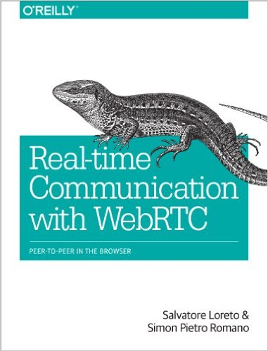](http://www.amazon.com/Real-Time-Communication-WebRTC-Peer---Peer/dp/1449371876/httpwwwtuto0a-20) [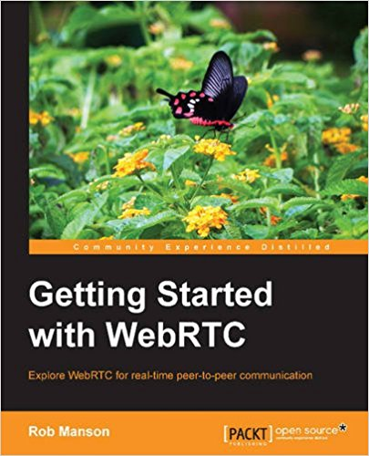](http://www.amazon.com/Getting-Started-WebRTC-Rob-Manson/dp/1782166300/httpwwwtuto0a-20) [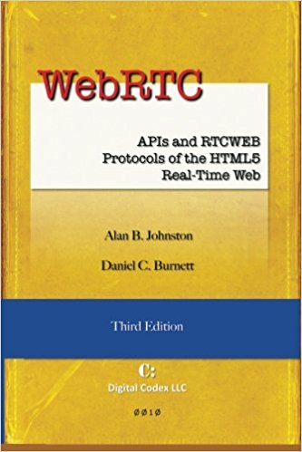](http://www.amazon.com/WebRTC-RTCWEB-Protocols-HTML5-Real-Time/dp/0985978864/httpwwwtuto0a-20)
* [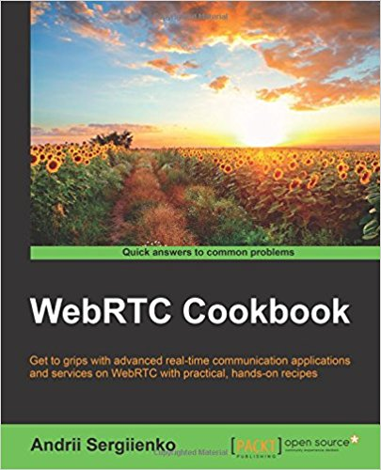](http://www.amazon.com/WebRTC-Cookbook-Andrii-Sergiienko/dp/1783284455/httpwwwtuto0a-20) [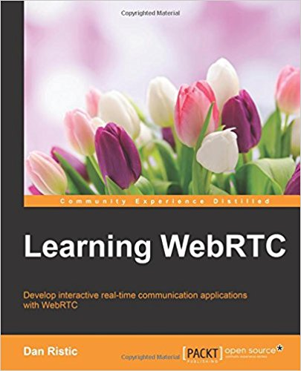](http://www.amazon.com/Learning-WebRTC-Dan-Ristic/dp/1783983663/httpwwwtuto0a-20) [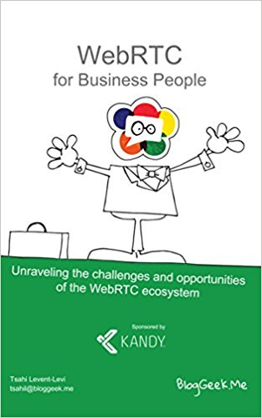](http://www.amazon.com/WebRTC-Business-People-Unraveling-opportunities-ebook/dp/B00PKLJOA6/httpwwwtuto0a-20)

To enlist your site on this page, please drop an email to [**contact@tutorialspoint.com**](mailto:contact@tutorialspoint.com)

# Discuss WebRTC

With Web Real-Time Communication (WebRTC), modern web applications can easily stream audio and video content to millions of people. In this tutorial, we would explain how you can use WebRTC to set up peer-to-peer connections to other web browsers quickly and easily.

# Computer Glossary

## **Applet**

A small Java application that is downloaded by an ActiveX or Java-enabled web browser. Once it has been downloaded, the applet will run on the user's computer. Common applets include financial calculators and web drawing programs.

## **Application**

Computer software that performs a task or set of tasks, such as word processing or drawing. Applications are also referred to as programs.

## **ASCII**

American Standard Code for Information Interchange, an encoding system for converting keyboard characters and instructions into the binary number code that the computer understands.

## **Bandwidth**

The capacity of a networked connection. Bandwidth determines how much data can be sent along the networked wires. Bandwidth is particularly important for Internet connections, since greater bandwidth also means faster downloads.

## **Binary code**

The most basic language a computer understands, it is composed of a series of 0s and 1s. The computer interprets the code to form numbers, letters, punctuation marks, and symbols.

## **Bit**

The smallest piece of computer information, either the number 0 or 1. In short they are called binary digits.

## **Boot**

To start up a computer. Cold boot means restarting computer after the power is turned off. Warm boot means restarting computer without turning off the power.

## **Browser**

Software used to navigate the Internet. Google Chrome, Firefox, Netscape Navigator and Microsoft Internet Explorer are today's most popular browsers for accessing the World Wide Web.

## **Bug**

A malfunction due to an error in the program or a defect in the equipment.

## **Byte**

Most computers use combinations of eight bits, called bytes, to represent one character of data or instructions. For example, the word **cat** has three characters, and it would be represented by three bytes.

## **Cache**

A small data-memory storage area that a computer can use to instantly re-access data instead of re-reading the data from the original source, such as a hard drive. Browsers use a cache to store web pages so that the user may view them again without reconnecting to the Web.

## **CAD-CAM**

**Computer Aided Drawing** - **Computer Aided Manufacturing.** The instructions stored in a computer that will be translated to very precise operating instructions to a robot, such as for assembling cars or laser-cutting signage.

## **CD-ROM**

**Compact Disc Read-Only Memory,** an optically read disc designed to hold information such as music, reference materials, or computer software. A single CD-ROM can hold around 640 megabytes of data, enough for several encyclopaedias. Most software programs are now delivered on CD-ROMs.

## **CGI**

**Common Gateway Interface,** a programming standard that allows visitors to fill out form fields on a Web page and have that information interact with a database, possibly coming back to the user as another Web page. CGI may also refer to Computer-Generated Imaging, the process in which sophisticated computer programs create still and animated graphics, such as special effects for movies.

## **Chat**

Typing text into a message box on a screen to engage in dialogue with one or more people via the Internet or other network.

## **Chip**

A tiny wafer of silicon containing miniature electric circuits that can store millions of bits of information.

## **Client**

A single user of a network application that is operated from a server. A client/server architecture allows many people to use the same data simultaneously. The program's main component (the data) resides on a centralized server, with smaller components (user interface) on each client.

## **Cookie**

A text file sent by a Web server that is stored on the hard drive of a computer and relays back to the Web server things about the user, his or her computer, and/or his or her computer activities.

## **CPU**

Central Processing Unit. The brain of the computer.

## **Cracker**

A person who breaks in to a computer through a network, without authorization and with mischievous or destructive intent.

## **Crash**

A hardware or software problem that causes information to be lost or the computer to malfunction. Sometimes a crash can cause permanent damage to a computer.

## **Cursor**

A moving position-indicator displayed on a computer monitor that shows a computer operator where the next action or operation will take place.

## **Cyberspace**

Slang for internet ie. An international conglomeration of interconnected computer networks. Begun in the late 1960s, it was developed in the 1970s to allow government and university researchers to share information. The Internet is not controlled by any single group or organization. Its original focus was research and communications, but it continues to expand, offering a wide array of resources for business and home users.

## **Database**

A collection of similar information stored in a file, such as a database of addresses. This information may be created and stored in a database management system (DBMS).

## **Debug**

Slang. To find and correct equipment defects or program malfunctions.

## **Default**

The pre-defined configuration of a system or an application. In most programs, the defaults can be changed to reflect personal preferences.

## **Desktop**

The main directory of the user interface. Desktops usually contain icons that represent links to the hard drive, a network (if there is one), and a trash or recycling can for files to be deleted. It can also display icons of frequently used applications, as requested by the user.

## **Desktop publishing**

The production of publication-quality documents using a personal computer in combination with text, graphics, and page layout programs.

## **Directory**

A repository where all files are kept on computer.

## **Disk**

Two distinct types. The names refer to the media inside the container:

A hard disc stores vast amounts of data. It is usually inside the computer but can be a separate peripheral on the outside. Hard discs are made up of several rigid coated metal discs. Currently, hard discs can store 15 to 30 Gb (gigabytes).

A floppy disc, 3.5" square, usually inserted into the computer and can store about 1.4 megabytes of data. The 3.5" square floppies have a very thin, flexible disc inside. There is also an intermediate-sized floppy disc, trademarked Zip discs, which can store 250 megabytes of data.

## **Disk drive**

The equipment that operates a hard or floppy disc.

## **Domain**

Represents an IP (Internet Protocol) address or set of IP addresses that comprise a domain. The domain name appears in URLs to identify web pages or in email addresses. For example, the email address for the First Lady is first.lady@whitehouse.gov, whitehouse.gov, being the domain name. Each domain name ends with a suffix that indicates what top level domain it belongs to. These are : .com for commercial, .gov for government, .org for organization, .edu for educational institution, .biz for business, .info for information, .tv for television, .ws for website. Domain suffixes may also indicate the country in which the domain is registered. No two parties can ever hold the same domain name.

## **Domain name**

The name of a network or computer linked to the Internet. Domains are defined by a common IP address or set of similar IP (Internet Protocol) addresses.

## **Download**

The process of transferring information from a web site (or other remote location on a network) to the computer. It is possible to download a file which include text, image, audio, video and many others.

## **DOS**

Disk Operating System. An operating system designed for early IBM-compatible PCs.

## **Drop-down menu**

A menu window that opens vertically on-screen to display context-related options. Also called pop-up menu or pull-down menu.

## **DSL**

**Digital Subscriber Line,** a method of connecting to the Internet via a phone line. A DSL connection uses copper telephone lines but is able to relay data at much higher speeds than modems and does not interfere with telephone use.

## **DVD**

Digital Video Disc. Similar to a CD-ROM, it stores and plays both audio and video.

## **E-book**

An electronic (usually hand-held) reading device that allows a person to view digitally stored reading materials.

## **Email**

Electronic mail; messages, including memos or letters, sent electronically between networked computers that may be across the office or around the world.

## **Emoticon**

A text-based expression of emotion created from ASCII characters that mimics a facial expression when viewed with your head tilted to the left. Here are some examples:

* Smiling
* Frowning
* Winking
* Crying

## **Encryption**

The process of transmitting scrambled data so that only authorized recipients can unscramble it. For instance, encryption is used to scramble credit card information when purchases are made over the Internet.

## **Ethernet**

A type of network.

## **Ethernet card**

A board inside a computer to which a network cable can be attached.

## **File**

A set of data that is stored in the computer.

## **Firewall**

A set of security programs that protect a computer from outside interference or access via the Internet.

## **Folder**

A structure for containing electronic files. In some operating systems, it is called a directory.

## **Fonts**

Sets of typefaces (or characters) that come in different styles and sizes.

## **Freeware**

Software created by people who are willing to give it away for the satisfaction of sharing or knowing they helped to simplify other people's lives. It may be free-standing software, or it may add functionality to existing software.

## **FTP**

**File Transfer Protocol,** a format and set of rules for transferring files from a host to a remote computer.

## **Gigabyte (GB)**

1024 megabytes. Also called gig.

## **Glitch**

The cause of an unexpected malfunction.

## **Gopher**

An Internet search tool that allows users to access textual information through a series of menus, or if using FTP, through downloads.

## **GUI**

**Graphical User Interface,** a system that simplifies selecting computer commands by enabling the user to point to symbols or illustrations (called icons) on the computer screen with a mouse.

## **Groupware**

Software that allows networked individuals to form groups and collaborate on documents, programs, or databases.

## **Hacker**

A person with technical expertise who experiments with computer systems to determine how to develop additional features. Hackers are occasionally requested by system administrators to try and break into systems via a network to test security. The term hacker is sometimes incorrectly used interchangeably with cracker. A hacker is called a white hat and a cracker a black hat.

## **Hard copy**

A paper printout of what you have prepared on the computer.

## **Hard drive**

Another name for the hard disc that stores information in a computer.

## **Hardware**

The physical and mechanical components of a computer system, such as the electronic circuitry, chips, monitor, disks, disk drives, keyboard, modem, and printer.

## **Home page**

The main page of a Web site used to greet visitors, provide information about the site, or to direct the viewer to other pages on the site.

## **HTML**

**Hypertext Markup Language,** a standard of text markup conventions used for documents on the World Wide Web. Browsers interpret the codes to give the text structure and formatting (such as bold, blue, or italic).

## **HTTP**

**Hypertext Transfer Protocol,** a common system used to request and send HTML documents on the World Wide Web. It is the first portion of all URL addresses on the World Wide Web.

## **HTTPS**

**Hypertext Transfer Protocol Secure,** often used in intracompany internet sites. Passwords are required to gain access.

## **Hyperlink**

Text or an image that is connected by hypertext coding to a different location. By selecting the text or image with a mouse, the computer jumps to (or displays) the linked text.

## **Hypermedia**

Integrates audio, graphics, and/or video through links embedded in the main program.

## **Hypertext**

A system for organizing text through links, as opposed to a menu-driven hierarchy such as Gopher. Most Web pages include hypertext links to other pages at that site, or to other sites on the World Wide Web.

## **Icons**

Symbols or illustrations appearing on the computer screen that indicate program files or other computer functions.

## **Input**

Data that goes into a computer device.

## **Input device**

A device, such as a keyboard, stylus and tablet, mouse, puck, or microphone, that allows input of information (letters, numbers, sound, video) to a computer.

## **Instant messaging (IM)**

A chat application that allows two or more people to communicate over the Internet via real-time keyed-in messages.

## **Interface**

The interconnections that allow a device, a program, or a person to interact. Hardware interfaces are the cables that connect the device to its power source and to other devices. Software interfaces allow the program to communicate with other programs (such as the operating system), and user interfaces allow the user to communicate with the program (e.g., via mouse, menu commands, icons, voice commands, etc.).

## **Internet**

An international conglomeration of interconnected computer networks. Begun in the late 1960s, it was developed in the 1970s to allow government and university researchers to share information. The Internet is not controlled by any single group or organization. Its original focus was research and communications, but it continues to expand, offering a wide array of resources for business and home users.

## **IP (Internet Protocol) address**

An Internet Protocol address is a unique set of numbers used to locate another computer on a network. The format of an IP address is a 32-bit string of four numbers separated by periods. Each number can be from 0 to 255 (i.e., 1.154.10.255). Within a closed network IP addresses may be assigned at random, however, IP addresses of web servers must be registered to avoid duplicates.

## **Java**

An object-oriented programming language designed specifically for programs (particularly multimedia) to be used over the Internet. Java allows programmers to create small programs or applications (applets) to enhance Web sites.

## **JavaScript/ECMA script**

A programming language used almost exclusively to manipulate content on a web page. Common JavaScript functions include validating forms on a web page, creating dynamic page navigation menus, and image rollovers.

## **Kilobyte (K or KB)**

Equal to 1,024 bytes.

## **Linux**

A UNIX - like, open-source operating system developed primarily by Linus Torvalds. Linux is free and runs on many platforms, including both PCs and Macintoshes. Linux is an open-source operating system, meaning that the source code of the operating system is freely available to the public. Programmers may redistribute and modify the code, as long as they don't collect royalties on their work or deny access to their code. Since development is not restricted to a single corporation more programmers can debug and improve the source code faster.

## **Laptop and notebook**

Small, lightweight, portable battery-powered computers that can fit onto your lap. They each have a thin, flat, liquid crystal display screen.

## **Macro**

A script that operates a series of commands to perform a function. It is set up to automate repetitive tasks.

## **Mac OS**

An operating system with a graphical user interface, developed by Apple for Macintosh computers. Current System X.1.(10) combines the traditional Mac interface with a strong underlying UNIX. Operating system for increased performance and stability.

## **Megabyte (MB)**

Equal to 1,048,576 bytes, usually rounded off to one million bytes (also called a meg).

## **Memory**

Temporary storage for information, including applications and documents. The information must be stored to a permanent device, such as a hard disc or CD-ROM before the power is turned off, or the information will be lost. Computer memory is measured in terms of the amount of information it can store, commonly in megabytes or gigabytes.

## **Menu**

A context-related list of options that users can choose from.

## **Menu bar**

The horizontal strip across the top of an application's window. Each word on the strip has a context sensitive drop-down menu containing features and actions that are available for the application in use.

## **Merge**

To combine two or more files into a single file.

## **MHz**

An abbreviation for **Megahertz,** or **one million hertz.** One MHz represents one million clock cycles per second and is the measure of a computer microprocessor's speed. For example, a microprocessor that runs at 300 MHz executes 300 million cycles per second. Each instruction a computer receives takes a fixed number of clock cycles to carry out, therefore the more cycles a computer can execute per second, the faster its programs run. Megahertz is also a unit of measure for bandwidth.

## **Microprocessor**

A complete central processing unit (CPU) contained on a single silicon chip.

## **Minimize**

A term used in a GUI operating system that uses windows. It refers to reducing a window to an icon, or a label at the bottom of the screen, allowing another window to be viewed.

## **Modem**

A device that connects two computers together over a telephone or cable line by converting the computer's data into an audio signal. Modem is a contraction for the process it performs : modulate-demodulate.

## **Monitor**

A video display terminal.

## **Mouse**

A small hand-held device, similar to a trackball, used to control the position of the cursor on the video display; movements of the mouse on a desktop correspond to movements of the cursor on the screen.

## **MP3**

Compact audio and video file format. The small size of the files makes them easy to download and e-mail. Format used in portable playback devices.

## **Multimedia**

Software programs that combine text and graphics with sound, video, and animation. A multimedia PC contains the hardware to support these capabilities.

## **MS-DOS**

An early operating system developed by Microsoft Corporation (Microsoft Disc Operating System).

## **Network**

A system of interconnected computers.

## **Open source**

Computer programs whose original source code was revealed to the general public so that it could be developed openly. Software licensed as open source can be freely changed or adapted to new uses, meaning that the source code of the operating system is freely available to the public. Programmers may redistribute and modify the code, as long as they don't collect royalties on their work or deny access to their code. Since development is not restricted to a single corporation more programmers can debug and improve the source code faster.

## **Operating system**

A set of instructions that tell a computer on how to operate when it is turned on. It sets up a filing system to store files and tells the computer how to display information on a video display. Most PC operating systems are DOS (disc operated system) systems, meaning the instructions are stored on a disc (as opposed to being originally stored in the microprocessors of the computer). Other well-known operating systems include UNIX, Linux, Macintosh, and Windows.

## **Output**

Data that come out of a computer device. For example, information displayed on the monitor, sound from the speakers, and information printed to paper.

## **Palm**

A hand-held computer.

## **PC**

Personal computer. Generally refers to computers running Windows with a Pentium processor.

## **PC board**

**Printed Circuit board,** a board printed or etched with a circuit and processors. Power supplies, information storage devices, or changers are attached.

## **PDA**

**Personal Digital Assistant,** a hand-held computer that can store daily appointments, phone numbers, addresses, and other important information. Most PDAs link to a desktop or laptop computer to download or upload information.

## **PDF**

**Portable Document Format,** a format presented by Adobe Acrobat that allows documents to be shared over a variety of operating systems. Documents can contain words and pictures and be formatted to have electronic links to other parts of the document or to places on the web.

## **Pentium chip**

Intel's fifth generation of sophisticated high-speed microprocessors. Pentium means the fifth element.

## **Peripheral**

Any external device attached to a computer to enhance operation. Examples include external hard drive, scanner, printer, speakers, keyboard, mouse, trackball, stylus and tablet, and joystick.

## **Personal computer (PC)**

A single-user computer containing a central processing unit (CPU) and one or more memory circuits.

## **Petabyte**

A measure of memory or storage capacity and is approximately a thousand terabytes.

## **Petaflop**

A theoretical measure of a computer's speed and can be expressed as a thousand-trillion floating-point operations per second.

## **Platform**

The operating system, such as UNIX, Macintosh, Windows, on which a computer is based.

## **Plug and play**

Computer hardware or peripherals that come set up with necessary software so that when attached to a computer, they are recognized by the computer and are ready to use.

## **Pop-up menu**

A menu window that opens vertically or horizontally on-screen to display context-related options. Also called drop-down menu or pull-down menu.

## **Power PC**

A competitor of the Pentium chip. It is a new generation of powerful sophisticated microprocessors produced from an Apple-IBM-Motorola alliance.

## **Printer**

A mechanical device for printing a computer's output on paper. There are three major types of printer:

* **Dot matrix -**creates individual letters, made up of a series of tiny ink dots, by punching a ribbon with the ends of tiny wires. (This type of printer is most often used in industrial settings, such as direct mail for labelling.)
* **Ink jet -**sprays tiny droplets of ink particles onto paper.
* **Laser -**uses a beam of light to reproduce the image of each page using a magnetic charge that attracts dry toner that is transferred to paper and sealed with heat.

## **Program**

A precise series of instructions written in a computer language that tells the computer what to do and how to do it. Programs are also called software or applications.

## **Programming language**

A series of instructions written by a programmer according to a given set of rules or conventions (syntax). High-level programming languages are independent of the device on which the application (or program) will eventually run; low-level languages are specific to each program or platform. Programming language instructions are converted into programs in language specific to a particular machine or operating system (machine language). So that the computer can interpret and carry out the instructions. Some common programming languages are BASIC, C, C++, dBASE, FORTRAN, and Perl.

## **Puck**

An input device, like a mouse. It has a magnifying glass with crosshairs on the front of it that allows the operator to position it precisely when tracing a drawing for use with CAD-CAM software.

## **Pull-down menu**

A menu window that opens vertically on-screen to display context-related options. Also called drop-down menu or pop-up menu.

## **Push technology**

Internet tool that delivers specific information directly to a user's desktop, eliminating the need to surf for it. PointCast, which delivers news in user-defined categories, is a popular example of this technology.

## **QuickTime**

Audio-visual software that allows movie-delivery via the Internet and e-mail. QuickTime images are viewed on a monitor.

## **RAID**

**Redundant Array of Inexpensive Disks,** a method of spreading information across several disks set up to act as a unit, using two different techniques:

* **Disk striping -**storing a bit of information across several discs (instead of storing it all on one disc and hoping that the disc doesn't crash).
* **Disk mirroring -**simultaneously storing a copy of information on another disc so that the information can be recovered if the main disc crashes.

## **RAM**

**Random Access Memory,** one of two basic types of memory. Portions of programs are stored in RAM when the program is launched so that the program will run faster. Though a PC has a fixed amount of RAM, only portions of it will be accessed by the computer at any given time. Also called memory.

## **Right-click**

Using the right mouse button to open context-sensitive drop-down menus.

## **ROM**

**Read-Only Memory,** one of two basic types of memory. ROM contains only permanent information put there by the manufacturer. Information in ROM cannot be altered, nor can the memory be dynamically allocated by the computer or its operator.

## **Scanner**

An electronic device that uses light-sensing equipment to scan paper images such as text, photos, and illustrations and translate the images into signals that the computer can then store, modify, or distribute.

## **Search engine**

Software that makes it possible to look for and retrieve material on the Internet, particularly the Web. Some popular search engines are Alta Vista, Google, HotBot, Yahoo!, Web Crawler, and Lycos.

## **Server**

A computer that shares its resources and information with other computers, called clients, on a network.

## **Shareware**

Software created by people who are willing to sell it at low cost or no cost for the gratification of sharing. It may be freestanding software, or it may add functionality to existing software.

## **Software**

Computer programs; also called applications.

## **Spider**

A process search engines use to investigate new pages on a web site and collect the information that needs to be put in their indices.

## **Spreadsheet**

Software that allows one to calculate numbers in a format that is similar to pages in a conventional ledger.

## **Storage**

Devices used to store massive amounts of information so that it can be readily retrieved. Devices include RAIDs, CD-ROMs, DVDs.

## **Streaming**

Taking packets of information (sound or visual) from the Internet and storing it in temporary files to allow it to play in continuous flow.

## **Stylus and tablet**

An input device similar to a mouse. The stylus is pen shaped. It is used to draw on a tablet (like drawing on paper) and the tablet transfers the information to the computer. The tablet responds to pressure. The firmer the pressure used to draw, the thicker the line appears.

## **Surfing**

Exploring the Internet.

## **Surge protector**

A controller to protect the computer and make up for variances in voltage.

## **Telnet**

A way to communicate with a remote computer over a network.

## **Trackball**

Input device that controls the position of the cursor on the screen; the unit is mounted near the keyboard, and movement is controlled by moving a ball.

## **Terabytes (TB)**

A thousand gigabytes.

## **Teraflop**

A measure of a computer's speed. It can be expressed as a trillion floating-point operations per second.

## **Trojan Horse**

See [virus](https://www.tutorialspoint.com/computer_glossary/index.htm#vi).

## **UNIX**

A very powerful operating system used as the basis of many high-end computer applications.

## **Upload**

The process of transferring information from a computer to a web site (or other remote location on a network). To transfer information from a computer to a web site (or other remote location on a network).

## **URL**

Uniform Resource Locator.

* The protocol for identifying a document on the Web.
* A Web address (e.g., www.tutorialspoint.com). A URL is unique to each user. See also domain.

## **UPS**

Universal Power Supply or Uninterruptible Power Supply. An electrical power supply that includes a battery to provide enough power to a computer during an outage to back-up data and properly shut down.

## **USB**

A multiple-socket USB connector that allows several USB-compatible devices to be connected to a computer.

## **USENET**

A large unmoderated and unedited bulletin board on the Internet that offers thousands of forums, called newsgroups. These range from newsgroups exchanging information on scientific advances to celebrity fan clubs.

## **User friendly**

A program or device whose use is intuitive to people with a non-technical background.

## **Video teleconferencing**

A remote "face-to-face chat," when two or more people using a webcam and an Internet telephone connection chat online. The webcam enables both live voice and video.

## **Virtual reality (VR)**

A technology that allows one to experience and interact with images in a simulated three-dimensional environment. For example, you could design a room in a house on your computer and actually feel that you are walking around in it even though it was never built. (The Holodeck in the science-fiction TV series Star Trek : Voyager would be the ultimate virtual reality.) Current technology requires the user to wear a special helmet, viewing goggles, gloves, and other equipment that transmits and receives information from the computer.

## **Virus**

An unauthorized piece of computer code attached to a computer program or portions of a computer system that secretly copies itself from one computer to another by shared discs and over telephone and cable lines. It can destroy information stored on the computer, and in extreme cases, can destroy operability. Computers can be protected from viruses if the operator utilizes good virus prevention software and keeps the virus definitions up to date. Most viruses are not programmed to spread themselves. They have to be sent to another computer by e-mail, sharing, or applications.The worm is an exception, because it is programmed to replicate itself by sending copies to other computers listed in the e-mail address book in the computer. There are many kinds of viruses, for example:

* Boot viruses place some of their code in the start-up disk sector to automatically execute when booting. Therefore, when an infected machine boots, the virus loads and runs.
* File viruses attached to program files (files with the extension .exe). When you run the infected program, the virus code executes.
* Macro viruses copy their macros to templates and/or other application document files.
* Trojan Horse is a malicious, security-breaking program that is disguised as something being such as a screen saver or game.
* Worm launches an application that destroys information on your hard drive. It also sends a copy of the virus to everyone in the computer's e-mail address book.

## **WAV**

A sound format (pronounced wave) used to reproduce sounds on a computer.

## **Webcam**

A video camera/computer setup that takes live images and sends them to a Web browser.

## **Window**

A portion of a computer display used in a graphical interface that enables users to select commands by pointing to illustrations or symbols with a mouse. "Windows" is also the name Microsoft adopted for its popular operating system.

## **World Wide Web ("WWW" or "the Web")**

A network of servers on the Internet that use hypertext-linked databases and files. It was developed in 1989 by Tim Berners-Lee, a British computer scientist, and is now the primary platform of the Internet. The feature that distinguishes the Web from other Internet applications is its ability to display graphics in addition to text.

## **Word processor**

A computer system or program for setting, editing, revising, correcting, storing, and printing text.

## **Worm**

See [virus](https://www.tutorialspoint.com/computer_glossary/index.htm#vi).

## **WYSIWYG**

What You See Is What You Get. When using most word processors, page layout programs (See desktop publishing), and web page design programs, words and images will be displayed on the monitor as they will look on the printed page or web page.